Spring 2015

Group 3:

Juammy Lora Emmanuel Martinez Devesh Maharaj Randy Aybar

Drone Hunt

04/23/15

**Table of Contents**

1.0 Executive Summary 1

2.0 Project Description 3

2.1 Project Motivations and Goals 3

2.3 Project Requirements and Specifications 6

2.3.1 Functional Requirements 6

2.3.1.1 Drone System 6

2.3.1.2 The Laser Gun System 7

2.3.1.3 The Ultrasonic Proximity system 8

2.3.1.4 The Server Subsystem 8

2.3.1.5 The Ground Control System 8

2.2.2 Non-Functional Requirements 9

2.2.2.1 Drone System 9

2.2.2.2 The Laser Gun System 9

2.2.2.3 The Ground Control System 10

3.0: Research related to Project Definition 11

3.1 Existing Similar Projects and Products and Relevant Technologies 11

3.2 Possible Architectures and Related Diagrams 18

4.0 Project Design Detail 23

4.1 Drone Subsystem 23

4.1.1 Frame Structure 23

4.1.2.1 Flight System 24

4.1.2.2 Flight Control System 26

4.1.3 Power System 31

4.1.3.1 Peripherals Power System 31

4.1.3.2 Flight Power System 32

4.1.4 Artificial Intelligence 37

4.2 Laser Subsystem 43

4.2.1 Laser Transmitter 43

4.2.2 Laser Receivers 45

4.3 Server Subsystem 45

4.3.1 Hardware 47

4.3.3 I/O and Application Flow 54

5.0 Design Summary 68

5.1 Drone Subsystem 68

5.2 Laser Subsystem 69

5.3 Server Subsystem 71

5.4 Ground Control Subsystem 72

6.0 Project Prototype Construction & Coding 75

6.1 Bill of Materials 75

6.1.1 Drone 75

6.1.2 Lasers, LEDs and Proximity Sensors 76

6.2.2.1 4PCB 79

6.2.2.2 OSH Park 79

6.2.2.3 Express PCB 79

6.3 Final Coding Plan 80

6.3.1 Coding Architecture and Diagrams 80

6.3.3.1 Mission Planner 83

6.3.3.2 Web Application 83

7.0 Project Prototype Testing 86

7.1 Hardware Test Environment 86

7.1.1 Drone 86

7.1.2 Laser, LED’s and Sensors 89

7.1.2.1 Ultrasonic Proximity Sensor 89

7.1.2.2 Laser System 90

7.1.2.3 LED System 90

7.2 Hardware Specific Testing 92

7.2.1 Drone 92

8.0 Product Instructions 106

8.1 Setting up Mr. DJ 106

8.2 Setting up Ground Control Station 106

8.3 Game Setup 108

8.4 Playing Drone Hunt 108

8.5 Troubleshooting 110

9.0 Administrative Content 116

9.1 Milestones Discussion 116

9.1 Budget and Finance Discussion 119

9.2 Sponsoring Discussion 119

9.3 Group's Ethics 120

9.4 Distribution of Work 121

Appendices 123

A. Copyright Citations 123

B. Permissions 125

1.0 Executive Summary

Drone Hunt derived from Duck Hunt, Laser Tag, and Skeet. The idea behind it all is to have a sensor-equipped, medium-sized, lightweight, and fast quadcopter flying both autonomously and user-controlled (players can set this mode as desired) while players target and shoot the drone with modified guns for a high score under adjustable time constraints. The onboard sensors will send real-time scores and statistics to the server host which resides on land and displays the data through a web-application.

The ArduPilot 2.6 Flight Control Autopilot Module will be implemented running a modified version of Mission Planner 2.0 on-screen display. The APM 2.6 is a complete open source autopilot system which allows the quadcopter to be turned into a fully autonomous multi rotor vehicle capable of traveling relative to waypoints set on the ground control station via Mission Planner 2.0. Communication between the flight controller and the ground station will be handled by the 3DRobotics Radio Telemetry Kit which uses the 915 MHz frequency to provide great range for a small price. This telemetry kit also uses open source firmware so it provides a more flexibility for modifications to fit the needs for a small price. Mission Planner 2.0 will be the platform used for user I/O for autonomous control and a real-time stream of flight data. It uses the 3DR telemetry radio to gather information from the drone's GPS and inertial measurement unit (IMU) which will be displayed onto Mission Planner’s on-screen display (OSD).

The laser subsystem that is included in the project will be used as the main feature of the project itself. This system will consist of two to four modified guns that will transmit a laser each time the trigger is depressed. The laser transmitter on each gun will all have a modulated wavelength so that each beam is unique making it possible to differentiate between the different guns and therefore allowing pinpointing which player made a hit on target. On the underside of the drone several solar panels will be attached to be used as receivers for the laser. Every time a laser from a specific gun hits a receiver the data is transmitted to our server where the data is tabulated and scores are displayed on the output of the ground control station.

At the ground control station, all the components will be combined to provide a unified experience for the end-user in this case being the players.  An application will be developed and ran from a single BeagleBone Black that will be running a web server with PHP and several other extensions providing the basics for a web-based app that can be accessed from any type of device on our mini control center.  The application itself is to be written using JavaScript derivatives such as jQuery possibly alongside node.js to give flexibility.  The role of the web app is to provide a friendly interface for game settings and customization as well as provide game statistics such as player score, hit rate, and accuracy.  On the backend of the application a database will be keeping this data as well as a history of the drone’s vitals to help calculate battery usage.  For the most part the app will drive the player user experience.

In addition to the drone and the laser, if time allows, this project will also be equipped with a portable ground control station. This station will be a light-weight portable case that consists of a laptop for the web application, the communication components, the laser guns, battery charger, and some LCD’s to display battery life. To start, the plan the plan is to use an old computer’s motherboard, a laptop screen that is already owned and integrate it all into one easy to transport military case that can be connected to AC power if available. Having this ground control station will provide a more professional final product so that assembling and disassembling of parts and cables would not be necessary in order to showcase the product on the field. Moreover, an objective for this ground control station is to provide more design into the project. The reason for that is because this project could be made much better and the amount of design being done in the drone and laser allows being included such a flexible and universal solution for controlling the drone.

2.0 Project Description

The following section will highlight the entire project in a high-level manner which will provide a basis for the rest of the project. Each subsection will be divided into four different topics: Project Motivation and Goals, Project Requirements and Relevant Technologies, Functional Requirements, and finally the Drone Subsystem. This section will give an overview of what is expected to be accomplished throughout the course of the project plan and build.

2.1 Project Motivations and Goals

Since the first semester here in the university, a couple of the current members of this group already knew that they would be pairing up for senior design. They were anxious and motivated to get started on this experience already had an idea of making some type of robot with a unique feature. At the beginning of this semester each member of the group comes up with at least five ideas to the table. After narrowing down the top best ideas, the team stumbled across deciding on making a quadcopter that simply overshadows a person and follows him/her. But it was then decided that that idea was yet too simple and common. Following that idea, it was then said that this group would make an autonomous drone that for simplicity carries a package, sends it to a destination and returns back. Then again, it was agreed that that idea was also too simple and common. Then, the group finally all came together and by just one of the member saying the word laser, the idea of combining duck hunt with a drone come to the table. This group believed that Drone Hunt would enable the group members from both engineering disciplines to utilize all of the knowledge obtained during the four years at UCF to not only create something fun, new, and exciting, but to create something that everyone will remember for many years to come. After making the final decision, the team started brainstorming on names for the actual drone itself. A clever member of this group said that the first letter of each of each names as an acronym should be used. Therefore, it was concluded that the name of the drone would be “Manny, Randy, Devesh, Juammy” in that order which produces the name “Mr. DJ.”

The main motivation of this group was to develop a product that serves as entertainment for users as well as some type of skill practice. This project is not only targeting a personnel that enjoys games and fun activities, this team is also aware that across the US, military companies use laser guns and robotic devices for the use of training troops. This product will also be very compatible with the US military training activities; a great motivation to develop a product in senior design.

It’s obvious by now that drones are here to stay and will be used for many different applications in the future which only time will tell what they may be. With major defense and aerospace companies such as Boeing [1] dropping manned-military aircraft programs such as the FA/18 Super Hornet and the F-15 to replace them with drone research and development. What better senior design project can provide the type of experience to prepare students to work for the best of the best?

While the mechanical drone itself has been outdone in the engineering community with the various hobbyists coming out with mod after mod, creativity can prove to reinvent and spark interest. After much brainstorming and research the idea of a laser shooter game seemed somewhat unique when it came to the drone community. Due to the fact that the drone itself is scalable the idea becomes possible with a modular design that can be added and integrated to come out with our product in action.

This project carries some similarities to laser tag as they are both multi person shooter style interactive games. One would automatically think that this group would use the same technology used in the laser tag industry. However instead of going with the regular infrared based transmitters, this team will be implementing a laser based transmitter in our project. After researching the infrared technology there was a major downside to using this form of transmitters. With increased range the infrared transmitters became much less accurate. Since this project implements multiple hit zones (receivers) on the underside of the drone, using an infrared transmitter would actually hit more than one sensor at increased distances. The lasers on the other hand, for the range requirements of our project would lose no accuracy at all due to the highly accurate nature of the laser beams and allow for more accurate hits on each individual receiver.

In conclusion, it is known that developing a full product of a drone and all the devices for communication and laser guns will be a very messy showcase. This team wants to develop a very professional product. The idea of designing a ground control system came across because this group wants a clean, complete product that users can fully enjoy; not only the gaming aspects of the product but also the display and the controlling experience of the product. When this product is complete, there will be many times where each member would have to carry all the laptops, router, boards, guns, battery charger wherever the product is presented and assemble and disassemble those parts along with all the cables, USB’s, etc. It was agreed that if all of these components were inside one durable and portable military case and design this ground control system, our lives would be easier. Drone Hunt is very motivated to develop a ground control system because having this will add to this product a fully durable, portable,  and a military feel case to it that can be opened and operated anywhere in the world.

**2.2 Objectives**

First of all, as with any flying object, Mr. DJ must be lightweight, robust, and efficient with power consumption to provide maximum flight times and optimal aero-agility. Navigation will come from two different modes (user-controlled and autonomous) which makes Mr. DJ semi-autonomous. For these features to be possible, Mr. DJ must be equipped with a flight controller that has the ability to sense and react to the many unpredictable forces of nature. In other words, the flight controller must compute algorithms based on the data it receives from external sensors and reacts accordingly while relaying this telemetry information wirelessly to the ground control station and transmitter. If a user wants to control the drone, he or she can simply switch the transmitter into user-mode to have full control of Mr. DJ. If the user wants to watch or play Drone Hunt, instead they can choose autonomous mode which will have custom waypoints and boundaries set by the user on APM Planner 2.0’s on-screen display.

Secondly, the main feature of this product will be an aerial multi-player shooter using laser guns and photodiodes. The laser subsystem in this project will implement the means for the prototype to serve this purpose as it will be used by the end user (players) to interact with the drone while it is flying. Laser technology is being used as part of our prototype instead of the more common infrared because of the very high level accuracy of laser beams as compared to infrared. Using the laser technology allows this group to apply a vast amount of knowledge acquired over the past four years in frequency modulation, circuit design, semiconductor devices (photodiodes), and use of microcontrollers.

Since the prototype will have an autonomous mode the very first issue that comes to mind is, “What if it crashes into something?” To cope with this problem implementation of a safety system is a must. The primary safety feature involves an obstacle avoidance system in Mr. DJ which comprises of proximity sensors attached to the exterior of the drone, that when linked to a microcontroller will solve our obstacle problem. After some research the best option to use for obstacle detection seems to be infrared technology, which is what will be implemented in Mr. DJ.

Mr. DJ will also incorporate an LED lighting subsystem on the drone. The purpose this system will serve is for both increased visibility at night as well as providing feedback to the players to show them when a hit is made on the drone. This subsystem will comprise multiple LED diodes attached to the underside of the drone so that it can be seen by the players while the drone is flying. The circuit for this system will allow this group to implement circuit design in creating the network of LED diodes. The circuit will then be controlled by the onboard microcontroller on the drone, which will be programmed with specific lighting options for different scenarios.

While much of the subsystems can hold up on their own the most important aspect of presenting our design is having an application that takes all these subsystems and their features to produce gaming environment that the user would experience.  The application will come in the form of program coded and tailored to a specific platform and would provide the signals that each of the subsystems would receive to do the designed task.  For example the program running would allow the players to choose the drone’s flight pattern, difficulty, LED color per player, and gun number.  This information would be relayed from the server (BeagleBone Black) and onto the various embedded devices that control the autonomous movement for the drone, the color of the individual LEDs and the settings of the individual guns.  Game statistics would be displayed as the game progresses coming back from the device to the server.  Once the game is over the server would once again the necessary signals to send the drone back to the ground to have its batteries changed and charged for the next round to begin.  This gives one clear objective of the project and provides much challenge as final integration and testing comes into focus.

Finally, our objectives for this section of this project is to fully design and develop a complete ground control system for users to have easy access for all the software, battery charging, and communication components for the complete drone experience all in one system. Our first step will be to gather a good condition military case with the adequate space for all the components going into this system. An LCD screen and keyboard will be required for display purposes and also for user inputs and software operations. A bare desktop motherboard will be used as the computing power for the software sending control signals to Mr. DJ. The LCD screen will be mounted on the lid side of the case and the keyboard on the base side of the case. The cables will be tied up and routed out of the way to allow for additional components to be placed inside. The bare system will be running the Mission Planner software that communicates with the Flight Control system on Mr. DJ. The BeagleBone Black microcontroller will help the bare motherboard system in providing the web application service. In addition to that, the control system will have the routers and antenna the communication will be requiring. In addition, a battery station will be implemented where users may charge the drone’s battery when the game is over. In order for this ground control system to be fully portable, there must be some sort of power supply for the laptop, routers, boards, etc. Therefore, the station would include a 12V/6A SLA(Sealed Lead Acid) battery which will provide enough to power all these components for more than two hours.  In addition to all these components a digital LCD is planned to be implemented dedicated to displaying the battery life of the drone.

2.3 Project Requirements and Specifications

This following section of this paper takes care of all the requirements that this project requirements. In more details, this section is broken up in two different sections. One section discusses the types of requirements that this each subsystem definitely needs in order to function. The second section (non-functional), describes the types of requirements that the system does not necessary require in order to function properly.

2.3.1 Functional Requirements

This section of this paper presents talks about all the functional requirements that each subsystem must have. In other words, these are all the requirements that a system must have in order for this specific system to properly function.

2.3.1.1 Drone System

This following table was developed after analyzing all the requirements that the drone system shall have. It describes all the functional requirements that the drone must have.

|  |
| --- |
| No.1: The drone shall have a medium-large quadrotor frame |
| No.2: The drone shall have brushless motors |
| No.3: The drone shall have a portable max 12V power supply |
| No.4: The drone shall have a 1:1 ratio of electronic speed controllers to motors |
| No.5: The drone shall have a flight controller |
| No.6: The drone shall have a Compass & GPS |
| No.7: The drone shall have a Gyroscope |
| No.8: The drone shall have an Accelerometer |
| No.9: The drone shall have a Magnetometer |
| No.10: The drone shall have a Barometer |
| No.11: The drone shall have an RC Transmitter |
| No.12: The drone shall have a RC Transmitter Battery |
| No.13: The drone shall have a Battery Charger |
| No.14: The drone shall have an RC Receiver |
| No.15: The drone shall have a 1:1 ratio of propellers to motors |
| No.16: The drone shall have a telemetry communication |
| No.17: The drone shall have a an on-screen display |
| No.18: The drone shall have a Power Regulating Module |

Table 2.1: Functional Requirements of the Drone

2.3.1.2 The Laser Gun System

This following table was developed after analyzing all the requirements that the laser gun system shall have. It describes all the functional requirements that the laser gun system must have.

|  |
| --- |
| No.1: The laser gun system shall have two modified guns designed to emit a laser beam that each has a modulated frequency |
| No.2: The laser gun system shall have a Wi-Fi adapter to transmit information back to the ground control station |
| No.3: The laser gun system shall have a programmed microcontroller chip for calculating trigger pulls and then transmit that data back to the ground control station |
| No.4: The laser gun system shall have photo sensors placed on the drone that will receive the laser beams, and each hit on one of the photo sensors will be detected by the microcontroller |
| No.5: The laser gun system shall have a microcontroller that will also distinguish which gun the laser originated from by recognizing the frequency and then relay this information back to the ground control station |

Table 2.2: Functional Requirements of the Laser Gun System

2.3.1.3 The Ultrasonic Proximity system

This following table was developed after analyzing all the requirements that the infrared system shall have. It describes all the functional requirements that the infrared system must have.

|  |
| --- |
| No.1: The ultrasonic proximity system shall have multiple ultrasonic sensors attached to the exterior of the drone |
| No.2: The ultrasonic proximity system shall have a microcontroller attached to the sensors on the drone |

Table 2.3: Functional Requirements of the Sensor System

2.3.1.4 The Server Subsystem

This following table was developed after analyzing all the requirements that the server system shall have. It describes all the functional requirements that the server system must have.

|  |
| --- |
| No.1: The server system shall have a Raspberry Pi (Model B, rev. 1) installed with a proper installation of Linux for ARM that allows for a web server to be implemented |
| No.2: The server system shall have a wireless router to provide the basics for a small network of devices |
| No.3: The server system shall have a Wi-Fi module for Raspberry Pi for communication across network |
| No.4: The server system shall have an Arduino microcontroller (goes on drone) and Wi-Fi module to communicate back to Pi or BeagleBone Black board back at the base station |

Table 2.4: Functional Requirements of the Server Subsystem

2.3.1.5 The Ground Control System

This following table was developed after analyzing all the requirements that the ground control system shall have. It describes all the functional requirements that the ground control system must have.

|  |
| --- |
| No.1: The ground control system shall have a BeagleBone Black to serve as the main motherboard of the entire ground control system |
| No.2: The ground control system shall have a small tablet size screen to display |
| No.3: The ground control system shall have a keyboard(with mouse pad) for input and software use |
| No.4: The ground control system shall have a type of power supply for powering the station |
| No.5: The ground control system shall have all the communication components(router, antenna, Wi-Fi adapter, server) |
| No.6: The ground control system shall have the battery charger to easily charge the drone’s battery when needed |
| No.7: The ground control system shall have a fan to serve as a cooling system |

Table 2.5: Functional Requirements of the Ground Control System

2.2.2 Non-Functional Requirements

This section of this paper presents talks about all the non-functional requirements that each subsystem may have. In other words, these are all the extra requirements that a system may function without the presence of.

2.2.2.1 Drone System

This following table was developed after analyzing all the non-functional requirements that the drone system must have. It describes all the functional requirements that the drone may have.

|  |
| --- |
| No.1: The drone may have LED Matrix lights |
| No.2: The drone may have Extended Landing Gear: F450 Flame Wheel Legs |

Table 2.6: Non-Functional Requirements of the Drone System

2.2.2.2 The Laser Gun System

This following table was developed after analyzing all the non-functional requirements that the laser gun system must have. It describes all the functional requirements that the laser gun may have.

|  |
| --- |
| No.1: The laser gun system may have LED Diodes |
| No.2: The laser gun system may have Programmed microcontroller to control led output |

Table 2-7: Non-Functional Requirements of the Laser Gun System

2.2.2.3 The Ground Control System

This following table was developed after analyzing all the non-functional requirements that the ground control system must have. It describes all the functional requirements that the ground control system may have.

|  |
| --- |
| No.1: The ground control system may have LCD(s) to display additional information about the drone’s being |
| No.2: The ground control system may have rocket toggle switches |
| No.3: The ground control system may have wheels |

Table 2.8: Non-Functional Requirements of the Ground Control System

3.0: Research related to Project Definition

This following section for this senior design paper will take care of all the research developed by each of the members on their corresponding system for this project. This section will include the projects that already exist out in the world that may be of some type of use when it comes to the development of this Drone Hunt senior design project. The knowledge attained from this research section will allow all group members to implement the design for each of their respective subsections based on already existing similar projects.

3.1 Existing Similar Projects and Products and Relevant Technologies

Because technology is always moving forward and quite rapidly new projects can quickly arise whether it is an improvement to an existing design or something that can be claimed to be original from the start.

Advances in communication continue to change the way that aerial devices are controlled and maneuvered.  While commercial and military units have been around for much of the 20th century, it is during the latter half that the average consumer is able to experience radio controlled flight on a smaller scale.  Since then a community was born where not only do hobbyists help those seeking interest but also sharing ideas of what can be accomplished with these drones.

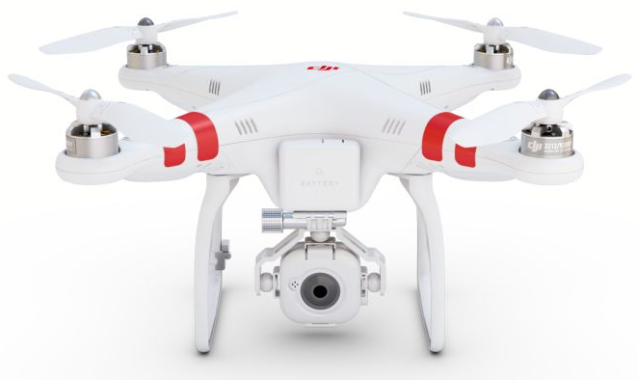

Figure 3.1: DJI Phantom 2 FPV Quadcopter [2]

When the team started planning on a multicopter design, several drones’ designs were analyzed. Many of these drones featured different shapes and sizes ranging from mini tricopters used for stunting to large 1000mm+ sized octocopters used for heavy payload carrying. However none of the drones were used for interactive gaming so it was up to the team to come up with a certain frame-size and flight system that would best suit the needs for the project. During the research period the group reached out to the many hobbyist communities such as DIYDrones.com and RC-Groups.com to learn more about their designs and why they chose to go with their configuration. After two weeks of research and discussion, it was concluded that the weight and size of Mr. DJ needs be greater than the small agile stunting drones but less than heavy payload carriers, our ideal target weight would be similar to the larger than average first-person-view (FPV) flyers which are extremely popular these days.

Retail FPV drones such as the DJI Phantom 2 are commonly found taking aerial photography and videography, broadcasting live sporting events, capturing beautiful landscapes, and filming Hollywood movies. These (mostly) closed-sourced drones are readily available to purchase from major online and retail stores for a cost of $600-$2500 depending on how heavily modified you want it. While these drones are easy to configure, reliable, and ready to fly out of the box, they lacked the freedom to modify the software and hardware in ways that the team's design required. This led the team to explore open-sourced FPV drones. Open-source drones are found in the same applications as retail drones but provide the ability to have full control of all the specific hardware and software implemented in team's design and the freedom to build it in any shape or size needed want for a manageable budget.

When it comes to frame structure, there is a simple linear relationship between strength, weight, size, and cost:

*cost =frameSize + frameStrength + frameWeight*

Equation 3.1

The frame options available were carbon fiber, fiberglass, aluminum, plastic, and many more.  After weighing the needs it was decided that the material of the frame must be made of fiberglass and polyamide nylon.

There is a wide array of choices when it comes to electronics communications. With the exponential growth in everyday use of wireless networking, most of our telemetry used for communication between the ground station, Turnigy 9X transmitter, FrSky D8R-II receiver and Mr.DJ will be handed by 2.4GHz wireless technology. This is common in most modern RC flyers and RC cars these days simply because there is virtually no possibility of interference, faster response time, and no longer a need to control your frequency.

After coming up with the idea of the interactive game using a quadcopter drone, the research phase began. First off, the game idea is similar to the game of laser tag. However, after researching into the game it was discover that laser tag actually uses infrared technology. Infrared transmitters are not very accurate at further distances as the hit radius increases with increasing range. Due to this high level of inaccuracy it was decided to not go with infrared transmitters, instead a much more accurate laser beam will used.

Further research revealed military applications of lasers being used in training exercises for soldiers called Multiple Integrated Laser Engagement System or MILES. This system uses lasers and blank cartridges for simulating actual battle. This application of lasers is much better suited to be implemented into our project. The MILES System is designed in such a way that individual soldiers carry small laser receivers scattered all over their bodies which detect when a soldier has been hit by a firearm’s laser. Depending on the hit region on the soldier’s body, determined by the receiver hit, and the range and firearm type, determined by data transferred using the laser, the injury sustained by a hit could be determined. The MILES System could be used in conjunction with real-time data transmission to send position and event data back to a central location for data collection, analysis and display. There are even more sophisticated versions for tanks and APC’s that use various techniques to allow more precise targeting of armored vehicles.

Many hobbyists have adopted the concept from the MILES system and created several different do-it-yourself projects with the same technology for recreation purposes. One such hobbyist, MacDynamo has an online tutorial where he shows his build on a breadboard on how the system works and gives step by step instruction on how to build it. He used the parts listed below which were priced at RadioShack.

* (opt.) x2 $.48 8 pin IC socket
* (opt.) $.99 14 pin IC socket
* (opt.) $1.99 perf board (these 1.99-cheapies should have enough holes)
* $1.99 piezo speaker (some higher dB speakers are more costly)
* $1.49 .01 microfarad cap
* $.99 10k ohm resistors (5-pack)
* $.99 65k ohm resistors (5-pack)
* $.99 100 ohm resistors (5-pack)
* $2.99 CdS photoresistors (5-pack)
* $3.99 5mm tactile switch
* (opt.) $3.99 SPDT toggle switch
* (opt.) $1.49 trimmer resistor
* (opt.) $3.99 pager motor ("rumble" motor)
* (opt.) $2.99 breadboard
* $2.99 assorted LEDs (20 pack - cost effective if you want to make more suits)
* $1.69 LM555 timer chip (8-pin)
* $3.69 (from Wal-Mart) Laser pointer or bright flashlight (sensitivity will be explained in the build and explanation sections)
* Wires and/or alligator clips, 9v battery clip
* 9V battery

Using the above parts list he gave step by step instruction on how to build a laser tag receiver circuit and a laser tag transmitter for the game. The below schematic uses the parts list given to design a tone generating laser receiver circuit that emits a tone using the piezo speaker as the output whenever the laser hits the receiver.

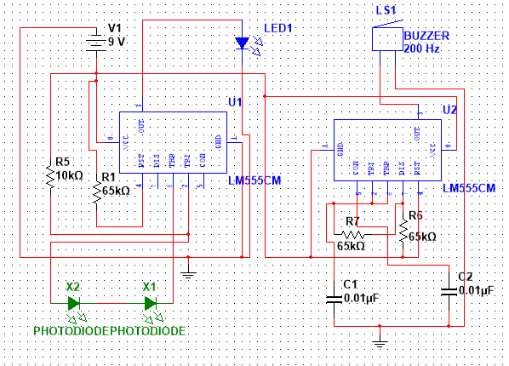

Figure 3.2: Schematic of the tone generating laser receiver circuit.

Since Mr. DJ will also have an autonomous mode, one thing that needs to be taken into account is obstacle avoidance to prevent the done from crashing into any objects while flying. To accomplish this, the team chose to use ultrasonic proximity sensors on the drone which should allow detection of nearby objects. Ultrasonic proximity sensors are the most commonly used type of proximity sensors on flying drones. Sensor operation during flight on a quadcopter is a challenging environment for an ultrasonic sensor to operate reliably. The most obvious issue is the amount of wind turbulence the ultrasonic wave must travel through. Adding to this acoustic noise is the noise the propellers generate. Due to all of the interference for the sensor, it is critical to choose a high quality reliable ultrasonic proximity sensor for the drone.

Ultrasonic sensors are commonly used for a wide variety of noncontact presence, proximity, or distance measuring applications. These devices typically transmit a short burst of ultrasonic sound toward a target, which reflects the sound back to the sensor. The system then measures the time for the echo to return to the sensor and computes the distance to the target using the speed of sound. There are a wide variety of sensors currently on the market that differ from one another in their mounting configurations, environmental sealing, and electronic features. Acoustically, they operate at different frequencies and have different radiation patterns. It is usually not difficult to select a sensor that best meets the environmental and mechanical requirements for a particular application, or to evaluate the electronic features available with different models.

LED lighting will also be incorporated in the drone for lighting effects during gameplay and also to increase visibility of the drone during flight. Adafruit offers a simple, scalable and affordable full-color LED called Neopixels. Neopixels are chainable from one to the next so that you can power and program a long line together to so that you can create a string of 5050 LEDs. Adafruit also has an extensive library for programming an Arduino board to control the Neopixels and have very helpful guides for hobbyists to use when implementing Neopixels into their projects.

Before settling down with the idea of Drone Hunt, the team searched for quite some time to see if such a project existed.  An idea that was similar was told in the form of a story.  The idea’s tagline is given as “Think paintball meets laser tag and add massively multiplayer online gaming”.  The game is describes itself with two teams competing against who can shoot down the most drones in an arena using lasers that are controlled by players online.  All drones and arena equipment would all communicate using standard Wi-Fi technology connecting to the network via an access point which allowed public connections from the internet.  Since there was no indication of whether the project was actually it was decided to be fair enough to proceed even though there was much more complexity and our project only consisted of a single drone where the project mentioned was made up of an army of drones all scattered through a specialized arena.  Another similar project that was found during the initial research include a much more militarized version of the laser system in where its primary purpose is for military training with much more sophisticated equipment that used the usual spread spectrum RC technology.  Within the community of forums research showed that there wasn’t anything closer than what our goal was to achieve therefore the idea was confirmed to stick around.

While many technologies make up the drone, our design primarily focuses on the laser systems and software mechanics that will drive the game experience.  Our communication system will feature a mixture communication protocols.  Using wireless Ethernet standard (802.11) more commonly known as Wi-Fi and lower level communication that uses the 802.15.4 standard will be specifically used for relaying data between the laser guns, the laser panels on the drone, and the ground station control system.  The 802.15 standard has been established since 2003 by IEEE and it includes a wide variety of ways to connect devices in a small network referred to as a Personal Area Network (PAN or WPAN for wireless devices).  Bluetooth communication, which falls under this category (802.15.1), was planned at first but was dropped in favor of ZigBee based communication since it increases the range from 10 meters to 20 or more.  The overall communication system will be split in two.  The vitals of the drone that are provided by the flight controller are to be passed directly to the machine running the Mission Planner via the ZigBee communication line while all the lasers sensors and gun pulses are to be passed via Wi-Fi coming from a TI MSP430 fitted with a .  Any commands sent to the drone to signal movement will be sent back via the ZigBee line of communication.

The Drone Hunt game application will be web-based with several different languages behind it to pump data throughout the system.  Possible languages that may be involved include JavaScript variants node.js and jQuery, pHp, HTML5, CSS, and Python.  The JavaScript based languages can be used to perform calculations and handle data used to paint the page.  pHp can be used to fetch from a SQL database and draw data as well on the page.  HTML5 and CSS are most likely to be implemented to easily style the page without much hassle.  Python would provide a bridge to the Mission Planner software that will provide the live data.  Many of these languages easily overlap and as such using all of them may introduce unnecessary overhead.

Language List:

* Node.js + jQuery
* php
* Python
* HTML5/CSS

List of Adapters:

* CC3100 for MSP430
* XBEE if using Arduino
* External USB Wi-Fi adapter for BeagleBone Black (not necessary if decide to hook up via cable)

After all the other components of this project are completely functioning (the drone, the lasers, the communication, the web application), putting these components together in a presentable manner becomes a problem. This is when a physical case to store all these electronics becomes handy. The case will integrate these components and collectively become the Ground Control Station. This physical display of integration provides professionalism and style.

When the team first started researching on how the Ground Control System would be implemented, a project similar to the team's design was brought up. In February of 2013, a man named Elad was working on a project that consisted of a UAV plane. However, he realized that instead of using his laptop as the ground control system he would design and create a ground control station. The reason he decided this was because after many times of him carrying his laptop everywhere he would want to fly the UAV and would need to assemble and disassemble parts, cables, XBEE adapters, USB cables and such. With the custom ground control station he said, "Those days are over."

The steps for this project consist of the following. What he did first was that began to do research and looking for all the items in his inventory list. He then realized that he had an old laptop with a broken screen that could be in great use for this project. He also had a second laptop that the screen was in good shape and his plan was to use the motherboard of the broken computer with the screen of the good shape laptop. In order to do this, he had to purchase a LCD adapter that will let him use the VGA port on the motherboard with the internal laptop screen.

In addition, he had to look for a specific case that will be large enough to fit all the components he had. This case had to fit the motherboard, the laptop screen, another small screen that will fit in the remaining spacing, some LCD meters, and some switches. After long searches he finally found an economic old Pelican case with the size that was suitable for his budget and his project. Now that he had all the things he needed to begin putting this ground control station together, he needed to think of a way to install everything in a way that would give him easy access to the all the parts. After trying multiple materials such as Plexiglas, plywood, and others he decided that using a PVC foam will be the easiest material for him to deal with since he did not had all the tools required to cut and shape the plywood and Plexiglas. Finally, for the last touches of his project, he used vinyl sticker in a 3D carbon woven pattern for a nicer look.

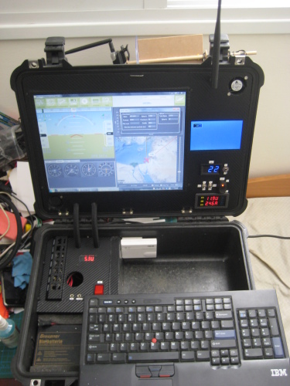

Figure 3.3: This is a completed Ground Control System [3]

Some of the relevant technologies that may apply to our project is that in the previously shown project, Elad uses various technologies that the team decided to incorporate in the design project. For example, a technology that is planned to be incorporated includes using a 12v @ 7Amp LSA small battery for powering the ground control system when it is fully portable. Using this battery helps because it is cheaper than a LiPo battery, better to handle, faster to charge, and heavier. All these battery features serve for a better ground control station.

In addition to the battery, Elad uses some LCD displays and some switches. The team plans on using similar technologies so that our ground control system has some nice looking display of the battery life of the Ground Control System as well as having any other useful information display on a secondary screen. The use for the switches would come in handy since it provides various uses with this ground control system.

Many other Ground Control Systems features that seemed interesting included having a touch-capable LCD to control waypoints. However due to the complexity already present of the core design it was decided to leave this feature out and simply use a standard LCD screen and input devices to enter all data used for the navigation of the drone and for the gaming aspect of the laser guns.

3.2 Possible Architectures and Related Diagrams

The diagram below (Figure [x]) shows the overview of how an APM powered drone should be configured to work properly for both manned and autonomous flights. As shown, the ArduPilot Module is the central commander for each of the peripherals that control fight, navigation, and communication. This setup is common for commercial and personal drones where most of the differences come from the varying flight control modules, battery size, motor and propeller size, and speed controller size.

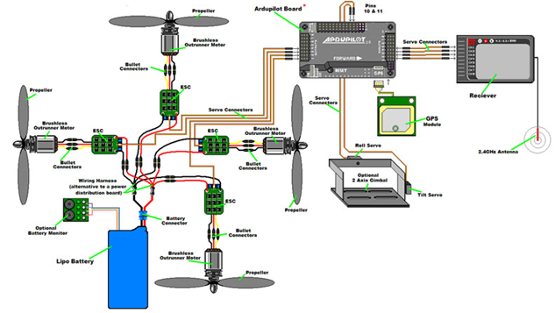Figure 3.4: Typical APM powered Quadcopter component layout [4]

Choosing a transmitter and receiver can be one of the hardest decisions to make when building a drone. Like most of the other components of Mr. DJ, if you want something more reliable with more features, you’re going to be paying much more. $450 can buy you one of the best transmitters on the market (Spektrum DX-9) which doesn’t include a receiver or battery. If you have a steady hand and are not afraid of getting them dirty while possibly damaging your transmitter, $150 can get you arguably the best (modified) transmitter with more features than even some of the best retail transmitters on the market thanks to open source and a large helpful community of RC hobbyists.

The main features that separate the best transmitters from lower tier transmitters are transmission range, accurate telemetry data getting sent from the receiver directly to the transmitters’ LCD screen, battery life, available channels, and failsafe capabilities. Below is a picture of a similar architecture implemented by the Paparazzi’s open source RC radio communications device which shows the dataflow from transmitter to receiver to ground control station and back to the transmitters LCD screen.

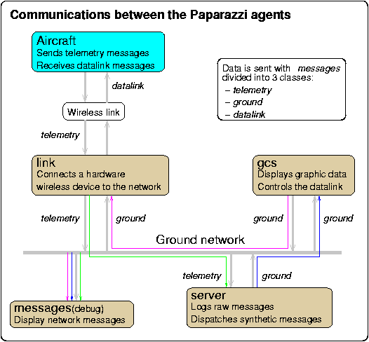

Figure 3.5: Paparazzi's Communication Dataflow [5]

Below is a circuit diagram for a similar project of a quadcopter drone using Neopixel LED lights being controlled by an Arduino. This diagram shows LED’s all around each of the four motors. However, the team's design changes the design to installing LED’s on all four arms going across rather than at the motors.

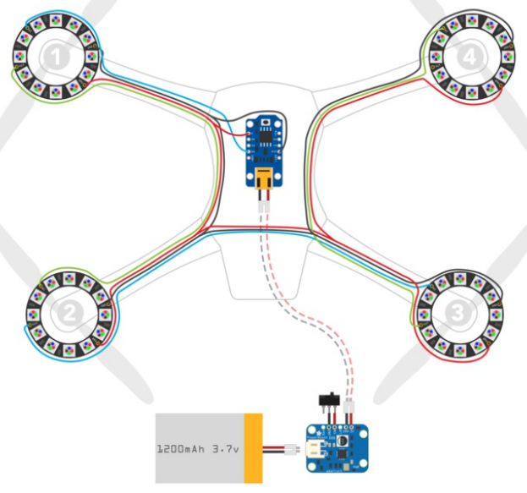

Figure 3.6: Schematic of possible architecture of LED circuit on a quadcopter drone. [6]

Below is a schematic of an ultrasonic proximity sensor being used to detect nearby objects. The sensor is emitting a sound wave and receiving the reflected sound waves back. Then based on the time it takes to for the echo to return to the sensor the distance of nearby objects could be determined. Mr. DJ will have multiple sensors on board for a greater range of detection for nearby obstacles and so will have a similar setup as the one below but using multiple sensors pointed in different directions.

The diagram below features a system involving two PX4 Autopilot drones communicating to a server using a special protocol called MAVLink and uses a 3DR radio to do so.  The server is accessible via the web using a multitude of devices in order to send commands to the units connected to the server itself.  While our implementation won’t include two separate drones this architecture provides a very similar visual layout of our network.

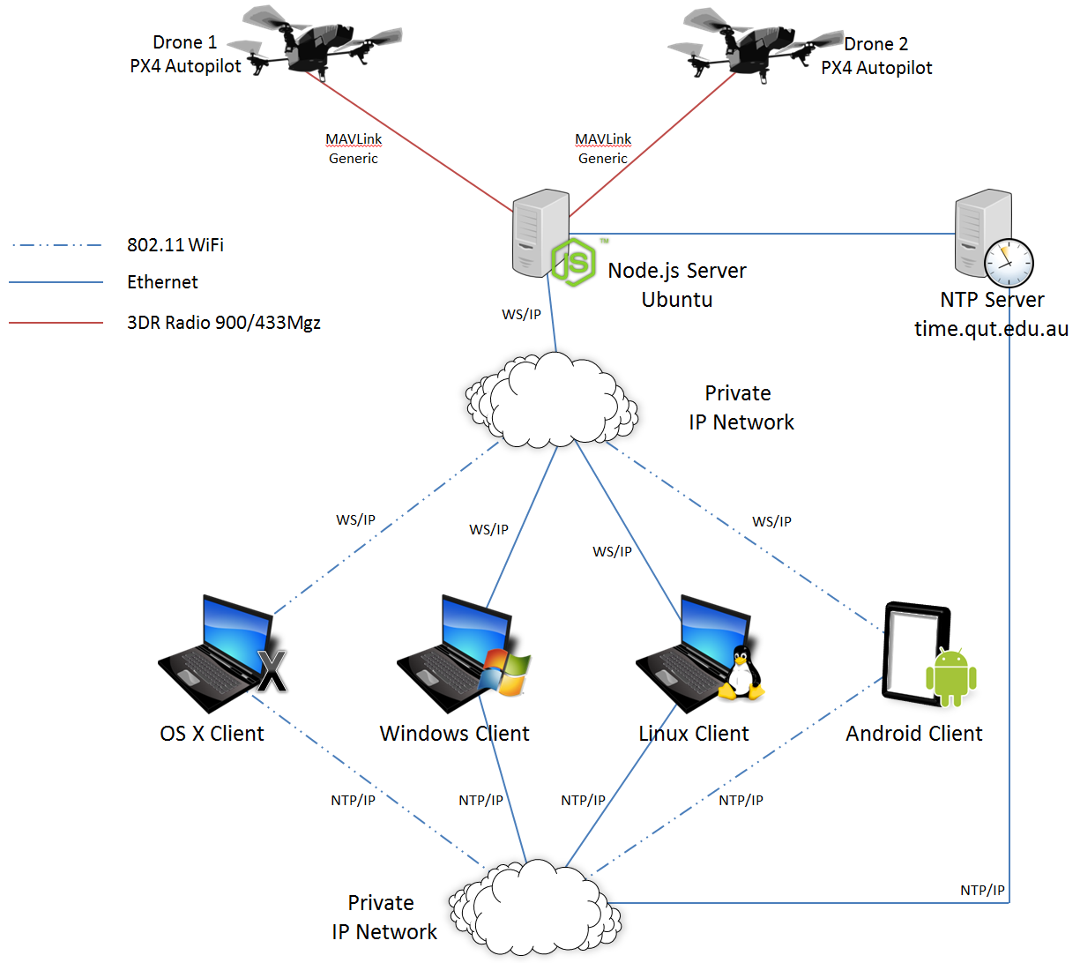Figure 3.8: Researched Communication Diagram [8]

Furthermore, below is a very similar architecture of a ground control system called a RAMA system which is a intended as a cheap, reasonably lightweight and compact universal control system. This system similar to the Drone Hunt is also composed of three main parts. The first part is called the Airborne Part (AP), the second is the Ground Station (GS), and lastly the Navigation Unit (NU). All these work together to allow a successful UAV to user communication to happen. The Ground Station is composed of a laptop computer, the RC transition, and the wireless communication. For this project, the ground control system is also composed of these three elements. In this RAMA system, the laptop is used only to visualize and record the on-line telemetry of the vehicle. Similarly, the Drone Hunt ground control system uses the laptop is used for the interaction of the user and the drone. This laptop will be running software that gathers inputs for the drone to perform and also projects the web application for the user to experience the entertainment aspect of this project. Below is a diagram of the RAMA UAV and ground station that shows the block diagrams between the UAV vehicle and the ground station that will be useful for this group’s drone project.

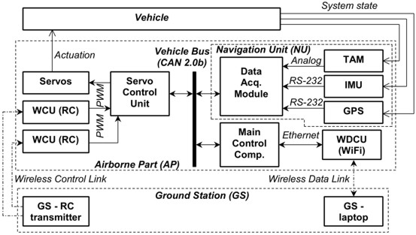

Figure 3.9: Research Ground Control System Diagram [9]

4.0 Project Design Detail

The following section goes into detail on how the project hardware is constructed and tested. Each subsection is divided into the following categories: Drone Subsystem, Laser Subsystem, Server Subsystem, and Ground Control Subsystem.

4.1 Drone Subsystem

The drone subsystem will be described as all of the hardware components that make up the physical features of Mr. DJ which enable him to properly fly and communicate to the ground control station. This hardware subsystem is split up into the following: Frame Structure, Flight System, Flight Control System, Power System, Artificial Intelligence, and Light System.

4.1.1 Frame Structure

When choosing a multi rotor frame, one can easily get discouraged and overwhelmed from the hundreds of different choices to choose from. The first question is usually, “Where do I start?” Since quadcopters exist in many different shapes and sizes ranging from something smaller than your palm, to frames over 1500mm, one must first decide the primary flight features of his/her design. Given today’s technology, there is no such thing as a “perfect build” mainly due to the *flight time to weight ratio* which will be discussed later in this section. The easiest and most effective method for choosing a frame to suit your design is by distinguishing your design between the two main types of multicopter builds: Fast and Agile or Large and Stable. Our group decided to lie somewhere in between the two builds.

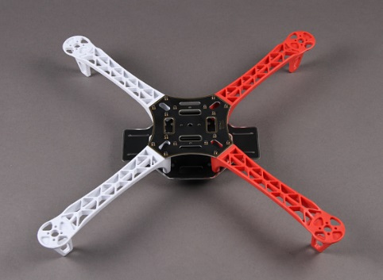

Figure 4.1: DJI Flamewheel 450 [10]

The frame being implemented into Drone Hunt is the HobbyKing Z700-V2 for several reasons. At a low-cost of just over $30, a large lightweight frame is provided made from quality materials that have plenty of real estate for present features and future modifications. Another great feature about the Z700-V2 is the ability to easily obtain spare parts such as replacement arms or landing legs in case things do not go as expected and the beautiful forces of nature take a turn against Mr. DJ’s favor. Below is a detailed list of Mr. DJ’s frame specifications:

|  |  |
| --- | --- |
| Attribute | Specification |
| Motor-To-Motor Width | 700mm |
| Height | 58mm without landing gear 258mm w/ith |
| Weight | 570g with landing gear |
| Motor Mount Bolt Holes | 16/19mm |
| Hook Rod Rail | 55-60mm center to center 12mm rod |

Table 4.1: Drone Frame Specifications

4.1.2.1 Flight System

After choosing a frame size a suitable motor and propeller configuration can be selected. This requires that the motor and propeller be relative to the motor-to-motor distance which was decided to be above would be 700mm. The two common types of motors used in multicopters are brushed and brushless. The team easily chose the brushless motor simply because of its power-to-weight ratio. High torque was desirable to allow for quick direction changes, which are qualities of an agile quadcopter. While choosing a brushless motor over a brushed motor was easy, choosing between hundreds of brushless motors might be more of a challenging task. In fact, this might be the most difficult part of the part-selecting decision process but thankfully was not so bad due to the large and helpful RC community on the internet sharing their setups and helping newcomers when questions arise. After performing research, a general rule of thumb used by many hobbyists when selecting their motors is:

*Required Thrust per Motor = (Weight x 2) / 4*

Equation 4.1

When choosing a motor, the manufacturer usually provides a great amount of helpful specification detail in their data sheets. The crucial specifications needed in determining which motor is best for our design are the *Pole Count, RPM Per Volt,* and *Motor Weight*. Pole count is the term used to state how many magnetic poles there are in a single motor. The more poles there are then the greater the amount of torque and the more torque means more lifting power which results in needing a larger propeller blade. A higher pole count also means that the RPM (revolutions per minute) per volt will decrease which leads to the disadvantages of a higher Pole Count. The main disadvantage is that the motors must be perfectly matched in the electrical current flow to keep the quadcopter flying in a stable manner. To easily counter this, it was ensured that all four motors purchased were of the same model. The RPM per Volt metric is measured in kV (kilovolts) and this gives information about rotational power that the motor produces. For example, if this group had an 800kV motor, then the motor would theoretically spin 800 times in one minute when a one volt is applied to the motor. The general rule of thumb is that a lower kV rating means a higher amount of torque while a higher kV rating means more rotational burst. For the team's design, it is desirable to be in the 700-900 kV range. The weight of the motor is pretty straight forward. A desirable motor for the design consists of one that has the best power gains while remaining as light as possible.

With all of these specifications at hand, we must choose between a brushed or brushless DC motor. Because brushless motors are much more performance oriented and have less friction within the motor, it makes it more efficient which in the end will give us more movement for the electrical energy to feed the propellers. More electrical energy fed to the power simply means much higher speeds. Another benefit of using a brushless motor over a brushed motor is the fact that they are maintenance free. With the following facts, the group has determined that four NPM Prop Drive 28-30S 800kV / 300W Short Shaft brushless DC motors will be used to drive Mr. DJ.

After choosing a motor, propellers are required and must ensure that they generate enough thrust to fly the quadcopter. Propellers are classified by a length and a pitch. Larger quadcopters generally require longer propellers due to the increased rotational momentum which will help with the aircraft stability, while the choosing the best pitch for the longer propeller can be a bit trickier. Due to the much larger-than-average frame size, it was decided to implement larger than average propellers at least in the 11-13 inch range. The design requires a good balance between propeller length and pitch, essentially a propeller than can generate a substantial amount of thrust while not wasting too much energy in the process. Generally, a propeller with a lower pitch tends to generate more torque and pull less current than a propeller with a higher pitch. However, a propeller with a larger pitch can increase the quadcopter speed which also means use more battery power. After careful consideration, it was decided to go with a 12 inch APC-style propeller and will run test’s using a 3.8 inch pitch versus a 6 inch pitch to see which configuration provides the optimal flying ratings.

With the following researched information it has been decided to experiment between several propeller setups with different pitches and lengths. This decision is due to the fact that every quadcopter is different when it comes to weight, size, and weight distribution. The decided length and pitch configurations that will be tested will be four 12" x 6", 12" x 3.8", and 12" x 4.5" APC-Style propellers. The 6" pitched propellers will provide the highest efficiency but the most unstable flight, whereas the 3.8" pitched propellers will ensure the most stability while being the most inefficient. It is estimated that the 4.5" pitched propellers will provide the best trade-off between stability and efficiency.

The DC brushless motors need to be simultaneously controlled individually because that is essentially how quadcopters maneuver. The motors are multi-phased (usually 3 phases) so a direct supply of DC power will not actually turn the motors on. In order to turn these motors on and control them individually, the group needed *electronic speed controllers* or ESC’s (one for each motor). Not only do ESC’s need to control each phase continually, it also needs to source a lot of current since each motor can draw a good amount of power. Each ESC is controlled by a pulse-with-modulation (PWM) signal that can vary in the 200-300Hz range so it must ensure that our selected ESC can handle the high enough frequency. The most important specification to keep in mind when selecting an ESC is the source current provided by the ESC. The general rule of thumb is to make sure the ESC sources at least 10A higher than the motor’s maximum current. For example, if the motor’s max current draw is 20A, it would be best to choose 30A ESC’s. A second useful feature is the ability to flash third party firmware into the ESC to provide a better performance and the ability to adjust certain options. A popular and well-trusted firmware is the SimonK ESC firmware which this team plans to immediately load into the selected ESCs.

4.1.2.2 Flight Control System

The flight control system consists of the essential electrical components that are connected to the microcontroller which ultimately makes decisions as to how to control the motors with the given input information provided from sensors. These components combined give many luxurious flying capabilities such as gyro stabilization, and autonomous waypoint navigation. Our goal was to find a flight control system that had the most built-in sensors with the most freedom to manipulate these sensors all at the lowest possible cost. Our end result was the well-known open source ArduPilot Module v2.6 made by 3DRobotics.

The ideal flight controller would be one with the most useful components already embedded into the board to provide the group with a more complete system with

The reason the APM 2.6 was chosen over the APM 2.5 was mainly due to the interference caused by the built-in GPS and compass module. The interference affected the 3DRobotics 915MHz telemetry radio which was dangerous to the project and most importantly the people who are in the vicinity of Mr. DJ. The APM 2.6 has an external 3DRobotics uBlox GPS and compass to fix this noise interference issue while all other features remain the same.

The APM 2.6 is stacked with more features than most flight controllers on the market. This flight controller is Arduino compatible thanks to the Atmel ATMEGA2560 and ATMEGA32U-2 chips which are used for processing and USB functions. The flight controller includes a MPU-600 3-axis gyroscope, accelerometer, magnetometer, and a MS5611-01BA03 high-performance barometer all combined for a whopping 9 degrees of freedom. The data logging procedures are handled by the onboard 4MB flash memory which can come in handy when troubleshooting or analyzing a flight. Think of this little guy as the “black-box” of the APM 2.6. The fact that the APM 2.6 is small, inexpensive and provides an array of open sourced features, it enables the users to do many things that cannot be done with other flight controllers.

The communication between Mr. DJ and the ground control station will be handled by the 3DRobotics 915MHz telemetry radios. While weighing less than 4 grams without the antenna, the radios make long range possible while maintaining a small size and weight. The transmitter radio is able to transmit power up to 20dBm (100mW) with the receiver radio able to sense -121 dBm all though an RS232 serial connection stream. This powerful transmission allows for data rates up to 250kbps at a range of approximately 1 mile. If that range is not enough, it is acceptable to extend the range by using a compatible bi-directional amplifier. Because of the wireless technology, it is known that data bits can be lost or cause errors. The 3DRobotics radios have built-in error correcting functions that can correct up to 25% of data bit errors. By using the 3DRobotics telemetry radios, a design provided with unparalleled ease of using our ground control station to view in-flight data, change flight patterns on the fly, and tune Mr. DJ to our liking.

The last required part to complete our flight system is one of the most important and this is the RC Transmitter. Nowadays it’s common for quadcopter to be both fully autonomous and user-controlled. While autonomous navigation is becoming more advanced and reliable, it’s still a good idea to be able to control the quadcopter using an RC transmitter, especially for this project considering one of the user game modes consists of a user controlling Mr. DJ while the players target and shoot him. After researching several different transmitters, it was decided to purchase a 9-channel Mode 2 that transmitter can receive telemetry from at least 1km and also be capable of providing the drone a failsafe feature. There are several transmitters that fit these requirements that range from $60 - $1000 but for this project it was settled for the $175 FrSky Taranis which is among one of the well respected and user-favorites out in the RC world due to its 9 (expandable to 16) channels that are easily programmable using the great open-source openTX firmware. This transmitter also has great features such as an SD card slot for telemetry data log storing, and audio haptic feedback to make flying that much easier for beginners.

Now that all flight control systems are fully installed and tested, it is now time to discuss the failsafe feature in further detail. There are several ways in the Drone Hunt system to trigger failsafe. In each separate event where failsafe is triggered, the quadcopter will run the return-to-home (RTH) function which autonomously flies the drone from the initial launching spot where the game began. The RC transmitter, 3DR telemetry radio, and GPS can all trigger the failsafe feature in their respective ways.

There are several ways to trigger failsafe. It was previously mentioned during the RC transmitter setup and calibration process that one of the switches was bound to enable the failsafe feature. If this switch is flipped on by the user, the quadcopter will automatically turn on its return-to-home function and return to its initial launch ground position autonomously. This way, the user has the ability to manually control the failsafe function. The second way failsafe is triggered is automatically and it happens in cases where the communication between the RC transmitter and the RC receiver which is attached to the flight controller is lost. This communication is lost in the following ways:

* User manually turns off RC transmitter
* RC transmitter battery dies
* Quadcopter travels outside of the RC range
* Receiver loses power
* In-flight connection/wiring issue

In the event of a triggered (manual or automatically) failsafe, if properly setup during initial setup stages, the failsafe will perform one of the following actions described in the following table:

|  |  |
| --- | --- |
| Nothing | The quadcopter is already disarmed |
| Motors will be immediately disarmed | If the quadcopter is landed or in stabilize/acro mode and the pilots throttle is at the zero position. |
| Return-To-Home | If the quadcopter has a GPS lock and it is more than 2 meters away from the initial launch position, the quadcopter will autonomously return. |
| Land | If the quadcopter has no GPS lock or is within 2 meters of initial launch position or if the FS_THR_ENABLE parameter is set to "Enabled Always Land". |
| Continue with Mission | If the quadcopter is currently set to AUTO mode and the FS_THR_ENABLE parameter is set to "Enabled Continue with Mission in Auto Mode" |

Table 4.2: Table explaining the different scenarios after failsafe is triggered

In the event that the transmitter and the receiver regain communication after failsafe has been triggered, the quadcopter will remain in its current failsafe state. So for example, if the quadcopter was in acro mode then suddenly failsafe was triggered the quadcopter would call the return-to-home function. Then, if during the return-to-home function the quadcopter suddenly regains communication, the quadcopter would remain in return-to-home mode until the user changes flight modes to something other than acro mode to regain user control of the quadcopter.

A great feature of the APM flight controller is the ability to test failsafe features without risking damaging the quadcopter in case a test fails. You can check successful failsafe setup by performing the following tests while the APM is connected to Mission Planner via USB or 3DR radio telemetry link. If planning to perform these tests with a LiPo battery, it would be a good idea to remove each propeller. Testing for each failsafe event can be done as follows:

|  |
| --- |
| Test #1: Using the "Low-Throttle" method, ensure the throttle channel drops with loss of radio contact. |
| 1. Make sure the RC transmitter is on and connected with the throttle at the zero position and flight mode set to "Stabilize Mode". 2. The throttle value shown in the Failsafe settings inside Mission Planner should be near the lowest position (lower 5%) in the PWM field. 3. Now turn off the transmitter power. The PWM value should now be seen at least 10% below the value seen from the previous step (#2). |
|  |
| Test #2: Checking for disarm of motors while in Stabilize or Acro mode with throttle at zero position. |
| 1. Switch the flight mode to Stabilize on RC transmitter. 2. Arm motors while keeping throttle at zero position. 3. Turn off transmitter. 4. Verify that motors disarm immediately and LED "A" starts flashing. The Mission Planners on-screen-display should also read DISARMED. |
|  |
| Test #3: Verifying that the flight mode changes to return-to-home or LAND when the throttle (channel 3) is above the zero position. |
| 1. Switch the flight mode to Stabilize on the RC transmitter. 2. Arm motors and raise the throttle from the zero position to the halfway position (50%). 3. Verify that the flight mode changes to return-to-home if GPS is locked. 4. If GPS is not locked, verify that the flight mode changes to LAND. |
|  |
| Test #4: Regaining user control after communication returns during failsafe. |
| 1. Continuing from Test #3, power up the RC transmitter. 2. Verify quadcopter is still in failsafe mode and return-to-home or LAND are currently executing. 3. Change the flight mode to another position and then back to stabilize mode. 4. Verify that the new flight mode displayed on the failsafe page in Mission Planner is the new flight mode that was just switched to. |
|  |
| Test #5 (Optional): Eliminating power from the RC receiver. |
| 1. Switch the RC transmitter flight mode to stabilize. 2. Arm motors and keep the throttle above the zero position. 3. Disconnect the power wires that are connected to the RC receiver from the APM flight controller. 4. Verify that the flight mode shown inside Mission Planner switches to return-to-home or LAND (as described in test #3). 5. Unplug the APM's power before reconnecting the RC receiver’s power. |

Table 4.3: Flight Control Failsafe Setup

There is one more type of failsafe method and this is known as the battery failsafe. The battery failsafe can also be configured to call the return-to-home or LAND functions as the RC communication loss methods did. The battery failsafe method is called when the quadcopter battery voltage or remaining power percentage has gone below a configurable threshold. It must be known that to use the battery failsafe, the quadcopter must be equipped with the APM Power module. The following bulleted list shows how the battery failsafe is triggered:

* The main battery powering the APM module drops below 10.5V (configurable) for more than 10 seconds.
* The battery's remaining capacity is below the configured threshold.

When failsafe is triggered by any of the events mentioned in the bulleted list above, there are several consequences that can occur. The table below shows what can possibly happen if a battery failsafe occurs:

|  |  |
| --- | --- |
| No Action | The quadcopter is already disarmed. |
| Disarmed Motors | If the quadcopter is currently in Stabilize or Acro mode and the throttle is set to the zero position, OR the quadcopter is landed. |
| Return-to-Home | If the FS_BATT_ENABLE parameter is set to "2" (RTL) OR the quadcopter is in AUTO mode, has a GPS lock and are at least 2 meters from the initial launch position. |
| LAND | Same as all of the previous cases. |

Table 4.4: Battery failsafe event descriptions

Now that the battery failsafe is explained in full detail of a failsafe trigger, it is now time to go into detail of how it is setup in Mr. DJ's system. The following list explains how to setup a battery failsafe in Mission Planner:

1. Ensure the APM Power Module is properly setup including setting the total battery capacity if using a current monitor. Detailed setup instructions will be discussed in 4.1.3 - Power System section.
2. Inside Mission Planner, navigate to INITIAL SETUP -> Mandatory Hardware -> Failsafe.
3. Ensure the following settings are toggled:
   1. Set "LOW BATTERY" threshold voltage (Ex. 10.5V).
   2. Set "Reserved MAH" or just leave it as "0" if the user prefers not to trigger the failsafe based on the estimated current consumed. From extensive research, many fellow pilots use "600" as an ideal number since it has about 20% battery left and that is sufficient enough to execute the LAND or return-to-home functions successfully.
   3. Set the desired behavior as "LAND" or "return-to-home" for the battery failsafe.

4.1.3 Power System

While the drone could have been powered up by a single battery on one system, it was determined that by separating power between drone peripherals and the flight system, it reduced the interference that each component received while in full operation.

4.1.3.1 Peripherals Power System

All peripherals mounted on the drone such as LEDs, microcontrollers and their respective transmitters are to be powered up by a separate 12.6V battery, much smaller than the actual flight battery. A printed circuit board (PCB) will be designed to step down and distribute power to these smaller components. The PCB contains two voltage regulators of model LD1117, one to step down to 3V and the other to 5V in order to properly power the microcontrollers. The microcontrollers themselves are attached via IC sockets of their respective size. With four strips of LEDs used, there will be four separate areas with three pads each to supply data (1) and power (2). The schematic for the PCB can be found below.

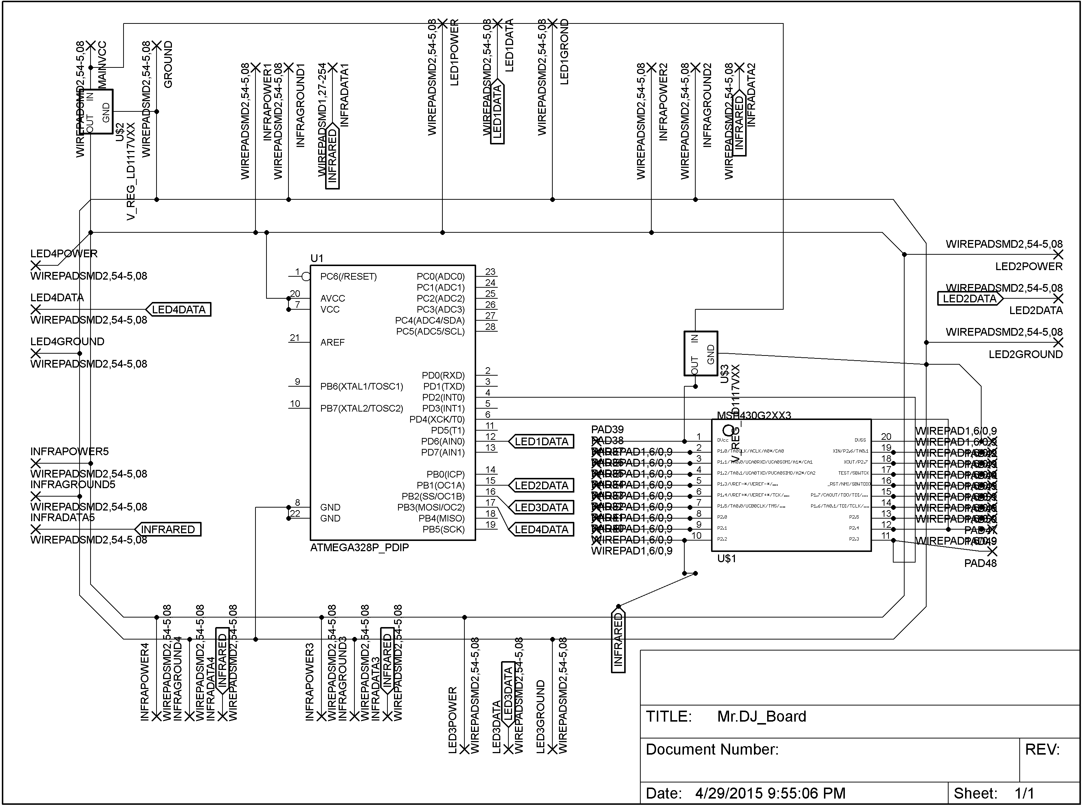Figure 4.4a: Drone Peripherals PCB

A better look at the physical packages and traces can be seen as well in the following diagram:

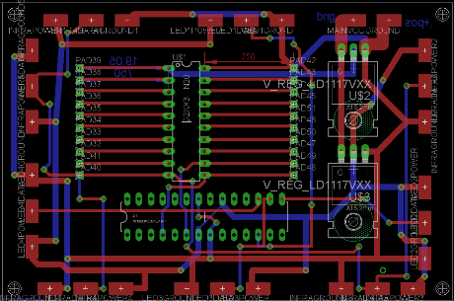  
Figure 4.4b Drone Peripherals PCB – Trace Layout

4.1.3.2 Flight Power System

All of the flight control components need clean and well regulated power coming from the high capacity batteries. While there are many different style batteries to choose from there is a lot of thought and number crunching that needs to go into choosing a battery to power your electrical components. While larger batteries technically allow for longer flight time, that doesn’t necessarily mean that it will increase flight time in the specific design. Unfortunately the increase in battery size is not proportional to the increase in flight time, in fact larger battery sizes could actually reduce flight time because batteries with more capacity also tend to weigh more. Because of this tradeoff, a member performed careful and in-depth research on choosing a suitable battery for Mr. DJ. The group found a great guide provided by Oscar Liang on his blog over at oscarliang.net. His steps were fairly detailed and straightforward:

1. *Find Max Current Draw and Battery C-Rating:* Work out the possible max current draw from the motors. Most of the information can be found on the data sheets which tell you current draw at 50%, 75%, and 100% throttle. The formula is:

*maxCurrent = capacity * C-rating*

Equation 4.2

1. *Gather Initial Data:* Take data such as battery capacity (mAh), battery weight, and cost and make some charts such as the ones below:

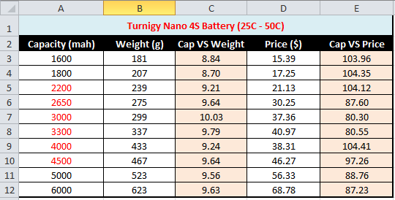

Figure 4.2: Basis Specifications of the Turnigy Nano 4S Battery

From this chart, some useful graphs can be derived to aid on narrowing down our battery and getting the best performance bang for the buck. From here, a member of the group was able to obtain a density graph (capacity per gram = capacity / weight) and a value graph (capacity per dollar = capacity / price):

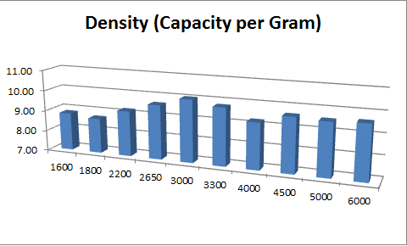

Figure 4.3: Density Graph (Capacity/Weight)

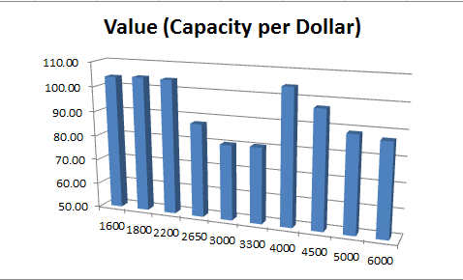

Figure 4.4: Value Graph (Capacity/Price)

From the above graphs you can see a variety of different things. If you don’t care about price you can clearly see the battery with the best density, but if you do care about the cost, then the 4000mah battery would be the best price/performance ratio which is easily seen by looking at the value chart. To choose the best battery from these, the team must go one step further and investigate the weight to flight-time model. After calculating the ratio using this model, the group will be able to calculate and get a decent estimate of our flight time using any battery which will optimize performance and possibly save money.

1. *Choose A Battery:*The third step is to choose any battery and collect data using it. The data required to get started are flight times under different loads. For example, if this team start with a 2200mAh 4S Lipo Battery as a references and tested the flight times under different weights this would end up with a chart that looks like the following:

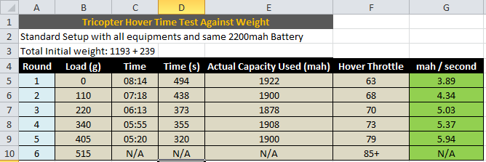Figure 4.5: Hover Time vs Weight using 2200mAh 4S LiPo Battery

After plotting these values on a graph it can estimate a linear relationship and derive an equation that will be dependent on battery mAh/s vs battery load. Realistically it is not a linear relationship but for the purpose of this project it suits for more than well enough to get close to optimal performance out of the battery. The equation derived from this data is the following:

*f(x) = 0.0049x + 3.8635*

Equation 4.3

With this equation the model can be furthered investigated. If the group starts by assuming that the voltage drops down to 3.5V when the battery is at 86% then it can be said that the capacity at 3.5V (86%) is the effective capacity that can be used during a flight. By using this assumption, the first model can be worked out one step further by obtaining the mAh/s for each battery depending on their weight. The following chart shows this data:

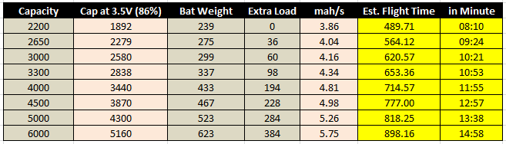Figure 4.6: Effective Capacity during flight for selected batteries

With this information a plot can be produced that helps calculate flight time with the available battery capacity. The flight time vs battery capacity graph is estimated by using the estimated flight time obtained by dividing effective capacity by mAh/s. For example, with a 6000mah battery, our effective capacity would be 5160 mAh at 86% and the speed of power consumption would be 5.75 mAh/s. With this data, the flight time can be calculated time to be 898.16 seconds; which is nearly 15 minutes of flight time and our selection of choice for our battery.

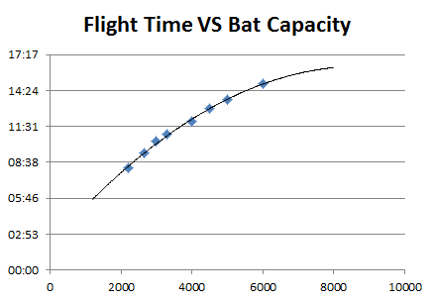

Figure 4.7: Flight time vs Battery

After choosing a battery, the group must regulate the battery voltage and current to prevent it from burning up our components. There are a few different types of voltage regulators but the two most common ones to choose between when designing a quadcopter are linear and switching regulators. Switching regulators work by switching the input voltage on and off extremely fast (50,000-100,000 times a second) to charge an inductor depending on how much energy is needed by the electrical load at that instant. If it needs more energy at time t1, than it will be turned on for longer than if it needed less energy at time t2. Because of this switching regulation, the switching regulator is the more efficient of the two which typically has an 85% efficiency rate according to Oscar Liang. The pitfall of a switching regulator is that because it switches so fast, it emits a great amount of radio frequency interference in a ripple effect. This can be troublesome to our radio communication equipment so several tests need to be conducted to ensure a reliable communication stream while using switching regulators.

The linear regulator works by burning the excess heat which comes after taking the difference between the input voltage and the desired output voltages. The larger the difference, the more heat energy will be dissipated. This means that it is extremely inefficient and might actually waste more energy than it produces for our design. Because the team's design does not require too many radio frequency devices such as first-person-view cameras with live video streams, this won’t be worrying too much about the interference caused by switching regulators. Therefore, it was decided to implement the switching regulator mainly due to its great efficiency rating that will help achieve the flight time desired for the project.

The APM ArduFlyer Power Module v1.0 is a switching voltage regulator which provides a simple way of regulating clean and sufficient power from a LiPo battery as well as current consumption and battery voltage measurements. The power module is equipped with an on-board switching voltage regulator which outputs 5.3V at a maximum of 3A from up to a 7S LiPo battery. A maximum input voltage of 30V can be supplied while sensing current of a maximum of 90A however, out of the box the power module is configured for a voltage and current measurement of 5V ADC for the project which is exactly what is needed.

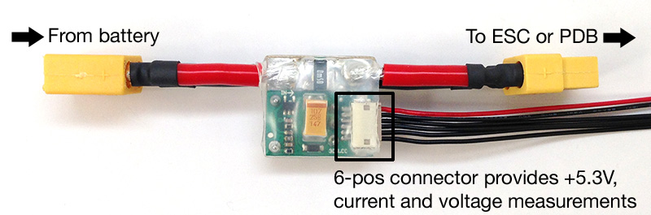

Figure 4.8: APM ArduFlyer Power Module v1.0

The previous section spoke about two different types of failsafe and one of them was a battery failsafe. Without the APM Power Module, battery failsafe would not be possible. There are several thoughts to keep in mind when using the Power module and they are the following:

* You should normally remove the APM's JP1 jumper when using the Power Module so that the APM board and receiver are powered from the same source which in this case will be the Power Module itself.
* Removing the JP1 jumper allows users to use the APM's servo output 5V rail to distribute power to other devices such as servos from the UBEC output of the ESC.
* In the case of using servos, make sure to use an ESC BEC or UBEC power and ground wire to provide a common power and common ground and avoid power loops.
* In case of using ESC's with no UBEC, it is okay to leave the JP1 jumper present as long as the user is not powering any servos from the output rail as this can cause a brownout.
* You can also individually power each servo from each individual ESC. This is the recommended way on the APM's website.

Setting up the APM Power Module is easy and it is all done through the Mission Planner software. Simply fire up Mission Planner and navigate to the HARDWARE -> OPTIONAL HARDWARE -> BATTERY MONITOR screen and follow the following steps

4.1.4 Artificial Intelligence

Inside Mr. DJ’s APM 2.6 flight controller lies the software running all of the algorithms needed to enable safe, smooth, and agile autonomous flights. The intuitive control interface used in this process is APM’s Mission Planner. It is a system that enables users to fully monitor all sensors of the quadcopter in-flight and it’s also equipped with a controllable navigation system. The navigation system enables the user to utilize the on-board uBlox GPS and compass by plotting points on a map displayed inside Mission Planner’s user interface which is then navigated autonomously by the quadcopter upon launch. On top of these features, Mission Planner also provides important safety features such as a return-to-launch (RTL) feature which is automatically triggered to ON if the quadcopter loses signal from the RC transmitter or if it loses communication with the 3DR telemetry radios. Once the RTL feature is triggered on, the quadcopter immediately stops what it was currently doing and autonomously flies back to the initial launch spot from where it took off accurate to approximately 1 meter.

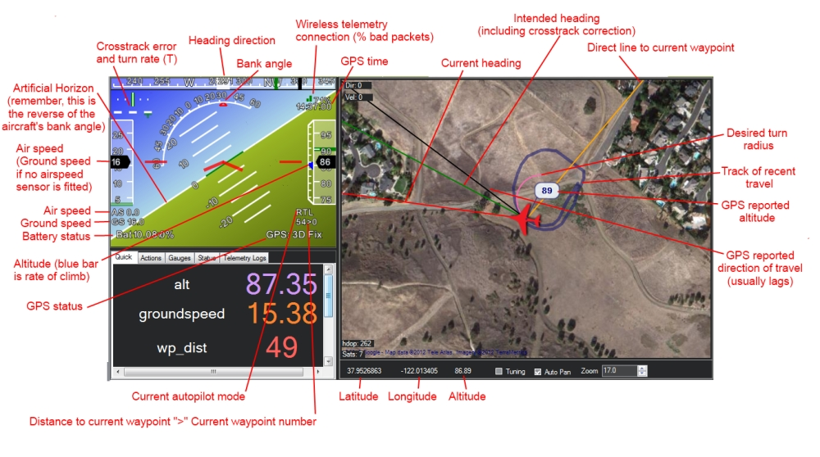Figure 4.9: Main Heads-Up Display from Mission Planner Control Station [11]

The safety feature for avoiding obstacles while in flight falls under the job of the artificial intelligence on Mr. DJ. An ultrasonic proximity sensor will be attached to Mr. DJ which will detect the distances of objects nearby in order to avoid them if the drone flies too close to them. The ultrasonic proximity sensor will work in conjunction with a microcontroller to achieve this goal.  Ultrasonic sensors use high frequency sound to detect and localize objects in a variety of environments. Ultrasonic sensors measure the time of flight for sound that has been transmitted to and reflected back from nearby objects. Based upon the time of flight, the sensor then outputs a range reading. If an object is too close within range of Mr. DJ, it will be preprogrammed to take evasive measures.

**4.1.5 Lighting System**

Mr. DJ’s design will incorporate an LED based lighting system as one of its numerous subsystems. This LED subsystem will serve the purpose of providing aesthetic lighting to the drone as well as have the functional purpose of providing visual feedback to the game’s players of hit on target, countdown for the start of the game/end of the game and also for increasing visibility of the drone in low lighting situations. To control the output from the LED’s a microcontroller onboard the drone will be used. This microcontroller will be preprogrammed with the multiple scenarios and under each situation will control the LED’s to light in a specified sequence.

|  |  |  |  |  |
| --- | --- | --- | --- | --- |
|  | Part Name | Cost per unit | Quantity | Total |
| 1 | Adafruit Neopixel Digital RGB LED Strip | $24.95 (1m) | 2 | $49.90 |
| 2 | MSP 430 | $9.99 | 1 | $9.99 |

Table 4.7: Parts for LED System

Incorporating LEDs into a drone is usually a messy process with a nest of wires and connections and can easily become troublesome with increasing complexity of the application design. Since this feature of Mr. DJ is one of the “may haves”, it was agreed to go with the easier option of a prebuilt LED network which would simplify this subsystem and allow for more time to focus on the more important must haves of the project. Adafruit provides a LED product that comes in a strip form called the Neopixel. The Neopixel has a dedicated LED driver chip for each individual WS2812 Integrated Light Source, which is then controlled by a microcontroller through a single wire. They can be used individually, chained into longer strings or assembled into more interesting form-factors. Adafruit’s Neopixel strips comes in different variations with 30 LEDs per meter, 60 LEDs per meter or 144 LEDs per meter. The 60 LED per meter strip will be used for Mr. DJ. “Neopixel” is Adafruit’s brand for individually-addressable RGB color pixels and strips based on the WS2812 and WS2811 LED/drivers, using a single-wire control protocol. Neopixels don’t just light up on their own; they require a microcontroller and some programming. Adafruit also provides a very extensive library for programming Neopixels on their website. Using this open source library with some modifications will make the task easier to program the game scenarios into the onboard microcontroller for the lighting sequence on Mr. DJ.

The 60 LED strip has a power consumption of 18 Watts max (~3.5 Amps @ 5V) per meter. The max rating is assuming all the LEDs are on full white, usually the actual current for colorful design is about 1/3 to 1/2 the max current. A good power supply of about a 5V - 10A supply is the key to optimal performance. Since the controller chip is inside the LED means that the chip only uses a single pin for input and a single pin for output. The protocol used is very timing-specific and can only be controlled by microcontrollers with highly repeatable 100nS timing precision. The 60 LED strip will not work with the Raspberry Pi, Basic Stamp, NETduino, any other interpreted/virtual machine microprocessor or any processor slower than 8 MHz. For those processors there is a 32 LED strip which has SPI-like input/output and works well with Pi, NETduino, and other processors.

There are 60 RGB LEDs per meter on the strip, and you can control each LED individually. This is the digitally-addressable type of LED strip. You can set the color of each LED's red, green and blue component with 8-bit PWM precision (so 24-bit color per pixel). The LEDs are controlled by shift-registers that are chained up down the strip so you can shorten or lengthen the strip. Only 1 digital output pin is required to send data down. The PWM is built into each LED-chip so once you set the color you can stop talking to the strip and it will continue to PWM all the LEDs.

Technical specs of the Neopixel 60 LED strip:

* 12.5mm (0.65") wide, 4mm (0.16") thick with casing on, 16.7mm (0.65") long per segment
* 60 LEDs per meter
* Removable IP65 weatherproof casing
* Maximum 5V @ 60mA draw per 0.65" strip segment (all LEDs on full brightness)
* 5VDC power requirement (do not exceed 6VDC) - no polarity protection
* 1 integrated RGB LEDs per segment, individually controllable
* LED wavelengths: 630nm/530nm/475nm
* Connector: 2-pin JST SM
* LED type: WS2812B 4-pin chip.

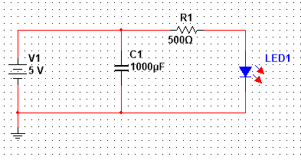  
Figure 4.13: Neopixel LED schematic with a 5V supply input

The 60 LED strip will be controlled by a MSP 430 microcontroller for the data input on the LED strip. In the schematic above is shown the 5V DC power source connected to the strip with an inline 1000 µF capacitor between the positive and negative terminals of the power supply. There is then connecter a 500 ohm resistor between the positive power supply and the positive voltage in of the LED strip. The purpose of this resistor is to prevent the first LED diode of the strip from burning out due to the voltage supply being turned on and off. The voltage supply circuit for the Neopixel strip will have the above layout with the microcontroller added in as well. The Neopixel strip also allows to be controlled by a 3.3V power supply. Doing so only slightly changes the output of the strip as the colors will not be as vibrant and will now show as bright. There will also be a smaller range of colors shown by the strip as the color changes will be more abrupt. The only changes in using the lower voltage supply would be changing the resistor value from 500 ohms to 300 ohms. One advantage of using a 3.3V power supply would be lower power consumption by the LEDs. However this would require adding another voltage regulator to the power distribution board to step down the voltage to 3.3V, since most of the components of the drone will be running with 5V already. After further testing is done and seeing the results of battery life it will be determined if to use the 3.3V power supply shown in the schematic below or if to go with the 5V option as above.

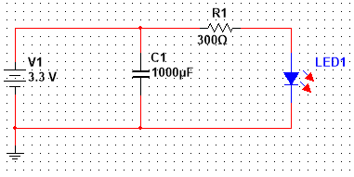  
Figure 4.14: Neopixel LED schematic with a 3.3V supply input

Depending on the input voltage required a step down circuit will be constructed to regulated the ~12V output of the LiPo battery down to the required 5V or 3.3V that will be used for the LEDs. The schematic below shows how the step down regulator circuit will be designed. The schematic shows first a step down to 5V then again steps the voltage down to 3.3V.

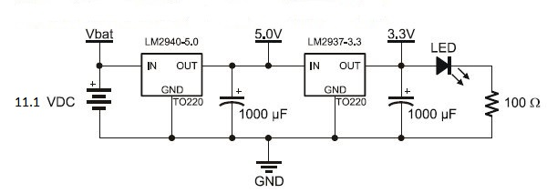Figure 4.15a: Circuit of Voltage Regulator for LED lights

Mr. DJ will have four arms each with a motor at the end. A piece of the 60 LED Neopixel strip will be attached running across the length of each arm of the drone. All the strips will run from the motor towards the center of the drone where there will be an MSP430 microcontroller. Among other things, one of the functions of this microcontroller will be to control the lighting sequence of each of the individual LEDs on each of the arms. The Neopixel LED will use a separate battery on board the drone as its power source instead of using the one being used to power the drone. In order to implement this, a power distribution board will be used to step down the 12V supply from the battery to a 5V that will be needed to power the LEDs then spilt into four outputs to be used for the voltage supply of the LEDs.

4.2 Laser Subsystem

The laser subsystem consists of a laser transmitting device that will be used by individual players, and a laser receiving device that will be mounted on the drone. The main focus of this subsystem is to implement the gaming aspect of the Drone Hunt project which ,similar to laser tag, allows the players to fire at a target that then determines that it has been hit and assigns points to the player that made the hit. The implementation of this system will involve the design and assembly of modified toy guns outfitted with lasers as a transmitter and a photosensitive panel (solar panel) attached to the drone that outputs a voltage when a laser beam hits to act as a receiver. The data output by the laser transmitter and the data analysis by the receiver will all be done using a microcontroller that will be programmed to do so appropriately.

4.2.1 Laser Transmitter

This section of the project involves a vast amount of design work as it requires the design of a laser transmitting circuit that can output a distinguishable laser beam. This laser transmitting circuit will be embedded into a toy gun to give the player the ability to hold a gun to simulate a first person shooter interface. This gun will also have a Wi-Fi adapter inside as well that will allow for direct connectivity to the web application. The purpose for this connection is to transmit data to the web app each time the player pulls the trigger of their gun. Each trigger pull will be recorded by the application showing a total number of shots fired during each round of the game and also provide other gaming statistics as well.

In order to build one of these laser transmitters the following list of hardware will be required:

* One toy guns which will be possibly donated by a laser tag shop or purchased by the team. This toy gun will serve as the shell that houses the circuitry for the laser transmitter system and all its components.
* One MSP430G2553 microcontroller will be embedded into the circuit of the laser transmitter and will serve as the brain of the laser gun and will store the data that will be transmitted by the laser beam.
* One LM555 Timer chip from TI
* One CC110L booster packs for MSP430 microcontroller. This booster pack will add Wi-Fi connectivity to the laser guns and allow them to transmit trigger pull data to the web application.
* IR LED
* Double Convex Lens
* The above list of materials will be assembled inside the toy guns and will also implement a custom printed circuit board to simplify the circuitry and miscellaneous electrical components to realize the laser transmitter gun. .

Several circuits are required to be pieced together in order to give the optimum signal needed to be transmitted via the IR transmitter. The first of these circuits consist of a oscillator that provides a 38KHz transmission wave in which is coupled with an AND gate and microswitch to ensure that the signal only transmits useful when the trigger is being pressed.

  
Figure 4.15b 38KHz Oscillator with 555 Timer Chip

To ensure that the signal generated had enough strength to be deciphered on the other end an amplifier circuit was added just before the beam is shot out through the IR transmitter. This consists of a traditional BJT

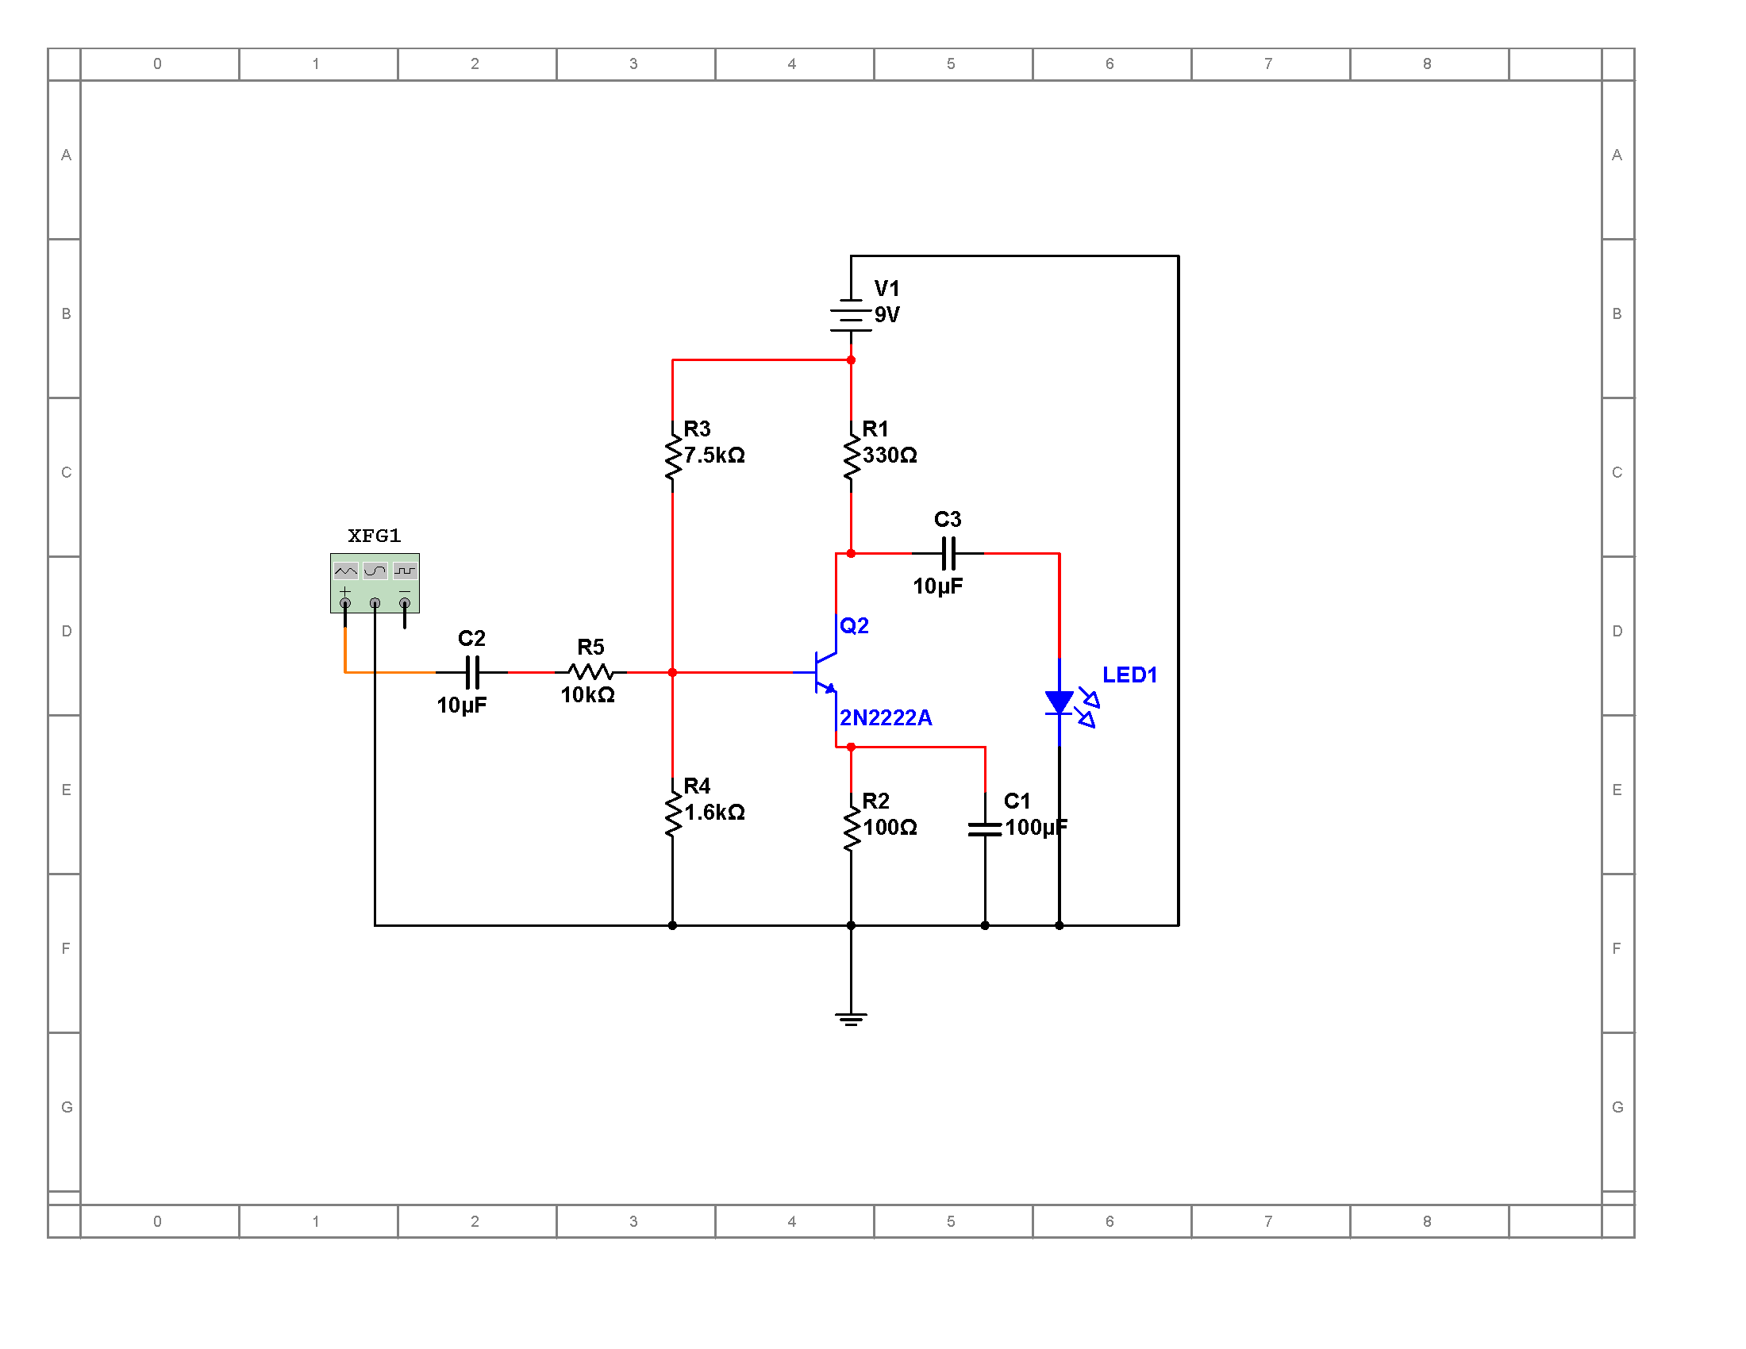  
Figure 4.15c BJT Transistor Circuit

4.2.2 Laser Receivers

The laser receiver subsystem will be positioned on the underside of the drone in such a way to allow them to be the target of fire from the laser transmitters while the drone is in flight. This system will be able to detect a hit from a laser beam with the use of a photosensitive panel. This panel will be connected to a microcontroller that will be on the drone which will serve to detect when a laser beam hit the panel. These panels will output a voltage each time the laser hits them. This voltage will be detected by the microcontroller which will be able to distinguish which player made the hit. This information will then be transmitted by the Wi-Fi system that is onboard the drone to the server and then displayed through the web application.

In order to build one of the laser receivers the following list of hardware will be required:

* Five VS1738 IR Receivers
* One MSP430G2553 microcontroller which will be on the drone and will be used for several of the other subsystems as well.

With the above hardware list the receiver system will be assembled by connecting the IR senors in paralllel to an input pin of the microcontroller. The microcontroller will be programmed appropriately to detect the inputs from the IR sensor and then output the data received to the ground control station.

4.3 Server Subsystem

The server subsystem consists of maintenance of the IP network that nodes will connect to via an access point as well as the main server providing web services and computation for the main Drone Hunt app.  Mr. DJ’s semi-autonomous movements will be dictated by the configuration given by the application at game time while aided by the Mission Planner which will pass this movement data back to Mr. DJ via the ZigBee channel. All laser transmitters and receivers will communicate via the Wi-Fi channel.

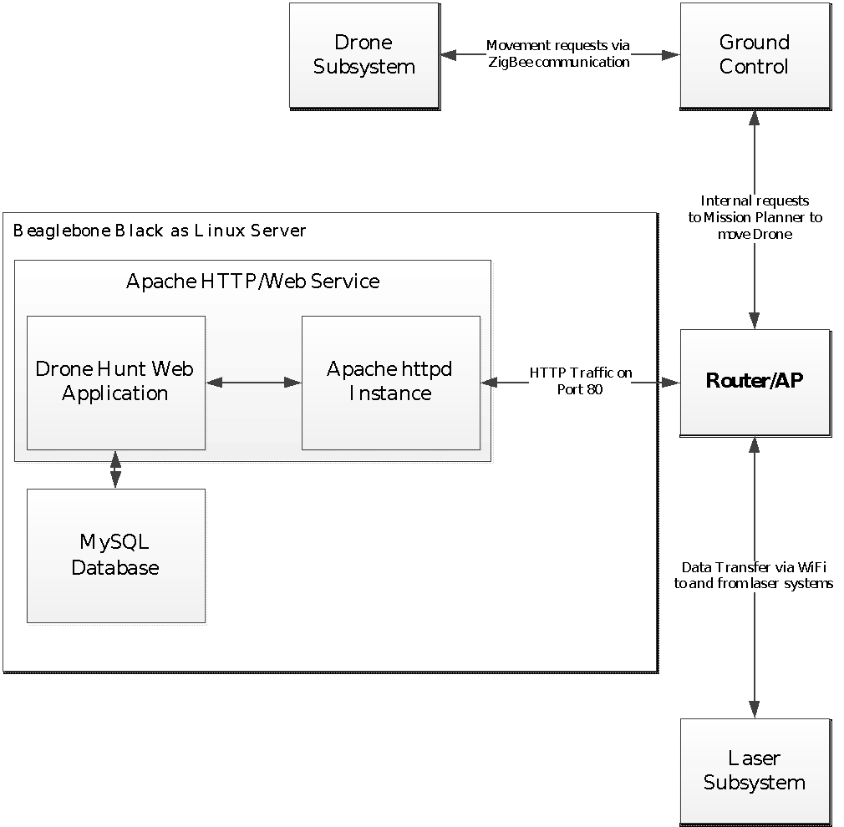

Figure 4.16: Quick Overview of Server and Communication Subsystem (Block Diagram)

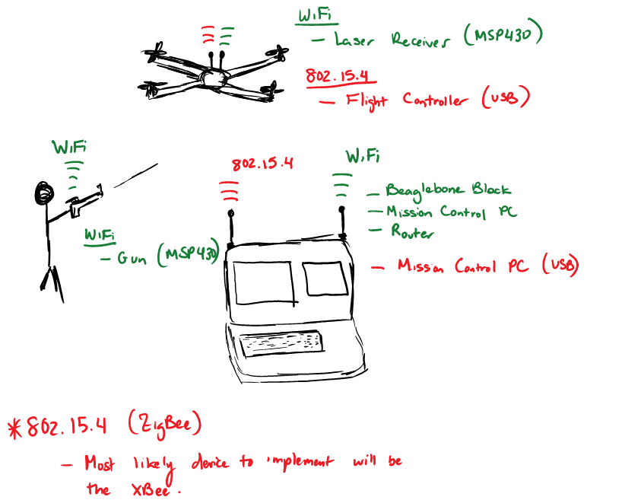

Figure 4.17: Physical Representation of Communication System

4.3.1 Hardware

Much of the game data processing and communication will be handled by the dedicated game server.  This game server will be powered by a BeagleBone Black which features an ARM Cortex-A8 CPU running at 1GHz with 512MB RAM, sufficient enough to run a Linux based web server.  Equipped with an 8GB microSD card in addition to its internal 4GB there should be plenty of room to keep enough data for many game observations.  The distribution of Linux elected to run on this equipment will be the Angstrom Distribution since it has the highest level of support for this type of board.

|  |  |  |
| --- | --- | --- |
| Model |  | BeagleBone Black |
| Released |  | 23-Apr-13 |
| CPU |  | AM3358/9 |
| Frq (MHz) |  | Cortex-A8 + 2xPRU(200MHz) |
| GPU |  | 1000MHz |
| DSP |  | PowerVR SGX530 (200 MHz) |
| Memory | Type | DDR3 SDRAM |
|  | Amount (MiB) | 512 |
| USB 2.0 |  | 1 x Standard A host port (direct).  1x mini B device port (direct) |
| Video outputs |  | Micro-HDMI, cape add-ons |
| Audio outputs |  | Micro-HDMI, cape add-ons |
| Onboard storage |  | 8-bit eMMC (Rev B: 2 GB Ångström pre-installed, ReV C: 4 GB Debian pre-installed ), microSD card 3.3 V Supported (No Card Supplied) |
| Onboard network |  | Fast Ethernet (MII based) |
| Low-level peripherals |  | 4xUART, 8x PWM, LCD, GPMC, MMC1, 2x SPI, 2x I²C, A/D Converter, 2x CAN bus, 4 Timers |
| Power ratings |  | 210–460 mA @5 V |
| Power source |  | Mini USB or 2.1 mm x 5.5 mm 5 V jack |
| Size |  | 86.40 mm × 53.3 mm (3.402 in × 2.098 in) |
| Weight |  | 39.68 g (1.400 oz) |

Table 4.8: BeagleBone Black Specifications

The figure provides a look at the feature set of the BeagleBone internally. Despite its physical appearance as an inexpensive microcontroller, internally it is capable of features that can be used to host a multitude of services including a web server which is crucial for the design of the project. The BeagleBone also supports high definition video output in the case that we may feature an upgrade design to the ground control station by added yet another LCD display showing relevant data.



Figure 4.18: Internal Block Diagram of BeagleBone Black

In order to make use of the data given off by the laser systems on the guns and Mr. DJ itself, all these devices will have a TI microcontroller added to their circuitry.  The TI MSP430F229 was chosen in conjunction with the TI CC3100 booster pack module to enable Wi-Fi communication on these devices since their inputs will solely be signals coming in from the laser equipment. The specifications for these TI devices are provided below.

|  |  |
| --- | --- |
| *Model* | MSP430F5529 |
| *Frequency (MHz)* | 25 |
| *Flash (KB)* | 128 |
| *SRAM (kB)* | 8 |
| *GPIO* | 63 |
| *I2C* | 2 |
| *SPI* | 2 |
| *DMA* | 3 |
| *ADC* | 12-bit SAR |
| *Comparators* | Yes |
| *Multiplier* | 32x32 |
| *BSL* | USB |
| *Operating Temperature Range (C)* | -40 to 85 |
| *Package Group* | LQFP |
| *Approx. Price (US$)* | 3.58 | 1ku |
| *Estimated Package Size (WxL) (mm2)* | 80LQFP: 12 x 12: 196 mm2 |

Table 4.9: Texas Instruments MSP430 F5529 Microcontroller Package

|  |  |
| --- | --- |
| *Device Type* | CC3100 |
|  | Wireless Network Processor |
| *Processor* | External MCU |
| *Key ROM Features* | Wi-Fi Driver & Supplicant  TCP/IP Stack  TLS/SSL Stack |
| *Integrated Bluetooth Controller* | No |
| *Key Wi-Fi Features* | 802.11bgn  STA, AP & Wi-Fi Direct Mode  SmartConfig |
| *Throughput (Max) (Mbps)* | -16 (UDP)  -12 (TCP) |
| *Peripherals* | SPI  UART |
| *Wi-Fi RX Current (mA)* | 53 (@54 OFDM) |
| *Wi-Fi TX Current (mA)* | 223 (@ 54 OFDM, 14.5 dBm) |
| *Wi-Fi Idle Connect Current (mA)* | 0.69 (DTIM = 1) |
| *Wi-Fi TX Output Power (dBm)* | 18.0 (@ 1 DSSS) |
| *Wi-Fi RX Sensitivity (dBm)* | -95.7 (@ 1 DSSS) |
| *Operating Temperature Range (C)* | -40 to 85 |
| *Package* | VQFN (64-pin QFN) |

Table 4.10: CC3100 Module Specifications

To provide basic networking services and an access point for the Wi-Fi devices, the design calls for a traditional Linksys WRT54G to work from within the ground control station and take on such a duty.  Although the BeagleBone could have possibly provided routing services it may be wise to move that stress to a dedicated device since the BeagleBone Black may not multitask as well as a standard PC would.

**4.3.2 Web Application**

The Drone Hunt application is broken up into several parts (tabs in the web application) in order to provide an organized system.  Features of the web application include the actual game function, override controls, and diagnostics.  The application will be primary written in JavaScript derivatives jQuery and Node.js along with Python to allow communications with the libraries available for the Mission Planner software.

In game configuration will allow for a single or two player games with the capability to add more players with addition hardware upon detection.  A difficulty setting will determine the patterns and semi-autonomous behavior that Mr. DJ should take on while the game is going on.  Movement randomness will be increased as the player chooses a higher difficulty setting and more sophisticated flight patterns would be taken.

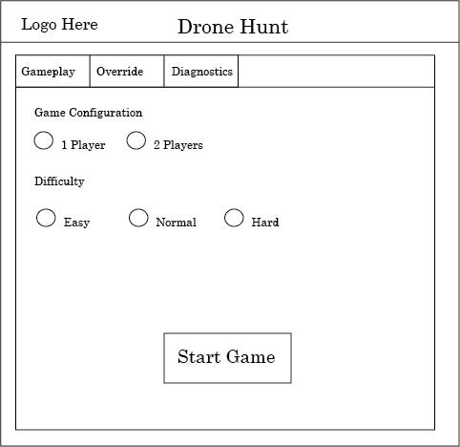

Figure 4.19: Gameplay configuration

When the game starts the players would be shown a screen with each players score and the current leader in the game.  At the bottom, special achievement messages will briefly be displayed as the player fulfills the requirements for such a message.  The time remaining will be placed at the bottom letting players know how much time they have left to continue scoring.

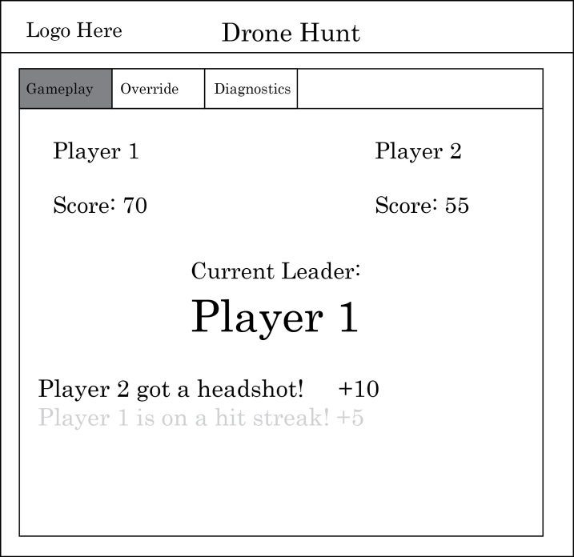

Figure 4.20: Example of game in-progress

When the game finishes the winner is declared and a statistics page will be displayed depicting each player’s performance.  This includes the number of shots fired and actual hits, hit distribution, and fire rate.  Other miscellaneous stats may be added in future updates.  The button at the bottom of the page will allow for a user to restart the same match or start a new game with new settings.

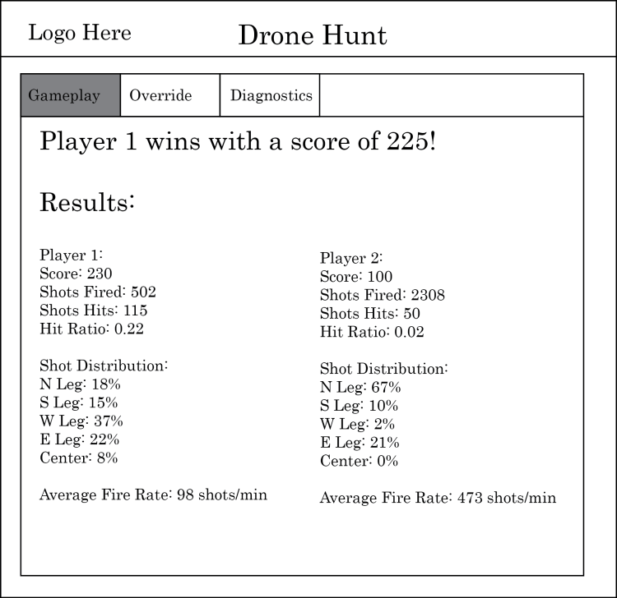

Figure 4.21: Game Over Screen

In addition to Mr. DJ’s RF remote control it can also be manually driven using the Override feature of the app.  In this page you can override the game’s stochastic movement and allow an additional person control.  If a game is in progress Mr. DJ will start listening to the controls given by this page while keeping the game in progress.  A stance determines how Mr. DJ will move about without before any actual preprogrammed movements are selected.  Keyboard control will disable the stance and allow the user to move the quadcopter using the keys on the keyboard while still providing preprogrammed movements.

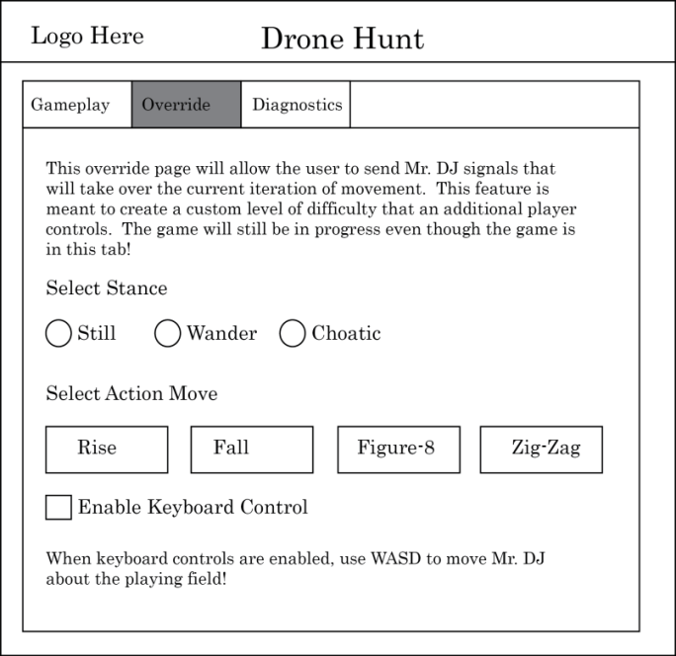

Figure 4.22: Override Controls Page

The Drone Hunt application will be fitted with a quick diagnostic page to provide feedback on all the devices it can communicate with and their current connection status.  Any game sessions currently running will be terminated to provide proper feedback although this may be allowed if a debug mode is enabled.

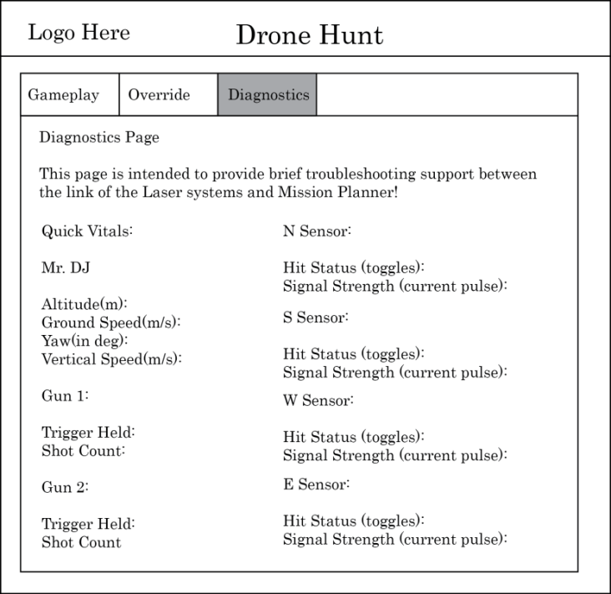

Figure 4.23: Diagnostics Page

4.3.3 I/O and Application Flow

The Drone Hunt web application is meant to drive the system in a way that all parts should be working seamlessly to enable the best experience without too much overhead taking away from the gameplay.

In the case of Mr. DJ and control station devices data will circulate although not always will there be a direct connection to the device it is meant to talk to.  For example, any movement information that the flight controller will receive usually will come from the machine running the Mission Planner software.  Through API programming the server will have to communicate to the Mission Planner in order to get the movements desired on Mr. DJ.  A quick overview on how data is supposed to travel in the system can be seen in the figure below.

Figure 4.24: I/O Dataflow Overview

The web application in a sense controls the much of the show since it will send the signals needed to get Mr. DJ up and flying and the guns operational.  Below is a quick overview of how the program will flow.

Figure 4.25: Drone Hunt Web app Flowchart

**4.4 Ground Control System**

This following section will go into details on the design aspects of building the ground control station. Also, this section discusses the design details on the power supply and the battery that will be used in this system. To finalize, this section concludes with a section that will integrate all the components together in a section called Integration.

**4.4.1 Design Specifications**

This section of our senior design project is considered as the icing on the cake. This subsystem has the main objective of bringing together every component required for a successful control, communication, and performance that a complete quadcopter drone must have into one portable medium military case. This subsystem called “Ground Control System” will be composed of a durable, lightweight, medium sized military case that the user will have to take with them wherever they will operate the quadcopter. Specifically, this ground control system will contain the following components:

|  |
| --- |
| *List Of Components* |
| 2 Antennas(2.4Ghz and 915Mhz) |
| Router |
| Server |
| Laptop Screen |
| Laptop Keyboard & Mouse Pad |
| PC Motherboard |
| Battery Charger (for Drone and Receiver) |
| LSA Battery |
| Power Supply System(with various adapter) |
| Housing for the transmitter(if space allows) |
| Small LCD Screen |
| Switches |
| Cooling Fans |

Table 4.11: List of Components.

This section will take in consideration all the design specifications for this ground control subsystem. A design specification; according to Wikipedia, provides explicit information about the requirements for a product and how the product is to be put together. The goal for this section is to provide specific examples of how the design of the project should be executed. Members who will work on this system to be produce properly.

The first subsection of this design specification section will be to consider our most important requirements so that this system functions as wished. All these requirements are things that are needed in our ground control system in order for the system to be fully capable of the entire task demand it to do, the drone, and the future users. Below, is a list of the requirement our ground control system have:

* The system shall have a PC motherboard.
* The system shall have a small tablet size screen to display.
* The system shall have a keyboard (with mouse pad) for input and software use.
* The system shall have a type of power supply for powering the station.
* The system shall have all the communication components (router, antenna, Wi-Fi adapter, and server).
* The system shall have the battery charger to easily charge any battery.
* The system shall have a fan to serve as a cooling system.

This second subsection of this design specification portion of this paper talks about the steps and process of how this subsystem will be put together. Designing a complete system means many steps must be taken; this second section will provide these such steps.

The most important step for this subsystem will be to design a drawing spec with all the dimensions, sizes, and positioning of all components that will go into the ground control system. With this idea in paper, this group would have a better understanding of what size the case will have to be in order to produce a good quality system. In addition, before any designing is done, one must perform a numerical analysis to see what is required and what is not required in order to have a successful subsystem. Below is a rough view of how the ground control system for this senior design project will look like.

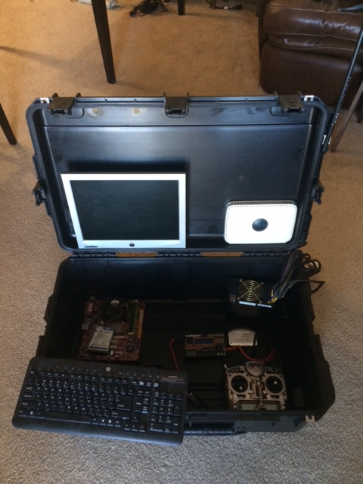

Figure 4.26: Rough View of Ground Control Station

This picture above displays a rough view of how the ground control station that this group Drone Hunt is planning on designing for this project. This picture shows the components that as of November 30th this group has in hands. For example, this group has a screen, the battery charger, the router, the PC power supply, the PC motherboard, and keyboard. Even though this is not the completed view of the ground control station, this will provide a preview of this ground control station. With this large sized military case, this group has more than enough room to maneuver all the components in this case. With this extra space, this group plans on adding a special casing slot for the drone transmitter to fit as a housing space. Like any other subsystem in the designing process, things are eligible to change around. But of course, this ground control station will have a good display for the user-system interaction. The PC, routers, and batteries will not be visible by the users. This group has decided that this will be a very professional looking ground control so that all the attention goes to the ground control station as well as the drone.

Next, the following steps will be finding and purchasing the specific case for the ground control system. Our first approach are to see if the neighbor of one of the members of this group; which is a veteran military who has possession of many military equipment. If that does not work, the plan will be to begin searching for the case in garage sales or any charity location. Finally, if those two plans do not work out, the only way to go about getting a hold of the case will be purchasing it online; which run at a pricy range between 70 and 200+ dollars. This group also has a contact who works for a company in the transport systems industry called SKB Cases. The group plans on sending him a professional email about the ground control system with details and hopes that he could help with a case at a good price or even donate. The way it was managed to obtain this contact was through the robotics club at UCF. One of the members is an active member of the club and he asked questions. Below are some pictures and tables of the pricing of cases, the type of case (Pelican 1600) this team is trying to obtain for this Ground Control System.

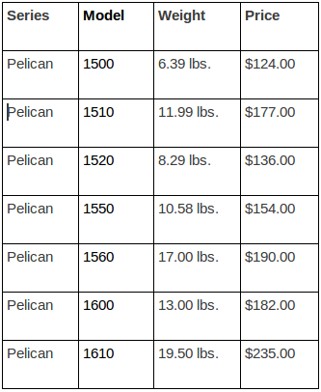

Table 4.12 - Price List of Pelican Cases

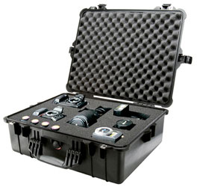

Figure 4.27: Pelican Case 1600

In addition, below is a table of all the specs of our desire pelican case:

|  |
| --- |
| *Interior (L x W x D)*  21.51" x 16.54" x 7.99" (54.6 x 42 x 20.3 cm) |
| *Exterior (L x W x D)*  24.39" x 19.36" x 8.79" (61.9 x 49.2 x 22.3 cm) |
| *Interior Cubic Volume:*  1.65 cubic feet (46.58 cubic decimeter) |
| *Lid Depth:*  1.75" (4.4 cm) |
| *Bottom Depth:*  6.12" (15.5 cm) |
| *Total Depth:*  7.87" (20 cm) |
| *Range Temperature*  -40 / 210° F (-40 / 99° C) |

Table 4.13 - Dimensions of Pelican Case 1600

The reason that it was decided to aim towards the military cases was because it’s durability and portability. This means, that the environments factors for this case to be properly working are close to none. This system can be operated anywhere, anytime; in the sun or at night. There is almost no limitation as to where can the ground control system may be opened and operated. As well as factors, this ground control system doesn’t need maintenance. The only possible maintenance will be software wise. Maybe the computer may need an upload on the software, but other than that, this system will be made to last decades without the need of taking everything out of its location and maintaining it.

Now, safety is another ball game. These cases are produced so that safety is what they stand for. According to Wikipedia.com, “Pelican cases are molded plastic containers that seal with an airtight and watertight gasket. Pelican cases include a barometric relief valve made of Gore-Tex to prevent pressure damage to the case, during transportation or when the air pressure in the environment changes. Pelican cases meet standards for waterproofing, stacking, impact, and durability including MIL-STD C4150-J for waterproofing, IEC IP67 rating indicating complete sealing against dust and water immersion to 1 meter, as well as ATA 300 rating indicating compliance with Air Transport Association standards for durability in shipping. Pelican cases feature a lifetime guarantee. In Europe, they are sold as Pelican cases because the name "“Pelican"” being trademarked by another company.”

**4.4.2 Power Supply and Battery**

Have you ever wonder what uses an old PC’s power supply has after years of simply laying around, well, this group does. It is planned to use the power supply of an old Desktop PC and modifying it so that it can be used in our ground control system.  Our plan for this ground control system is to have the power system serve as the AC power for the PC and as well as providing various voltage input for other components. This power supply will also be equipped with a USB adapter so that any type of component that takes in input voltage through a USB, this power supply can provide that. So, our main steep here is to modify the PC power supply to only be used in this way. This modification consisted of some steps that were required to take in consideration in order to make our own power supply. These steps were very electronics focused and required some components and adaptors.

The main and first step required to do the wiring of the power supply. This means separating all the 5 volts and putting them into one wire, as well as 3 volts, 12 volts and ground. As well as all the input wires, it was necessary to build each LED circuit because it was agreed that this power supply would have LEDs to turn on whenever a device was to be plugged in in a certain input. Below is a picture from the website that the team used to guide in modifying the power supply.

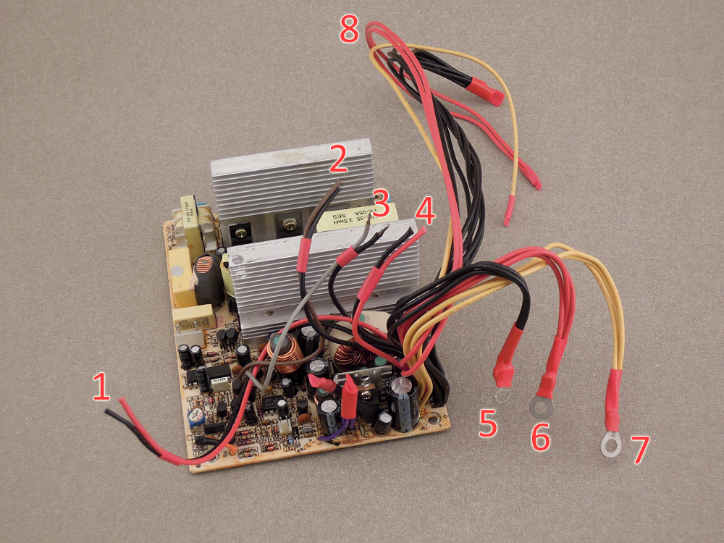

Figure 4.28: Opened Modified PC Power Supply [15]

Next, a 10W at 10Ω (ceramic: high temp) resistor had to be purchased and use it as the dummy load so that the power supply believes that it is actually connected to some type of computer and actually work.

Then, the next steps were simply making a presentable power supply by installing nice banana screws for the connection. It was required to drill holes on the frame to install these. Here is a picture of how our power supply will look like at the end of this project.

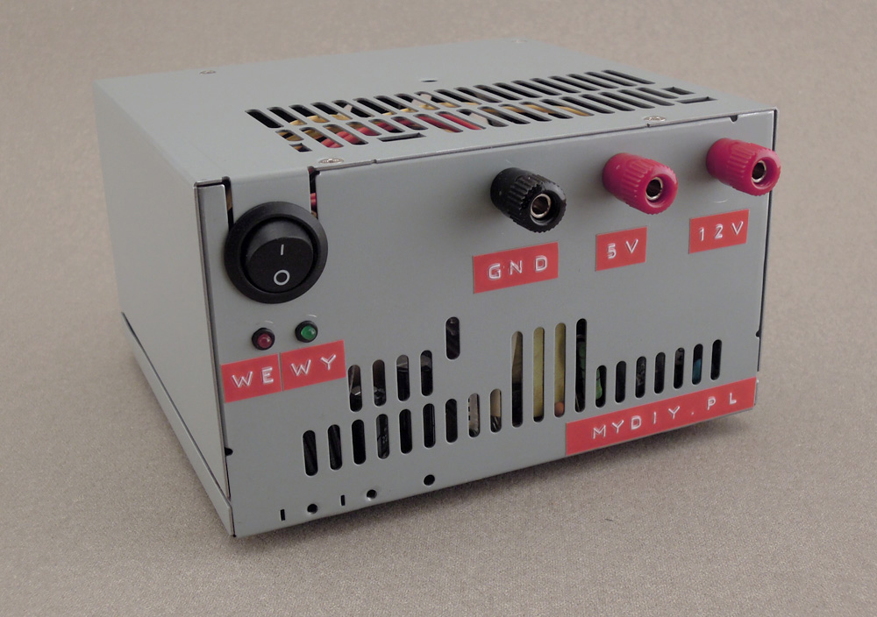

Figure 4.29: Finalized PC Power Supply [16]

On the other hand, it was also planned on having a Sealed Lead Acid (SLA) battery to serve as a separate power supply so that the ground control system may be a complete portable system. The purpose for this is so that there would not be a need of a power outlet in order for the computer and software to operate for the controlling of the drone. This group wants to use a SLA battery that outputs 12 volts at 7 amperes max. As well as the output, this group focuses on the dimensions. The group members want a small battery that would not spill, and that will be easy to handle since it will be placed inside a compact case. These batteries are known to have three major traits: internal pressure regulation through valve construction, immobilized electrolytes and oxygen recombination.

These batteries are known to have various features. These include:

* Maintenance free; there is no water topping-up required
* No free acid(Sealed battery)
* Low self-discharge rate, lower than 3% capacity loss per month
* Can be used in any orientation(excluding used inverted)

As well as features, these batteries also have a number of different applications that have been previously been seen. Some of the applications may be UPS, laboratory equipment, toy cars (robots), power packs, fishing lights, etc...Below is a table with all the specifications that apply to this battery.

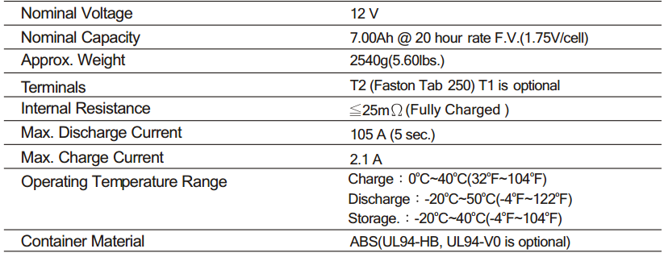

Table 4.14: Characteristics of a SLA Battery

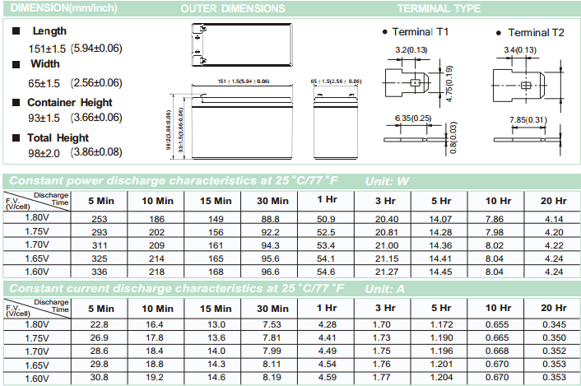Table 4-15: More Specific Specs on LSA Battery

In addition, this part of the project also will include a printed circuit board that was designed by one of the members of this group. This group has decided that a special circuit designed by this group should be incorporated into each subsystem. Therefore, a small voltage control has been developed to include in the ground control system for a special way of turning components on and off. Below is diagram of the schematic circuit that was designed. This schematic shows four different toggle switches (ON/OFF) that connect to four different components. These different components are represented by four resistors since it is not known what component it will be. In this schematic done by MultiSim each switch is connected to a common ground if the switch is toggled to the left side (the OFF side). The idea is that a few components get connected to this printed circuit board and when the ground control station is opened, there will be some military air jet style switches that will turn different components on and off.

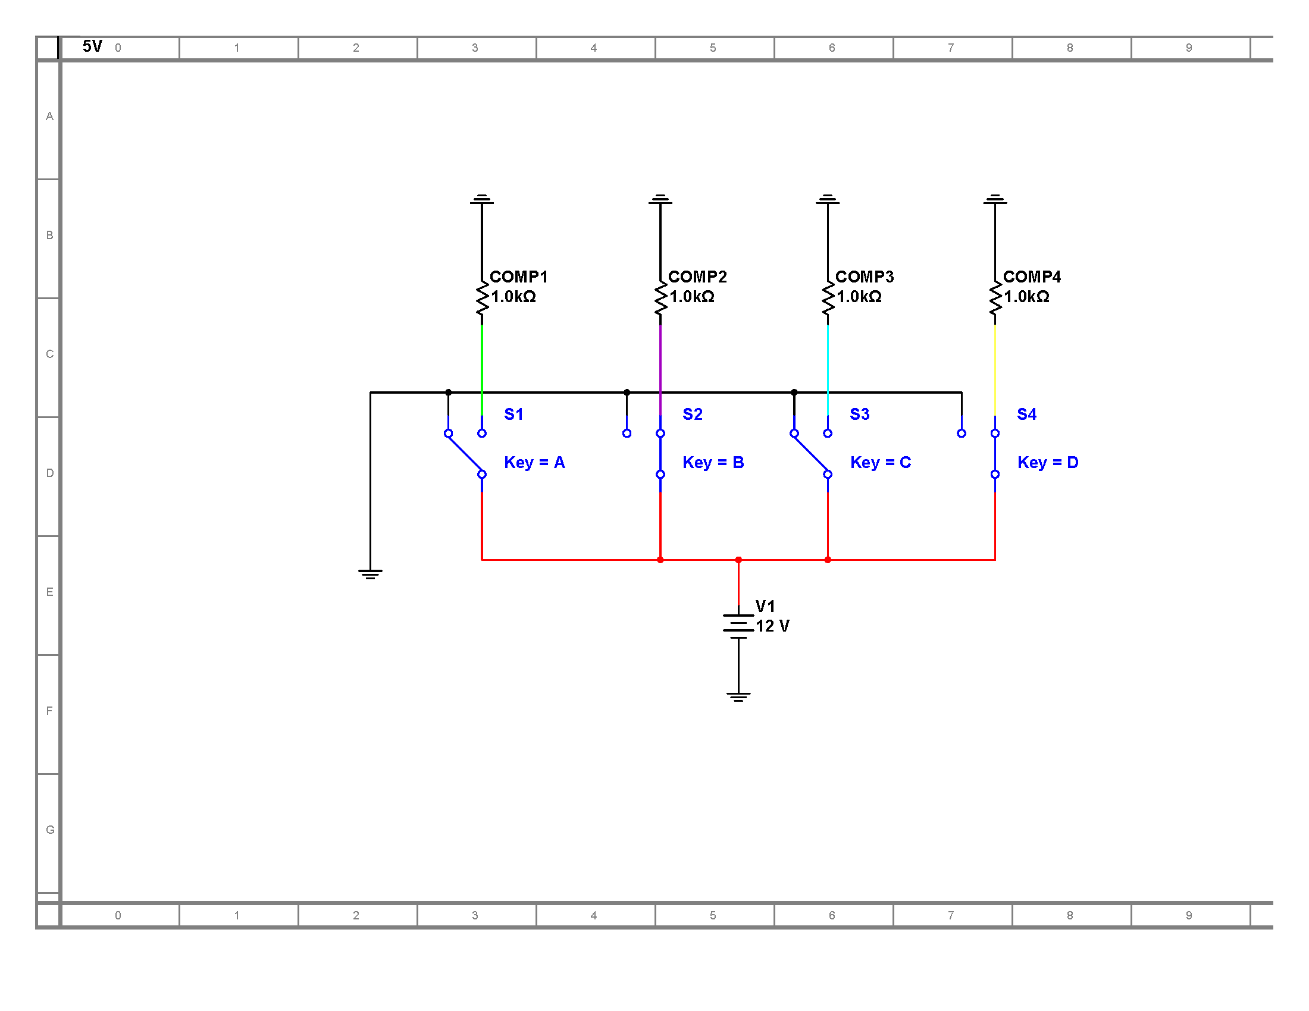

Figure 4.30a: Switch Circuit for Ground Control Station

In order to provide a continuous flow of electricity a circuit was design to automatically switch between the two available sources, battery and a fixed AC source. With the proper logic and several transistors to carry out the task this was achieved using the circuit below.

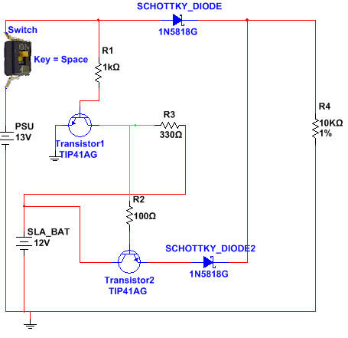  
4.30b: Battery Management Circuit

**4.4.3 Integration**

This subsection will focus on the fun part, putting everything together; the integration of the system. Here, all the designing specification and requirements will take into account. The steps have now simplified to the “actual work”. Now it will be time to make sure that the group has all the components that will go into the ground control system in hand so that the assembling the case and securing these to the case can initiate. Assuming that every component from the list provided above were in possession, the job is now to put it all together. However, Drone Hunt will make sure that all these components are functioning the way they are supposed to prior to assembling them to the case. To begin with, the way this will be done is by simply connecting the motherboard to the screen and the keyboard and make sure that they turn on properly as how a normal laptop will. Next, the group needed be completely sure that the communication system is working 100%. This will assume that the router, the BeagleBone black and all the other components are in sync and functioning correctly. The battery charger is already purchased and it is working properly, so the group would only have to allocate spacing for it. As well as all the other minor components that it was planned on adding to the ground control system. Doing this will be the smart thing to do rather than assembling it to the case and then realizing that something was wrong with it. So the plan is to properly assemble all the components and checking that they work how they are suppose and then securing it to the case.

5.0 Design Summary

5.1 Drone Subsystem

Building a quadcopter from scratch takes a lot of trial and error to see what works best for each different design. Building a small, fast, and agile quadcopter can be completely different than a large stable quadcopter built for carrying large loads. Because our design lays somewhere closer to the large payload carriers, it was necessary to find resources relative to the larger builds that were more focused towards FPV-style quadcopters. The Z700-V2 frame fits perfectly for our design for several reasons. The large size provides plenty of room to lay out sensors and experiment with motor position. The lightweight enables to pack more weight while still keeping battery efficiency. Finally, the low cost helps the team remain under budget.

The flight system is one of the most important pieces of the quadcopter puzzle that needs to be nearly perfect in order to optimize efficiency while keeping a safe and stable flight. There needs to be enough thrust generated by the motors and propellers that enable the quadcopter to carry the attached payload while not generating so much where the quadcopter is unstable and jerky during flight. By weighing our options and carefully calculating data using researched equations that were able to confidently choose the Turnigy 28 800kV brushless motors paired with 12 inch propellers. The pitch of the propellers will be determined after physical tests using two different pitch sizes - 3.8 inch and 6 inch pitch sizes. The final piece of the flight system are the four individual electronic speed controllers flashed with SimonK firmware(one for each motor) which are used to individually control the motors rotation speed using pulse-with-modulation signals. These 30A ESCs source are more than enough current to safely drive the motors effectively.

The user will have two different ways of communication with the drone, one is the good old fashioned RC Transmitter (FrSky Taranis 9Ch 2.4GHz transmitter) while the other way is the more modern semi-autonomous ground control station via Mission Planner which communicates with the flight controller. The quadcopters control will be managed by the ArduPilot Module v2.6 flight control system. This system monitors and controls the electrical components that are essential during flight and makes automatic decisions depending on how it was initially set up the flight controller. From automated gyroscope stabilization to GPS navigation, the flight controller ensures a safe flight that is controllable via a RC Transmitter using the 3DRobotics 915 MHz telemetry radios, or our ground control station software known as Mission Planner.

All of the electrical components need a well regulated and distributed power source to drive the mechanical devices. This power source will be an 11.1V 3S 4000mah Lithium Polymer battery which will be distributed via a custom power distribution board that the ESC’s and output voltage regulator would be connected to. The power distribution board will look similar to the following:

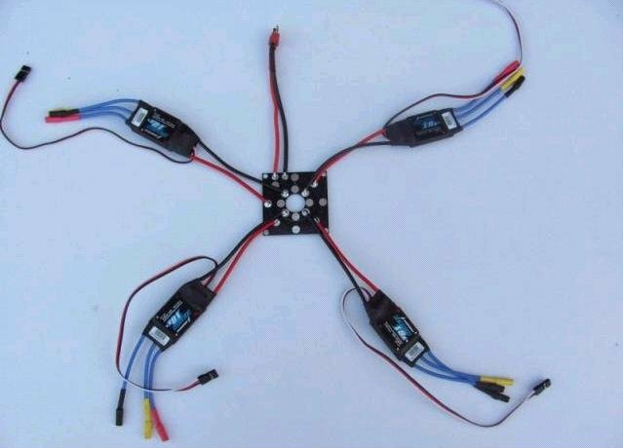

Figure 5.1: Example of a custom Power Distribution Board [17]

The power distribution board will have 1 input and 5 outputs. The input will be from the 11.1V 4000mAh battery which will be fed into each of the 5 outputs, 4 of the 5 outputs will be for the ESCs where each of them will have their own internal voltage regulator that will step down the voltage from 11.1V to 5V for each motor. The 5th output will be for the APM ArduFlyer Regulating Module which is the input for the APM 2.6 flight controller system.

The 11.1V will be regulated by an APM ArduFlyer Power Module switching voltage regulator. This battery was calculated to provide an optimal flight that will provide sufficient flight time without weighing it down to give Mr. DJ the ability to be agile. The battery feeds in 11.1V into the voltage regulator which outputs 5.2V. This 5.2V will be distributed throughout the quadcopter via a power distribution board which will be designed by one member to fit the build. With this clean regulated power Mr. DJ will be able to drive all of the electrical and mechanical components.

5.2 Laser Subsystem

Right now one of the most popular ideas for a senior design project is to design a robot drone. Many students go with the idea of a drone because of its flexibility with applying concepts learned while in engineering school. The possibilities with a drone are pretty much endless. When creating a drone a student has so many options to go with, from a drone that drives on land or one that works underwater or one that flies in the air. Then even from there you could go further and design one that is a hybrid that can be utilized in multiple environments. After the first group meeting the group immediately settled on the idea of a flying drone because of the multiple directions the group could go with the idea and also because it would be something fun and exciting to work on. Now from there the next step was to come up with an idea of what the purpose of our quadcopter drone would be. After passing over the ideas of an autonomous drone that could travel to waypoints or follow the user and then of a payload carrier the team settled on our current idea of Done Hunt. Drone Hunt’s idea of using a quadcopter drone to create a multiplayer interactive game seemed very intriguing to all the group members and seemed very challenging yet plausible. Using a gaming environment similar to that of laser tag this group will be using laser modules embedding into a airsoft gun as our transmitter and have light sensitive receivers on the underside of the drone to make our cleverly named drone, Mr. DJ the objective target.

The gun being used will need to have two functions, firstly to act as the laser source and secondly to be able to communicate with the ground control station. Communication is needed to keep track of each trigger pulled. In order to act as the laser source, there will be a laser module that will be powered by an internal battery in the gun. Since the game will be a multiplayer one, there will be more than one laser transmitter being used simultaneously. With multiple sources of laser beams being fired at Mr. DJ the game would need to distinguish each incoming beam from the other. For this to be possible the laser beam needs to be frequency modulated differently so that each source would be unique and therefore easily distinguishable by the receiver. Accomplishing the second function of the gun will require the use of a Wi-Fi adapter and a microprocessor chip in the gun. Each time the player pulls the trigger of the gun a signal will be transmitted over the Wi-Fi network to the server which lets the game know that the trigger was pulled and then keeps count for game statistic purposes. The below image is from an online tutorial on how to build a gun similar to what it will be designed. The gun is controlled by a microprocessor and has a beam transmitter, which in this case is infrared instead of laser.

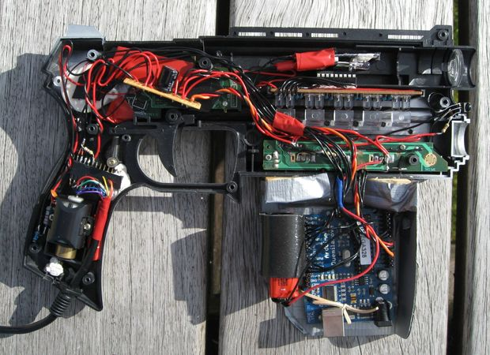

Figure 5.2: Laser Gun with Arduino

Attached to the drone will be five photosensitive panels. Each panel will act as the target to be hit by the transmitter with different scores for hitting different panels. These panels will be able to detect a hit from the guns and using the microcontroller determine which gun made the hit then transmit the information back to the ground control station to show the game’s score.

With an autonomous flying drone you will have to worry about the possibility of the drone crashing into an object mid-flight. In order to avoid this issue, it was decided to include ultrasonic proximity sensors on the drone. Ultrasonic sensors offer a means to make non-contact distance measurements. An ultrasonic sensor functions by having a transmitter that emits sound waves and a receiver for the reflected sound waves. The sensor then measures the time it takes a sound wave to propagate from the sensor, to an object and back to the sensor. Ultrasonic waves generated by a transmitter are reflected by the target and the returning waves are detected by a receiver. The measurement of elapsed time is used to determine the distance to the object. The farther away an object is, the longer it takes the sound wave to propagate. The way this concept works is pictured to the right. With two of these sensors attached to the quadcopter this group will be able to have a 360 degree view of the surrounding environment. Then whenever an object is within a predetermined range that is too close to the drone, Mr. DJ will take evasive measures to avoid the object.

Having a flying quadcopter can be very cool. Then throw the idea of having laser based rifles to try to shoot at your flying drone sounds even more awesome. With such a fun and exciting project that the group will be building, it was decided that it would be a good idea to make it look the part as well. In order to do this an LED lighting system was incorporated into the drone along with all the other subsystems. To simplify this usually messy subsystem of Mr. DJ, Adafruit’s Neopixel line of products will be utilized. This product comes as a strip of WS2812 LED lights each with its own integrated LED driver. The LEDs are then controlled using a microcontroller through a single wire to determine each individual LED’s color and brightness. Adafruit also provides a lot of open source code to program the Neopixels for a wide variety of lighting effects. Using the Neopixels will greatly simplify the lighting system of the drone and also allow for a lot more options with the lighting effects. These lights have been used by many hobbyists on their own quadcopter projects and have turned out very well. Adding this extra subsystem into Mr. DJ allows for applying more design to the project as well as making it stand out more against other projects.

5.3 Server Subsystem

While the idea of laser tag and flying targets might not be terribly original, the unique characteristics of the project will help propel the proposed design towards success.  The design of the web application will be the fundamental base that will guide data flow within the different subsystems in order to get Mr. DJ and the game fully operational.

Communication remains key in all subsystem designs as the actions that each subsystem will take will depend on the input and output of each subsystem.  The communication that handles movement explicitly lies on the ZigBee standard (802.15.x) which includes the flight controller and the ground station controller.  The link between the server and laser subsystem will be strictly Wi-Fi (802.11) via a wireless router that will also provide other networking capabilities.  The link between the server and the flight controller will be established via a local LAN link that the router will provide.

The objective of the application is to provide the users of the system a genuine game experience while retaining its simplicity in order to meet the deadlines imposed by project planning.  The application is to provide an interface to the players that will allow customizable game settings and other configurations required to launch Mr. DJ into game flight mode.  Game modes include a semi-autonomous configuration handled by application, a manually controlled experience or a combination of the two.  Programmable flight patterns will be a feature on the semi-autonomous side and on the manual side a person could take control of the quadcopter using the input devices on the system running the app such as the keyboard or even a gamepad.  Diagnostics are included in the event that the application requires troubleshooting.

5.4 Ground Control Subsystem

In summary, the ground control system will be the last touches of this entire project. This system will ensure that the drone and user experience is as clean, easy and professional as it can be. The secondary objective of this subsystem is to make the lives of the group’s members and the future users easier. Not having this component that puts everything together in a portable case, will require for multiple assembling and disassembling of all wires and other components every single time that the project will be demonstrated or used. As it has been mentioned, the steps for deciding, researching, designing and implementing this system will be restated in this section of the paper.

First of all, according to all the previous research done the idea of designing a ground control system came across because this group wanted a clean, complete product that users can fully enjoy; not only the gaming aspects of the product but also the display and the controlling experience of the product. This group feels that when the product is complete, there will be many times where carrying all the laptops, router, boards, guns, battery charger wherever this group decides to present the product and assemble and disassemble those parts along with all the cables, and USB’s will be necessary. If all the components required for a drone to fully perform are inside of a durable and portable military case, designing this ground control system would make everything easier. The motivation of developing a ground control system is there because having this will add to a fully durable, portable, and a military feel case to it that can be opened and operated anywhere in the world.

Moreover, after completely deciding that this project will consist of a ground control system, deep research was done in order to gather more useful information that will benefit this part of the project. The member in charge of this subsystem discovered that last year an individual had actually worked on a project on his own and designed and developed a ground control station very similar to what this group plans to develop. This individual’s name is Elad, and in February of 2013, Elad worked on a project that consisted of a UAV plane. However, he realized that instead of using his laptop as the ground control system he would design and create a ground control station. The reason he decided this was because after many times of him carrying his laptop everywhere he would want to fly the UAV he would have to assemble and disassemble parts, cables, XBee, USB cables and such; and he said those days are over. This very useful researched acquired will be in much use since this Elad individual states thin details the steps and components he used for his project in order to successfully make this ground control station. This deep research will benefit the designing and development of this ground control system that Drone Hunt plans to do.

In addition, the design aspect of this section of the project consists of first gathering all the requirements and all the designing calculation before putting everything into the making phase. Prior to deciding what exact case this ground control station was going to be using, this group member had to sit down and agree to all the requirements for this system. As this was done, the group came up with some requirements; which were that this system needed to have a PC motherboard, a laptop screen. a laptop keyboard, a type of power supply for powering the station, a fan for cooling, a battery charger to easily charge any battery. As well as agreeing with some specific requirements for the system, this section of the project needed to have an adequate amount of analysis been done to it. In other words, the most important step for this subsystem will be to design a drawing spec with all the dimensions, sizes, and positioning of all components that will go into the ground control system. With this idea in paper, a better understanding of what size the case will be in grasp in order to produce a good quality system. This means that before putting all the components into the case, a good amount of pre-calculations were needed. Specifically, this ground control system will contain the following components: 2 antennas, router, motherboard, screen, keyboard, PC power supply, battery charger, LSA battery, server, LCD, switches.

Next, the steps narrow down to deciding on the specific case and putting it all together. The Drone Hunt group decided that the best fit for our ground control system will be a Pelican Case model 1600 or anything very similar to that. This exact case provides the dimensions that are adequate for this project. The prices for this case are around $180.00 dollars. Drone Hunt also has a contact who works for a company in the transport systems industry called SKB Cases. The plan is to send him a professional email about our ground control system with details and hope that he could give this group a case at a good price or even donated. The way this contact was obtained was through the robotics club at UCF. One of the members is an active member of the club and he asked questions.

To conclude, to summarize it all up, in addition to the drone and the laser, this portable ground control station is our third main feature for the entire project. This station will be a portable case that consists of a laptop screen for the web application, a keyboard and mouse pad, a PC motherboard, the communication components, the laser guns, battery charger, and some LCD’s to display battery life. To start, it was planned on using an old computer’s motherboard, a laptop screen that it was already in possession of and integrate it all into one easy to transport military case that can be connect to a AC power if available. Having this ground control station will provide a more professional final product so that assembling and disassembling of parts and cables would not be necessary in order to showcase the product on the field. Moreover, an objective for this ground control station is to provide more design into our project. The reason for that is because the group believes that it could make this project much better and increase the amount of design being done in the drone and laser allows by including such flexible and universal solution for controlling the drone.

6.0 Project Prototype Construction & Coding

Project prototyping is an essential part of the design by allowing the design to become a physical reality. Although far from the final design, prototyping allows for early implementation and testing of the design with the option to tweak parameters before the final implementation is done. All components ready for use will be featured below in a bill of materials.

6.1 Bill of Materials

This first subsection of the project prototype construction and coding discusses all the bills of material of each individual subsystem that exist in this Drone Hunt senior design project has. Bill of materials consists of a list of the quantity, the description, and prices of each component.

6.1.1 Drone

The following is a table showing all of the possible components needed to complete a prototype that can be used for thorough user-controlled and autonomous flight testing. These parts will be individually ordered from HobbyKing.com which is a worldwide leader in RC Hobby vehicles.

|  |  |  |
| --- | --- | --- |
| Description | Qty |  |
| Turnigy 9X Transmitter w/ Module & 8ch Receiver (Mode 2) | 2 | $139.94 |
| Turnigy 2650mAh 3S 1C Lithium Polymer Battery | 1 | $13.30 |
| Turnigy Accucel-6 50W 6A Battery Balancer/Charger | 1 | $24.10 |
| Z700-V2 Quadcopter Frame w/ Crab Landing Gear V2 | 1 | $29.96 |
| Hobby King 30A ESC 3A UBEC | 5 | $53.25 |
| APC Style Propeller 12x6 | 4 | $10.24 |
| Turnigy Nano-Tech 4000mAh 3S 45-90C Lithium Polymer Battery | 1 | $39.08 |
| NTM Prop Drive 28-30S 800kV / 300W Brushless Motor (Short Shaft Version) | 4 | $63.48 |
| Turnigy Battery Strap 330mm | 1 | $1.75 |
| Nylon XT60 Connectors Male/Female (5 Pairs) | 2 | $6.92 |
| Turnigy Pure-Silicone Wire 16AWG (1mtr) Black | 2 | $2.72 |
| Turnigy 5mm Heat Shrink Tube (1 mtr) - Black | 2 | $2.16 |
| Turnigy Pure-Silicone Wire 16AWG (1mtr) Red | 2 | $2.72 |
| Turnigy 5mm Heat Shrink Tube (1mtr) - Red | 2 | $2.10 |
| Individual HXT 3.5mm connector for motor/ESC (12pc) | 2 | $5.32 |
| Turnigy 0X LCD Backlight kit - Blue (DIY) | 1 | $5.15 |
| APC Style Propeller 12x6R (Right Hand Rotation) | 4 | $10.12 |
| NTM Prop Drive 28 Series Accessory Pack | 5 | $10.45 |
| PolyMax 3.5mm Gold Connectors (10 Pairs 20PC) | 1 | $1.97 |
| APC 12x3.8SFP Slow Flyer Counter Rotating Propellers | 4 | $32.00 |
| Gardner Bender Automatic Wire Stripper and Crimper | 1 | $13.34 |
| Reel of 0.3mm Diameter Solder Flux | 1 | $5.35 |
| Weller ST7 0.03” X0.79mm ST Series Conical Soldering Tip | 1 | $7.89 |
| Umiwe 0.3mm 10m Tin Led Rosin Core Solder Soldering Wire | 1 | $2.79 |
| Hakko 599B-02 Solder Tip Cleaning Wire and Holder | 1 | $9.47 |
| Hubsan H107L X4 Mini Quadcopter | 1 | $40.30 |
| Raspberry Pi Model B | 1 | $0.00 |
| Transcend USB 3.0 SD Card Reader | 1 | $6.99 |
| FrSky Taranis 16Ch Full Telemetry Transmitter | 1 | $188.29 |
| FrSky DJT - JR Transmitter Telemetry Module | 1 | $22.40 |
| FrSky D8R-II Plus - 8 Channel Receiver | 1 | $29.25 |
| HobbyKing Power Distribution Board | 1 | $4.09 |
| APM 2.6 ArduPilot Flight Controller + GPS + 3DR 915 + Minimosd + Current Sensor | 1 | $129.99 |
| Drone Total |  | $916.88 |

Table 6.1: Drone BOM

6.1.2 Lasers, LEDs and Proximity Sensors

The laser subsystem includes any devices that send and receive any optical signal that will be sent back and forth between the copter and the field. Below is the Bill of Materials for such devices.

|  |  |  |
| --- | --- | --- |
| Part Name | Qty | Total |
| Adafruit Neopixel Digital RGB LED Strip (1m) | 2 | $49.90 |
| MSP-EXP430G2 | 3 | $29.97 |
| MB1200 XL-MaxSonar®-EZ0™ High Performance Ultrasonic Rangefinder | 2 | $89.90 |
| 20mW 650nm red laser module | 2 | $19.98 |
| 1W Solar Panel | 4 | $59.96 |
| Laser and LEDs Total |  | $249.71 |

Table 6.2: Lasers, LEDs and Proximity Sensors BOM

**6.1.3 Communication and Server**

Server and communications Bill of Materials only includes the micro server equipment and the wireless router portion of the ground control system.

|  |  |  |
| --- | --- | --- |
| Description | Qty | Price |
| BeagleBone Black 1GHz | 1 | $0.00 |
| Generic Cat5E Ethernet Cable (3 ft) | 2 | $0.00 |
| Kingston MicroSDHC 8GB | 1 | $12.99 |
| Linksys WRT54G Router | 1 | $0.00 |
| TI MSP430 Microcontroller (MSP430F229) | 3 | $0.00 |
| Server Total |  | $12.99 |

Table 6.3: Server BOM

**6.1.4 Ground Control System**

With an autonomous flying drone you will have to worry about the possibility of the drone crashing into an object mid-flight. In order to avoid this issue, it was decided to include ultrasonic proximity sensors on the drone. Ultrasonic sensors offer a means to make non-contact distance measurements. An ultrasonic sensor functions by having a transmitter that emits sound waves and a receiver for the reflected sound waves. The sensor then measures the time it takes a sound wave to propagate from the sensor, to an object and back to the sensor. Ultrasonic waves generated by a transmitter are reflected by the target and the returning waves are detected by a receiver. The measurement of elapsed time is used to determine the distance to the object. The farther away an object is, the longer it takes the sound wave to propagate. The way this concept works is pictured to the right. With two of these sensors attached to the quadcopter this group will be able to have a 360 degree view of the surrounding environment. Then whenever an object is within a predetermined range that is too close to the drone, Mr. DJ will take evasive measures to avoid the object.

For this section of the project, our expected Bill of Materials for the ground control system is listed below.

|  |  |  |
| --- | --- | --- |
| **Description** | Qty | **Price** |
| PC Motherboard | 1 | $0.00 |
| Laptop Screen and Keyboard | 1 | $0.00 |
| SBK case - R Series 2817-10 Waterproof Utility Case | 1 | $0.00 |
| LCD Controller Board DIY Kit | 1 | $25.00 |
| Delta Fan for Compaq 12vdc | 4 | $0.00 |
| AC Power Supply 100-240v input 12v output 3.2A or higher | 1 | $0.00 |
| 3-Position 6-Pin Switches | 4 | $2.00 |
| 12V 7.2Ah SLA Rechargeable Battery | 1 | $19.00 |
| Ground Control System Total |  | $46.00 |

Table 6.4: Ground Control System BOM

**6.2.1 - Power Distribution**

There are several ways to distribute power along the entire quadcopter system. Some hobbyists use wiring harnesses, others use custom or retail power distribution boards (PDB’s). For prototyping and testing it has been decided to use a separate power distribution board simply because of electrical component safety and the increased simplicity of troubleshooting in case time calls for it. By keeping the 11V away from the APM flight controller, it will decrease the chances of accidental shortages which can result in frying components. Also, if there is a problem with power issues, it would be easier to locate the troublesome areas by looking at the two separate power circuits (APM power circuit vs ESC power circuit).

The prototyping board will be the HobbyKing Quadcopter Power Distribution Board which is a small and lightweight silicon board laid out as described above. This board will ensure a clean distribution of a maximum of 20A and when implemented will enable the group to perform all of the required power distribution testing. The final implementation of a power distribution module will be embedded in the final printed circuit board which will also include components for the laser and server systems. Below is a picture of the HobbyKing PDB which will be used in prototyping and testing.

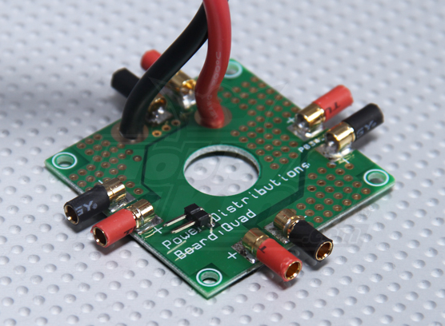

Figure 6.1: HobbyKing Power Distribution Board [18]

**6.2.2 PCB Vendor and Pricing**

The drone hunt project will be incorporating several printed circuit boards (PCB) into its design, with a complex one on the drone itself and then smaller, simpler ones in each transmitter gun. These PCBs will serve the purpose of electrically connecting electronic components within the device. For this project PCBs will be acquired from one of the numerous PCB vendors suggested on the senior design website. PCB Vendors provide services where they take Gerber files, which are files generated by a CAD software such as CADSoft Eagle, and use them to generate a PCB without any components soldered onto it. There are also PCB assembly houses which then professionally place and solder the components onto the fabricated PCB. In the assembly house machines are used to correctly place each component in the right location then runs the board through an oven that properly solders each component in place. Printed Circuit Board fabrication has a wide selection of possibilities to choose from. Due to time constraints a vendor which offers low pricing and quick turnaround time will be used for the PCB fabrication for this project.

This group has agreed that one of the companies that would be considered for the printing of our design printed board printing. The companies that the group is talking about are 4PCB and OSH Park. Below in the paper this group will discuss with more details why 4PCB was chosen instead of other competitors such as OSH Park.

6.2.2.1 4PCB

One of the PCB vendors available is 4PCB, which is an online company that manufactures printed circuit boards. 4PCB has student pricing available for their products, which includes a 2 layer board covering 60 square inches of circuit board space for $33.00 or a 4 layer board covering 60 square inches of circuit board space for $66.00. 4PCB also provides free manufacturing tests which mean they look at the PCB schematic that the customer provides them with and checks to ensure that trace widths and such are within the standards for PCB fabrication. 4PCB also has a turnaround time of five days for their fabricated printed circuit boards and even provides free software for creating your PCB designs.

6.2.2.2 OSH Park

Another vendor available online for manufacturing printed circuit boards is OSH Park. OSH Park accepts designs created using CADSoft Eagle, free PCB design software, and also offers a add-on for Eagle which will verify that your design meets their design rules and specifications. OSH Park prices their boards per square inch and they offer a 2 layer board at $5.00 per square inch or a 4 layer board at $10.00 per square inch. One of the benefits of choosing OSH Park to manufacture PCB is that they provide you with 3 copies of the PCB at no extra charge. OSH Park orders for the 2 layer board go to the fab every business day, and have a turn time of about 12 calendar days. Orders for the 4 layer board goes to the fab house weekly and have a turnaround time of about two weeks.

6.2.2.3 Express PCB

A third online PCB vendor at the team’s disposal is Express PCB. This online PCB manufacturer offers free CAD software through their website with instructions on how to use the software to design your desired PCB. The software determines the cost of the custom PCB that has been designed with the instant price quote feature within the software. Express PCB also offers a variety of boards with preset prices. They offer a double layer Protopro board with a maximum size of 21 inches for a fixed price of $166 for four boards and have a turnaround time of only two business days. The four layer proto pro board with the same specifications is $195 for four boards and has a turnaround time of three business days. Express PCB also has a smaller 2 or 4 layer miniboard that must be 3.8 x 2.5 inches. The two layer miniboard costs $51 for three copies of the board and the four layer miniboard costs $98 for three copies. The miniboards have a very fast turnaround time since they are shipped out by the next business day.

**6.2.2.4 Custom Circuit Boards**

Custom Circuit Boards, another option for an online manufacturer of printed circuit boards, offers PCB fabrication with an extremely fast turnaround time of 24 hours if needed. They do not have a standard two or four layer pricing matrix but quote each PCB separately.

From the evaluation of these companies, the best option for PCB fabrication seems to be 4 PCB. The pricing and space could not be matched along with the added feature of the design for manufacturability allows an expert pair of eyes to evaluate the PCB for any mistakes which could hinder the assembly of parts onto the board. Custom Circuit Boards will be approached once the PCB layout design is completed to receive a price quote. Once completed it will be a backup plan in case schedules start to become a problem and a PCB is needed quickly.

6.3 Final Coding Plan

The final coding plan provides insight on how the software aspect of the entire project will be accounted for. This includes any architectures and diagrams that we may need in order to implement the system.

6.3.1 Coding Architecture and Diagrams

The coding plan under the project requires that much of Mr. DJ’s basic hardware is assembled and that features that require no programming be operational such as flying the drone manually with a simple RC controller. Although the system is comprised of several different subsystems, the programming much work in a such a way that it allows intercommunication providing optimal data flow.

As referenced in Section 4.0 of this document, the I/O dataflow provides how data needs to be relayed therefore will determine the type of coding involved for each of these subsystems to talk to each other.  Programming will be first done at the unit or subsystem level and testing with fixed data as needed for the component to function on its own.  As each component completes its coding and testing that subsystem will be joined with an appropriate subsystem to extend the integration until the system comes around full circle.

The microcontrollers on the laser guns must be programmed to consider several elements.  Each gun must be aware of the trigger count during each match as well as the player ID that the gun is associated with.  Along with the tasks it must perform it will also need to be programmed to allow data transfer via Wi-Fi to the IP network back at the ground control station.  The data emitted to the server at the station includes the current time and shot count information.

On the laser receivers or the “targets” on Mr. DJ will also be controlled by a separate MSP430 controller which will decipher when a specific player hits a specific target.  This data will be bundled and be sent to the server via Wi-Fi as well each time one of the sensors is triggered by a laser hit.

At the ground control station the heavier coding will take place since the languages required are higher level and the system must perform more complex tasks than the microcontrollers.  From the server standpoint, it must communicate to the Mission Planner machine in order to send movements to Mr. DJ.  In addition to movements it must also receive data coming back from the sensors and guns in order to build statistics that will be used to construct the web page.

**6.3.2 Language of Use**

Since the system consists of a multitude of components, coding at different levels is necessary.  The laser guns and Mr. DJ will be equipped with MSP430 microcontrollers while the ground control station consists of the Mission Planner machine and the BeagleBone Bone.  The TI MSP430 microcontrollers involved will require low-level languages such as C and possibly assembly.  While it’s been decided that prewritten libraries will be used for most of the microcontrollers it is likely that tweaking will be involved requiring the basics of the languages mentioned. Below is a quick flow diagram indicating the languages to be used and how they will communicate with each component of the system.

Figure 6.2: Quick Language Diagram

At the ground control station the languages in use will differ than those of the compiled languages.  This consists of the web application backend, the web interface, and the code executing quadcopter movements via the Mission Planner API.

The web application’s backend will drive the movements using calls to predefined scripts.  These scripts are to be written in Python since the Mission Planner API is compatible via this invocation and provides an object-oriented approach to organizing the actions.  The calls are to be made via PHP which the driving backend will be written in.  Apart from the external scripts calls, the PHP code will also handle any connections to the SQL database in order to store data in an efficient manner.

The web application’s interface is just the eye candy of the entire application and will be constructed using the baseline HTML and CSS.  In an effort to provide an exciting interface, a variant of JavaScript will be layered on top to produce any additional client-side effects that will add to the experience.  This variant includes Node.js and it provides a flexible approach to the traditional JavaScript which can be cumbersome to rollout in a test environment.

**6.3.3 Implementation**

Several portions of the project require different software and coding tasks to implement. Mission Planner is required for successful flight of Mr. DJ while the web application will provide the game experience.

6.3.3.1 Mission Planner

In order to achieve the goal of allowing Drone Hunt players to set their difficulty level, the open source flight navigation program Mission Planner must be modified to receive inputs from the web application. After users select the difficulty on the web application, it will send the desired flight navigation waypoint pattern to Mission Planner which will then be flown by Mr. DJ once the game begins. To successfully complete this modification task, the user making modifications must be familiar with C# or C++, must have experience with the Microsoft Visual Studio development environment, and finally have experience with the Windows API which includes an understanding of streams, processes, threads, etc. The source code can be pulled from APM’s public repository which can be found over at GitHub.com.

6.3.3.2 Web Application

Unlike the Mission Planner software, the web application is to be written from scratch and developed using a variety of languages that differ from that of Mission Planner. The web application will require web developer tools in order to construct and analyze the various scripts that are needed to deliver the application contents to the client side, the Mission Planner machine.

The developer tools include all popular browsers including but not limited to Microsoft Internet Explorer, Mozilla Firefox, Google Chrome, Opera, and Dolphin. In addition to the web browsers, several browsers will benefit from developer plugins such as Firebug for Firefox or Web Developer plugin for Chrome. These plugins provide debugging of loaded scripts allowing following a script step-by-step, layout element analysis for graphical design, and various other tools that provide suggestions on improving code.

Aside from the client side programs that are mainly to display the resultant application the code itself will be written using Notepad++ which is a lightweight text editor but has features such as code specific syntax highlighting and advanced text manipulation features which allow for flexible yet quick editing for fast prototyping. It was decided that Integrated Development Environments or IDEs would be avoided for these languages since it would create unnecessary overhead and would stagnate development.

**6.3.4 Ground Control System**

This section will take a deeper step into the ground control system. Originally the design for the ground control system consisted of using laptop hardware but due to budgeting and alternative parts being available it was decided that a standard tower PC would be put in place instead.  The motherboard and processor combo are relatively old parts however provide more than enough power to process the APM Mission Planner software since during its time this specific motherboard and processor were top in their class computing components. The operating system of choice was Microsoft’s well matured Windows XP due to its simplicity and lightweight operation on older systems. The main objective is to make this case into a working portable computer that can run the mission planner software as well as opening the web application using a private network.

This motherboard that this team agreed on using for this project is a MSI P4M900M3-L. This motherboard is equipped with an Intel Pentium Dual-Core E2180 CPU and has an integrated GPU so an external video card will not be necessary and will reduce the battery power consumption of the entire ground control station. Below is a list of all the motherboard specifications.

|  |  |
| --- | --- |
| Manufacturer | MSI |
| Model | P4M900M3-L |
| Form Factor | mATX |
| FSB | 800MHz |
| Memory | 1GB DDR2 SDRAM 533MHz (PC4200) |
| CPU | Intel Pentium Dual-Core E2180 |
| CPU Clock Speed | 2.00GHz |
| Hard Drive | Western Digital Blue 2.5” (5400RPM) |
| Hard Drive Capacity | 160GB |
| Northbridge | VIA® P4M900 |
| Southbridge | VIA® VT8237S |
| GPU | VIA Chrome® 9 HC IGP (P4M900) |
| GPU Memory | 256MB Shared with System |
| Network Connectivity | Integrated Realtek 10/100 Ethernet Controller |
| Audio | Integrated Realtek HD Audio (ALC888) |
| OS | Microsoft Windows XP Professional (Service Pack 3) |
| Software for Flight | Mission Planner 1.3.10 for Windows |

Table 6.5: Table of Motherboard Specs

The Central Process Unit (CPU) equipped with this motherboard is an Intel Pentium Dual-Core Processor model E2180. The dual-core nature of this process provides enough power for the needs of this project. The processor itself is of an architecture that promotes multi-threaded applications such as Mission Planner on the 32-bit platform. The processor was popular amongst its class and it was favored over its competitor’s processor the AMD Athlon.

|  |  |
| --- | --- |
| Status | End of Interactive Support |
| Launch Date | Q3'07 |
| Processor Number | E2180 |
| L2 Cache | 1 MB |
| FSB Speed | 800 MHz |
| FSB Parity | No |
| Instruction Set | 64-bit |
| Embedded Options Available | No |
| Lithography | 65 nm |
| VID Voltage Range | 0.8500V-1.5V |

Table 6.6: Table of Microprocessor Specs

7.0 Project Prototype Testing

The following sections of this senior design research paper deals with the testing procedures and environments for each hardware and software aspects of this entire project. It details all the necessary tools, equipment and location for the proper testing of each individual subsystem and its hardware and software components. Within the section is also described in detail the procedure to be carried out step by step to ensure proper functioning of hardware and software as well as the expected results from each test implemented.

7.1 Hardware Test Environment

Hardware testing is a crucial component of any project and it needs to be thorough, methodical, and controlled for the project to be successful. When companies test a product, prior to releasing it to the market, there is a fine on how much testing should be done. Product testing costs money as well as takes time and therefore prevents a company from releasing the product in a timely manner and so losing money by not having the product out on shelves. However products that do not realize sufficient testing can lead to product failure and so be very detrimental to the company in the long run. The same concept applies to the drone hunt project as to ensure a successful final prototype. In order to achieve a successful project an abundance of test scenarios need to be run because failure in any one of the subsystems could lead to failure of the entire project. In the following sections a comprehensive hardware and software test matrix will be provided as to cover each sub system and full system test parameters which have to meet a certain criteria before the product could be labeled as a success.

7.1.1 Drone

The group envisions three test phases during Mr. DJ’s build and testing processes. Each phase will contain a different, but proper environment to achieve the best possible tests which will provide the group with the best possible results. During Mr. DJ’s early stages in life, he will be spending a good majority on the first phase inside a bedroom laboratory where he will get built from ground up. Screw drivers, soldering irons, Loctite thread locker, electrical tape and a whole lot of other essential tools will be used substantially throughout the early build process. Occasionally during a time when a certain tool is needed but not available in the bedroom laboratory, the testing environment may move to UCF’s TI innovation laboratory.

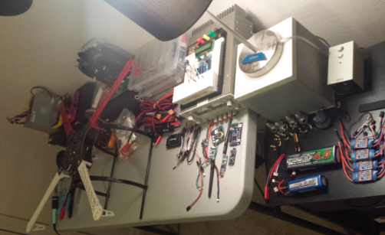

Figure 7.1: Phase 1 Testing Environment Bedroom Laboratory

The second testing phase will be inside a garage where the group will conduct the flight testing and flight control tuning. The 25’ x 25’ x 15’ indoor testing area will be enclosed with safety netting in case of uncontrollable mechanical failure which can save the group money in the long run to avoid replacing broken hardware. Because the phase 2 testing environment is indoors, it will provide the group with ideal testing conditions which gives the opportunity for precise tuning.

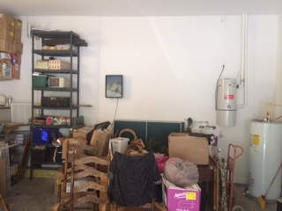

Figure 7.2: Garage Environment

This picture that is shown above is a current view of the environment where the drone will be doing its first flights. However, all the chairs and boxes in the middle of this picture will not be present the moment the testing will take place. This will be a very large open space that allows four people to work on this drone peacefully. This group has agreed that with this space available, it will be more than enough space to tie the drone from two frames so that if the drone decides to fly out of control, the two strings attached on the drone will keep it balanced and that way the team knows what direction the drone is going and this calibration can be done easily. As well as going to the left or to the right, the drone may also go extremely fast and reach the high elevations quickly. This garage provides a high ceiling of almost 15 feet. Therefore, this garage has been the safest environment for first time flight testing. The group also plans on covering the wall and other obstacles with some type of net so that if the drone for some reason loses control and crashes the walls, this net may provide a method of avoiding major damages to the drone.

The final hardware testing environment will be outdoors in a large field on UCF’s property. This testing phase will provide the group with a real-world testing conditions where wind and radio interference enter the equation. By the time the testing enters this phase, Mr. DJ should be able to handle any condition except for precipitation which the group will assume is not present. In this environment the group will have the freedom to test a variety of different scenarios which will be required to ensure a reliable and safe flying quadcopter.

7.1.2 Laser, LED’s and Sensors

This section goes into detail the environment for testing the laser, LED and proximity sensor systems for the Drone Hunt project.

7.1.2.1 Ultrasonic Proximity Sensor

Majority of the initial testing for the MB1200 MaxSonar EZ0 sensor will take place in home a workstation. The home workstation comprises a corner desk outfitted with a laptop and a secondary display monitor, as well as ample power outlets and lighting.

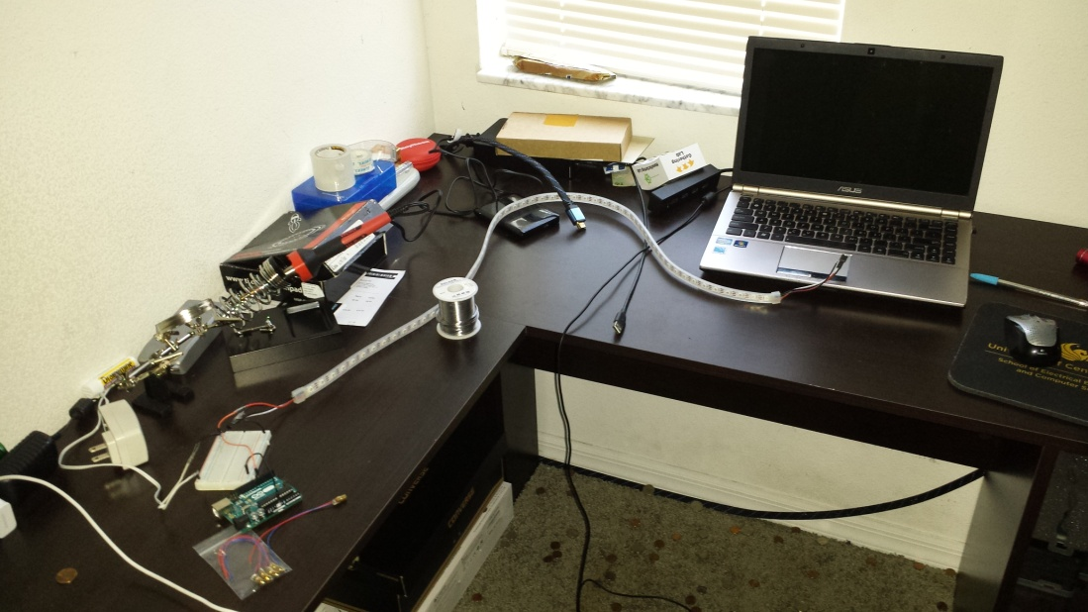

Figure 7.3: Desk Environment for LED and Laser

Using easily accessible equipment already owned by the group member. The required equipment list involves:

* MB1200 XL-MaxSonar®-EZ0™ High Performance Ultrasonic Rangefinder
* Arduino Uno Rev 3 Microcontroller
* USB A to USB B cable
* Soldering Iron and Solder
* Jumper wires
* Breadboard
* Laptop computer running Arduino ide
* Miscellaneous resistors, capacitors etc.
* 5V DC power supply
* Multi-meter

7.1.2.2 Laser System

Testing for the laser system is done in the same environment as the proximity sensor. Most of the required equipment is the same as it was for testing the ultrasonic proximity sensor. Additional equipment involves:

* 650nm 20mW red laser module
* Photodiode

7.1.2.3 LED System

Testing for the LED system is also done in the same environment as the proximity sensor and laser system. Most of the required equipment is the same as well. The only additional equipment necessary for testing the LED system is the Adafruit Neopixel LED strip.

**7.1.3 Communication**

Communications hardware testing involves having the IP network physically built with the router being configured to serve out IP addresses and having the wireless access point enabled for security. Testing will be done in several phases in order to verify the integrity of the system.

Phase one consists of testing outside of the approved case that the equipment will be sitting to verify that the given configuration and parameters are configured correctly. This will ensure that time is not wasted equipment being integrated with the case that holds the ground control station.

The environment specifications require testing outdoors since the whole project calls for the system to be in a spacious area. Tools that may be used for these tests include other non-related network devices such as a tablet, phone, or other laptop to verify that the network is running and provides an alternative way to ensure that the web service is properly serving the application as designed.

**7.1.4 Ground Control System**

Testing is one of the most important phases of a project. It doesn’t matter if it is a software, furniture, clothing, accessory, etc… they all need to go through the testing phase to insure that this final product will in fact work once it reaches the users hands. These types of test are called validation testing, and they are performed on the first engineering prototypes, to additionally ensure that the basic unit performs to design goals and specifications. For this section of this paper, all the testing steps and environments will be described when it comes to testing the ground control system.

The environment of testing for the ground control system will be in the garage of one of the members of this group. There is a section in the garage adequate for small project like these. This garage has a large desk where each member is able to sit and work on their specific part of the project. At this time of year, working in a garage is a perfect environment because the heat is not at its maximum and the humidity does not affect. Below is a picture of the section on the garage where the majority of that hard labor required for the ground control station will be held.

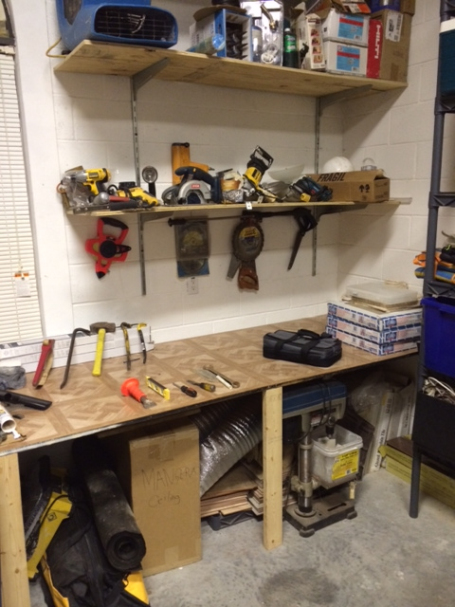

Figure 7.5: Garage Desk for Ground Control Station

However, if it gets too cold, simply closing the garage will be enough. The garage that this group member will be working on is a very large (two cars) garage that has been transformed for the construction tools and tables garage. All the basic tools are already provided. The reason for this being is that one of the parents of a member of this group is a construction and repair worker; therefore, this garage is filled with all basic tools such as power drills, power saws, screwdrivers, nails, screws, wood glue, black tape, heat gun, etc.

In addition, if extra electronic laboratory tools are required for this section of the main project, this group will in fact use the resources provided by the University of Central Florida. For example, since this group member does not have oscilloscope or soldering machines, it will required for the use of the TI Innovation lab as well as the use of the Senior Design Lab. Here, the more specific testing will be taking place.

7.2 Hardware Specific Testing

This following section discusses exactly how the hardware testing listed above will be taken into consideration for each of the members' corresponding part of this project. In other words, this section talks about the detailed steps of how the testing will be performed and just like a lab report would be for the hardware for this project.

7.2.1 Drone

There are several tests that need to be conducted on Mr. DJ before the group attempts the maiden flight. The individual components such as the wireless telemetry radio’s, GPS and compass module, and flight controller will be tested separately before getting mounted onto Mr. DJ’s frame for easier troubleshooting and reduced chances of circuit shortage. The specific testing will consist of the following:

|  |  |  |
| --- | --- | --- |
| *Mechanical* | *Communication* | *Other* |
| * Motor Balancing | * Wireless/Telemetry Communication | * Flight Time Optimization |
| * Propeller Balancing | * Failsafe | * Power Distribution |
| * Center of Gravity & Weight Distribution | * GPS/Compass Readings | * Vibration Dampening |
| * Frame Structure Strength | * ESC Response Time | * IMU Reading |

Table 7.1: Drone Hardware Testing Phases

The quadcopter needs to be mechanically sound if the group expects to have a smooth and stable flight. Improper balancing can lead to severe vibrations, toilet-bowl oscillations, and many more dangerous flight movements which will all lead to mechanical failure and a crash than can cost the group hundreds of dollars. The first step to achieve a safe and reliable flight is the proper balancing of the motors and propellers. When the motors get made in the factory, they are usually imperfect and need to be balanced by using one of the several available methods that can be found in many RC community forums. By balancing both the motors and propellers, the quadcopters’ vibration will lessen which will increase the flight controllers’ IMU reading accuracy. Like any flying object, the weight needs to be properly distributed along the frame to provide a precise center of gravity. Finally, the frame structure will be constructed using steel bolts and thread locker which will provide optimum strength for attached components.

Power distribution is important because electrical components can easily become damaged if improper voltage is supplied. After configuring the power distribution boards’ inputs and outputs, a multi-meter will be used to test proper voltage and current flow is obtained in the APM’s circuit. Once verified, the APM and its components will be safe to power and continue testing.

The first step of communication component testing will be connecting the APM 2.6 via the PC’s USB (which will also power the flight controller) and uploading the latest ArduCopter 3.2 firmware. Once the firmware is updated, the APM’s IMU (accelerometer, GPS, compass, barometer, etc.) will be calibrated. This process involves placing the APM and compass on all of the axis points while pointing due north. During the process, the APM will store sample data points which will later be used during flight to control the ESC’s power distribution to the motors. After calibration the APM will know be able to determine what axis it is on as well as where it is in the world. To verify the IMU is properly calibrated the group will use a mechanical compass and compare it with the APM’s compass. The accelerometer and gyroscope testing can be visually verified by tilting the APM on its axis and verifying correct data from the output which is displayed on the APM via the MAVLink connection (will be discussed later). This verification process will be crucial when it comes to setting up autonomous flight.

Once the flight controllers’ IMU is fully calibrated and tested, the group will focus on testing all of the APM’s functions wirelessly. After connecting the 3DR Telemetry Radio transmitter, GPS/Compass module, and RC transmitter receiver to the flight controller and the 3DR USB receiver adapter is connected to the PC, the APM will be ready to be powered up. Because the APM will no longer be receiving power from the PC’s USB port, it needs to be powered using a regulated battery or DC power supply. For this purpose, the group decided to use a DC power supply. Once powered with a 5V power supply, the APM must be connected to the PC’s APM Mission Planner software by selecting the appropriate baud rate (115k) and clicking connect. Once connected, the APM’s on-screen display will be showing several types of data outputs. Here is where the group can verify proper calibration settings for all of the previously mentioned electrical components.

Each ESC leaves the factory with a default firmware that works decent out of the box but can be improved by flashing a better firmware known as the SimonK firmware. This firmware is used in the best ESC’s out on the market and it can improve response time and better power flow to each motor. To flash the ESC’s, one must solder 6 wires onto the MISO, MOSI, GND, PWR, SCK, and RST pins on the Atmel processor embedded in the ESC. After this, one must connect to the proper analog pins on an Arduino UNO with loaded code that enables the user to flash the firmware. Once flashed, the group must calibrate the ESC’s by powering the FrSky Taranis transmitter, pushing the throttle knob to 100%, and then powering the ESC. Once the ESC beeps twice, the user needs to pull the throttle knob to 0%. The ESC will beep twice again which means it has been successfully calibrated.

The final communication step involves properly wiring the APM’s input pins to the FrSky receiver, and the APM’s output pins to each ESC. Once properly wired, the APM is ready to be armed to test motor response and frame vibration intensity. The arming sequence is as follows:

* Ensure propellers are disconnected
* Power the FrSky Transmitter.
* Lower throttle to 0% and set all switches to the zero position.
* ***Power the APM and ESC’s and wait for the beep sequence that signals “Ready to ARM”.
* Bring the throttle knob to the lower right corner (Throttle = 0%, Yaw = 100%) and hold for 3 seconds.
* Motors start to turn and respond to user transmitter input.

***: *The APM flight controller is equipped with a helpful diagnostic tool that uses LED blinking sequences along with beeping sounds during the boot up process to inform the user of the drones current health state and possible warnings. Once powered, the user should pay special attention to the LED's labeled ABC as it will fire a blinking sequence which corresponds to certain events. The chart below explains the LED's and their meanings:*

|  |  |
| --- | --- |
| LED: | Behavior: |
| *Power* | On when powered |
| *A (red)* | Solid = armed, motors will spin when throttle is raised. Single Blink = Disarmed (Motors will not spin). Double Blink = Disarmed (Motors will not spin, cannot arm because of failure in pre-arm checks). |
| *B (yellow)* | Only flashes along with A and B during calibration or as part of the in-flight auto trim feature. |
| *C (blue)* | Solid = GPS working and 3D lock. Blinking = GPS working and 3D unlock. Off = GPS not attached or not working. |
| *PPM/Serial* | Flashing when data is detected. |

Table 7.2: APM 2.6 LED Boot sequence codes

Once the quadcopter is armed and ready to run, the group can test for vibration caused by motor imbalance. This can be tricky as it involves adding weight to the lighter sides of each motor using small pieces of electrical tape. The procedure is similar to vehicle’s wheel balancing when small pieces of aluminum are added to the lighter sides of the wheel to balance the rotation. This process is a trial and error process and it uses a cell phone’s accelerometer to and vibration testing app that measures vibration. The phone is taped to the arm attached to the motor and vibration is continuously measured after adding weight on the lighter side of the motor. Once satisfied, the test can be conducted to the next motor. After each motor is individually balanced, the vibration should be reduced by up to 80%.

At this point, testing is ready to go airborne and be user controlled via the FrSky transmitter. The purpose of this testing is to ensure a safe, reliable, and smooth flight that confirms all of the previous tests that were conducted on land. Once stability is obtained, the group can move onto flight-time optimization by performing several tests such as component relocation, weight reduction, and even experimenting with different battery types to maximize the weight vs. flight-time ratio.

**7.2.2 Laser, LED’s and Proximity Sensor**

This section goes into detail the step by step procedure for testing the ultrasonic proximity sensor, laser subsystem and LED subsystem. The section involves connecting the subsystems and testing them to see if the expected results are realized. All the hardware testing in this section is done using an Arduino Uno Rev 3 microcontroller since it is already owned by one of the group members and majority of the open source online libraries available with code for running the Laser, LED and proximity sensor are available for the Arduino Uno Rev 3 instead of the MSP430 microcontroller that will be used for the actual final product.

**7.2.2.2 Laser System**

Since the laser system is what brings the concept of a game into the quadcopter project, it will be very important to make sure that this system functions properly. The process for testing the laser system will involve connecting the laser modules and the receivers then verifying that each time the laser hits the receiver, a signal is received by the microcontroller to verify this. The procedure for this is as follows:

* Connect the negative lead of the laser module to a ground source.
* Connect the positive lead to a 5V DC source.
* Connect the photodiode to the microcontroller as shown in the figure below.

If the system is functioning properly the microcontroller would be able to receive an input from the receiver circuit once the laser beam is pointed to the photodiode.

An oscilloscope was used to ensure that the carrier wave was coming out of the circuits as clean as possible and with the proper encoding. This was based on a 14-bit Manchester encoding scheme. The following diagrams illustrate the different outputs verified by tested individually and then collectively.

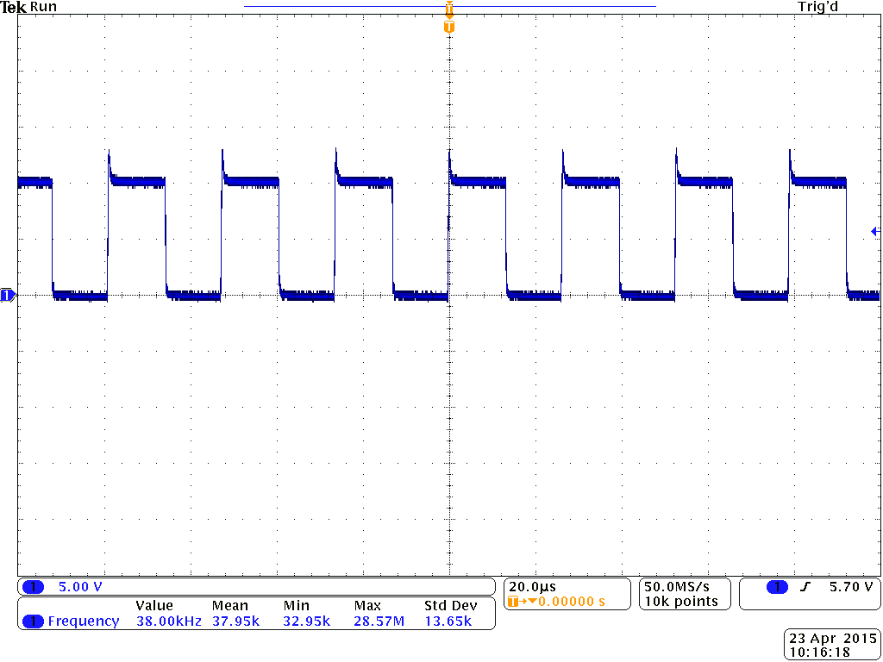  
Figure 7.6a: Clean 38KHz signal from the Oscillator

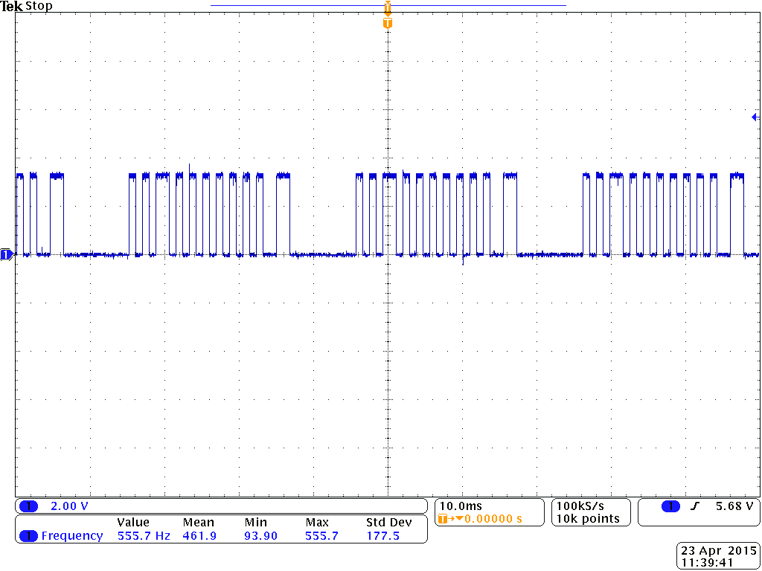

Figure 7.6b: Data Signal (14-Bits)

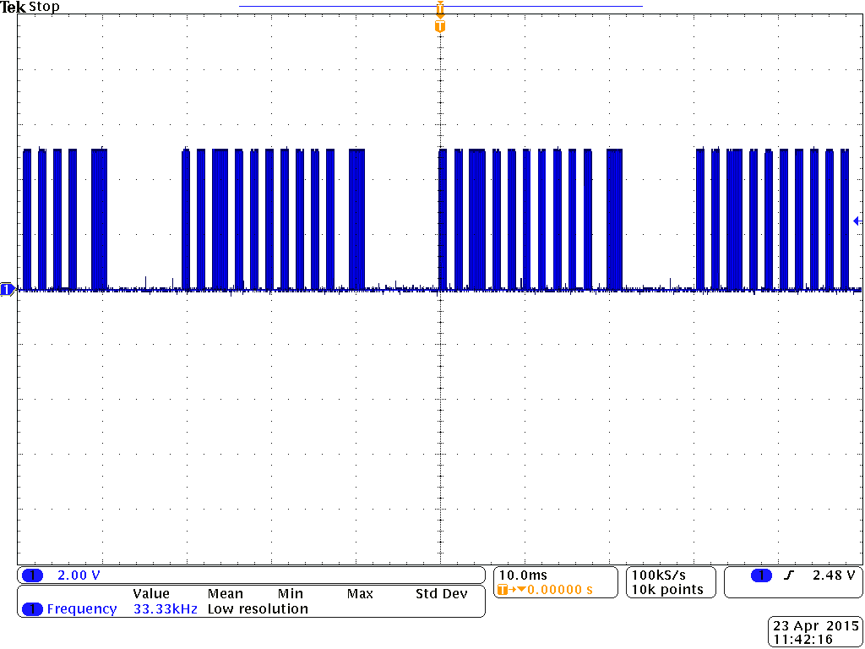  
Figure 7.6c: Final Carrier 38KHz Wave with Data

**7.2.2.3 LED System**

Hardware testing the LED strips to ensure proper functionality is quite simple. This process involves powering the LED strip, using a microcontroller to input a data signal to control the LEDs and then running a test program that confirms that each individual LED functions as required. The procedure for this process is as follows:

* Connect GND from microcontroller to GND or – on strip (always connect GND first)
* Connect 5V from Arduino to +5V or + on strip
* Connect Pin 6 from Arduino to DIN (or unmarked input) on strip
* Lay the strip out flat so you can see the entire thing, and then connect the USB cable from the computer to the microcontroller.
* Finally run a test program to confirm proper functioning.

Once this is done adjust values within the program to test different colors and brightness on each individual LED.

**7.2.3 Communication**

Hardware to be tested includes all the nodes and router ensuring that their power requirements are met by the given power supply. Much of the actual communication testing requires that the software is implemented and ready to serve its purpose, however there are a few hardware tests that can ensure that the equipment is not malfunctioning. Power cycling every device several times and ensure that they don’t hiccup at any point in time. The expected results should end up having the entire system communicating with each other and properly sending the correct commands and keeping the web application up to date with the information provided by Mr. DJ and the laser transmitter and receivers.

**7.2.4 Ground Control System**

This section will consider the more details steps of how exactly will this ground control system be tested in terms of the hardware. In reality, the only way of testing that all the hardware of this ground control system work properly is by connecting each component to both AC and DC power supply and verifying they all actually turn on. In more details, the first step will be to assure that the modified PC power supply gives voltage through each of the five different outlets. The way this will take into effect is that the PC power supply will be connected to a wall power outlet with the specific cord that the PC power supply need. To be more specific, this power supply has labeled 3, 5, 7, 12, Ground, & USB as all the available voltage supply. The first test will be that all these outlets provide exactly those labeled voltages. The most efficient way of measuring this will be by using a multi-meter and read the voltage.

Next, after making sure that the PC power supply works as it should, the second step in testing the hardware will be to see if the motherboard turns on by using the PC power supply that was previously modified. If the motherboard powers up (in other words, if the fans on the board turn on) that means that the AC power method is working properly when it deals with turning on the computer motherboard. The same steps will take into account when the screen, router, battery charger, LCD’s, etc... Since the modified PC power supply has multiple voltage outlets, each component that will be integrated in the ground control system will be tested. For instance, if the router only requires 6 volts to turn on, then the modified power supply will be connected through the 6 voltage outlet instead of the 3 or the 12 voltage. So the expected result is that if the charger is connected using the 12volts outlet, then the battery of the drone may be charged with no problem at all. In addition, since the PC power supply has an USB power outlet, the team will test this unit by plugging in various USB components such as a mouse, keyboard, etc… to see that the power supply is working properly.

However, this team wants a fully portable ground control system. Therefore, an SLA battery must be present in this system. The most common way of testing if a battery is in good shape is by measuring how much voltage it has. The way this simple test will be performed will be by using the multi-meter and touching the corresponding probes in the poles of the battery and reading the voltage. If the reading is around 12 volts, that means the battery is in great condition. The second way of testing that this battery serves as a good power source for at least 2 hours powering up the PC motherboard and the router is by connecting the positive and negative probes into the power in for the PC and finally, recharging this SLA battery for the next use.

To conclude, and to be a little bit more exciting, since this group is using a waterproof military case, a specific testing procedure will be taken into account before installing anything into this case. At the beginning of this ground control system being built, this group will submerge the empty, closed case into a pool. The exact procedures for this test will be that a heavy rock will be inside this case so that the weight can actually submerge the case. In addition, this group agreed that by inserting a piece of paper inside the case while in water serves as the best way of noticing if water entered the case or not. Waiting a few minutes and then removing it from the water will convince that the case is actually waterproof and can be accountable for that feature.

**7.3 Software Test Environment**

This following section discusses the environment that each member will be in when it comes to test each individual subsystem. In other words, this section talks about what equipment, tools, and labs are required in order to properly test the software of this project.

**7.3.1 Mission Planner**

T0he final implementation of APM Mission Planner will be running off of an outdated PC running a 2.0GHz Pentium Dual Core which can possibly struggle if too much bandwidth is passed through so it is essential that the group runs Mission Planner off of a lightweight operating system. To test the most efficient platform, the group will load the latest version of Mission Planner on a Debian/Ubuntu Linux distribution and Windows XP SP3.

**7.3.2 Laser Gun System**

Testing for the laser system is done in the same environment as hardware testing for the system. Most of the required equipment is the same as well. Additional equipment involves one 650nm 20mW red laser module, one photodiode sensor, one MSP430 microcontroller and one USB to mini USB cable, a laptop computer running the Energia IDE, miscellaneous resistor and capacitors of various values and a breadboard . The MSP430 microcontroller is being used in this phase of testing versus the Arduino Uno Rev 3 which was used in the hardware testing phase since the MSP430 is the final microcontroller that will be used in the prototype. The Arduino Uno was previously used since several online open source libraries were already available for that microcontroller from similar projects. The MSP430 microcontroller is the final one being used in the project since the group entered into the Texas Instruments Challenge which requires the use of three different Texas Instrument devices and this microcontroller will be one of the devices to meet the requirements.

**7.3.3 LED Lighting**

Software testing for the LED system is also done in the same environment as the hardware testing for the system. Most of the required equipment is the same as well. The only additional equipment necessary for testing the LED system is a one meter Adafruit Neopixel LED strip that is already owned by one of the group members, a laptop computer running the Energia IDE, an MSP430 microcontroller which will be used in the final project and a USB to mini USB cable

**7.3.4 Web-Application**

The web application depends on several pieces of data from different sources, however the server can be tested solo at first with dummy data and then include real data in order to integrate the units together. The web application’s environment comes down to the hardware specifications provided by the BeagleBone Black hardware. Using 512MB of RAM and 4GB internal flash storage the system is expected to run Angstrom Linux with no difficulty. An additional 8GB micro SD card will be added for additional applications needed and for memory paging as well. The services that will be running include a Node.js server that hosts the pages out of the server as well as a MongoDB server that will host the stats of the players at a given time Some sample screenshots of the game being tested can be found in the pages that follow.

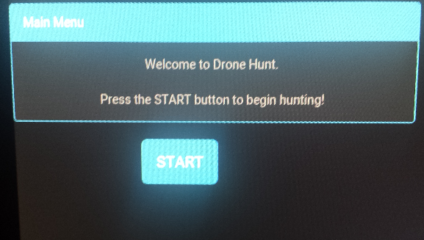  
Figure 7.7a: Start Page for Drone Hunt Web Application

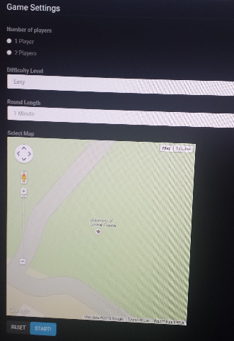  
Figure 7.7b: Early prototype of Map Selection screen

**7.3.5 Ground Control System**

This portion of the project is known to be as making a computer from scratch. Therefore, the environment for this portion of the project may be the same as when all the hardware was tested; in the garage of one of the members of this group. A computer without any software and operating system is not a very useful computer. After the computer has been assembled, all the required installation of software must sequentially take place. That means that after the software has been installed, they must be tested to ensure that they have been installed properly. When testing the operating system, the environment does not matter. This group can test if Windows XP was successfully install anywhere by simply running the computer and seeing if the main functions properly work. However, when testing the Mission Planner software, the environment for these tests will be in such location that the drone and the ground control station can communicate with each other. The reason for that being is that the mission planner APM is the software that talks to the Drone via wireless telemetry; transferring and receiving data at a very constant rate.

However, most of the times the drone will have to fly in order to follow the commands that the user tells the drone to do, therefore, most of the testing environment that this software testing will be taken place will be in a large open field. The location that this group agreed on was the large fields by the football field here in UCF. The plan is to begin using the mission planner’s command when the drone is limited to flying at least 5 feet off the ground. These initial testing may be done at the large garage that all the previous tests have been done. This environment will be more fit if the walls and floors are padded with some soft cushion so that if the drone was to hit the floor or walls, the drone won’t absorb a large impact. But when it is time to fly the drone at the high elevations the large grass fields will be adequate for the testing of the software mission planner.

**7.4 Software Specific Testing**

Software testing requires different procedures based on the system that is involved. Each system will be described in its own section below.

**7.4.1 Mission Planner**

Once Mission Planner is loaded onto the operating system, it will be loaded and connected to the APM where a serial connection is present with a data stream containing information from the integrated sensors. This provides the group with enough bandwidth to test system performance. This test will be conducted on both operating systems which will determine the operating system that better suits the ground control station’s hardware. Once the more efficient operating system is chosen, several more tests will be conducted to verify proper communication between the APM flight controller and the Mission Planner loaded on the ground control station.

**7.4.2 LED Lighting**

With the Energia IDE running on the laptop, the completed LED system program is compiled and debugged in the IDE to ensure no errors. Once this is successful the program is then run. The led strip circuit is set up and connected to the MSP430 microcontroller data output pin. First a led strip test program is run to verify the strip is connected properly and functioning as it should. Then the final program that needs to be used for the project is run. Input signals are sent using a push button to simulate laser hits and the led strip is verified to flash appropriately for various inputs.

**7.4.3 Laser Gun System**

With the Energia IDE running on the laptop, the completed laser system program is compiled and debugged in the IDE to ensure no errors. Once this is successful the program is then run. The laser circuit is set up on the breadboard and a laser beam is fired at the receiver. A single led diode is also placed on the breadboard and connected to an output of the microcontroller. This led will be used for the purpose of verifying that the software sends an output signal after processing the input data from the laser receiver input. It is then verified by a lit led that the software recognizes an input from the circuit then send output data to the server.

**7.4.4 Web-Application**

Testing the web application requires that be active data that would be coming from Mr. DJ and the rest of the equipment be replaced by an alternative source in order to proceed with unit testing. This stub data will be generated by a program running as a separate process on the BeagleBone server and will be written in preferably Python. If the task deems too cumbersome and static stub data will suffice then the transition will be made at such point.

Unit testing on the Drone Hunt web application requires testing of each individual module or page that is available in the application. This includes the welcome page, game configuration page, scoreboard page, victory page, manual control page, diagnostics page, and the developers’ credits page. Since the web application will be JavaScript oriented, the application can be as real time as possible without the need to reload a page like a traditional HTML page using hyperlinks for each individual component.

The components to be tested first are those that don’t require data from the external such as the welcome page and the credits page and will just require that the code be written to make the pages display and the buttons programmed to transition between the pages. The pages that follow are the diagnostics page to establish the initial connection between the external Mission Planner service and the configuration page to send various parameters for configuring the flight settings of Mr. DJ. The rest of the pages will be tested once the flight data is successfully sent and the program is behaving as it should. All these components are primary tested via coding and ensuring that the code is establishing this connection.

**7.4.5 Ground Control System**

It is very known to occur that certain software may work on a team member’s computer but not in others. Since this group is building a computer from scratch, this scenario may occur. Therefore, that is why the testing of software requires being very redundant. Even though software may work on a member’s personalized laptop, the software needs to operate in the ground control system’s computer; and it needs to perform perfectly.

The steps of performing a good amount of well tests are as follows. First, this group will ensure that Windows XP was successfully installed on the hard drive of the PC motherboard. By starting the computer and seeing that the Windows OS is running this team can agree that Windows did in fact install. Now, the steps are to see if Windows is running how it should. For example, one of the things that must be installed when running Windows XP is Service Pack 3. This service pack 3 is an important update that includes previously released security, performance, and stability updates for Windows XP. Another step in testing the software is that this team need is running the APM Mission Planner software. This system has plenty of features, and in order to know that the software is performing 100%, this group must go through a test on each of the main features of this APM software. The features include:

* Point-and-click waypoint entry, using Google Maps/Bing/Open street maps/Custom WMS.
* Select mission commands from drop-down menus
* Download mission log files and analyze them
* Configure APM settings for your airframe
* Interface with a PC flight simulator to create a full hardware-in-the-loop UAV simulator.
* See the output from APM’s serial terminal

In addition, the only way to verify that all these features or working properly, then the drone must react to each of these commands given by the user instantly. If a point to click command is pressed and the drone does nothing, then there is a problem in the software when communicating with the drone.

**7.5 Final Testing**

Now that the subsystems have all been tested separately and have been verified to be successfully working, unit integration for testing can commence. Unit integration will involve combining a single subsystem at a time taking several phases before the entire system is tested completely.

To begin a final testing phase, the first step is connect the drone to the ground control stations’ Mission Planner software and verify that each integrated data sensing component is properly transmitting live information. This is done is by plugging in the 3Drobotics USB 915MHz telemetry receiver into the ground control station, upload the latest firmware, and calibrate the IMU exactly as stated in section 7.1. Once the live data transmission is confirmed the user may proceed to testing flight modes and flight stability by performing user-controlled and autonomous flights from via FrSky Taranis RC Transmitter and the Mission Planner software. If the user has verified that the flight was stable and all flight modes and failsafe are properly working as previously stated in section 7.1, the user can conclude that the quadcopter module is successfully communicating to the ground control station module. Testing may now proceed to the laser and server modules.

Next, after a successful integration of the drone and the ground control station, the laser transmitter and receiver subsystem will be integrated into the drone. To do this, the receiver panels will be attached to the drone and connected to the onboard microcontroller. The working laser guns will be charged and turned on. With the guns turned on, it will be confirmed that there is proper communication between the gun and the web app. This is done by pulling the trigger on the gun and making sure that the web app registers a trigger pull. Next the laser will be fired at the receiver panel and it will be verified on the web app that a hit has been made. This will be done by both player guns and confirmed on the web app that each gun has made a hit.

The next addition to be tested is the LED subsystem. The LED strips will be attached to the drone. The power and ground will be soldered on to the power distribution board and the data input will be connected to the MSP430 microcontroller. Once connected, the LEDs will flash with the lighting sequence that is programmed to show every time the drone is turned on. After a game has started the LEDs will be verified to remain on a steady preset color, then with each hit from a laser, the strip on the corresponding arm that has been hit will flash the color of the player that made the hit.

In order to verify the data coming from the laser modules the Drone Hunt’s diagnostics mode will be launched the Mission Planner PC. This involves integrating the router and BeagleBone server inside the ground control station with the rest of the components. The router must be the first to be powered on to prepare networking services needed by the other machines and then the others will be powered. Network connectivity can be confirmed by invoking the each of the system’s “ping” command to each other system and verify communication. Once communication is established the diagnostics app can be launched. A browser instance will be launched and pointed to the diagnostics mode of the Drone Hunt web app. The page should display the following variables for the laser sensors:

* Laser location on Mr. DJ
* Hit Status
* Hit Count
* Signal Strength

The page will additionally provide the following variables for the laser transmitters:

* Gun/Player ID
* Current battery capacity
* Shot Count
* Trigger Status
* Signal Strength

Guns are tested via trigger pulses and the transmitter pointed at close range to test response. Distance is increased until the distance is equal to the optimal altitude as specified in the Section 4.

Finally, once all hardware has been successfully integrated and tested for basic functionality, the full functionality of the Drone Hunt web application can be tested to assess the completed system. This is accomplished by launching the web app on the Mission Planner PC. Instead of launching the diagnostics portion, the browser will be pointed to the main tab where the game configurations are established. The default settings will provide a typical normal game to start out. The game is started by clicking “Begin Game” and two players will test the guns while allowing Mr. DJ to soar up to its optimal altitude. The panels at the ground control station will be monitored by an additional spectator to ensure that the incoming data is consistent with the player and drone actions. After the game has finished and the victory screen is shown the system would have been tested completely and the finish product would be sealed for presentation.

8.0 Product Instructions

This section covers the setup of the Drone Hunt multiplayer game and setup for proper operation of Mr. DJ and other peripherals of the Drone Hunt project. Proper safety precautions should be taken at all times during setup and operation to avoid injury. This product is meant for outdoor use only. The following instructions should be properly read and followed prior to playing a game of Drone Hunt.

8.1 Setting up Mr. DJ

This sub-section covers all of the information you will need to properly configure Mr. DJ to work with the entire system:

1. Turn on the FrSky Taranis transmitter and open the Mission Planner software. Make sure the all of the position switches and knobs on the Taranis are switched to their lowest (or zero) position before powering on the transmitter.
2. Power up Mr. DJ by connecting the male XT60 connector from the 3S Turnigy 4000 mAh LiPo battery to the female XT60 connector attached to the power distribution board. Pay close attention to the APM’s boot sequence LED and beep sequence (Introduced in section 7.1) to verify that the flight controller booted successfully.
3. After successful boot up and GPS-lock is confirmed, move onto section 8.2: Setting up Ground Control Station.

8.2 Setting up Ground Control Station

This is a system that must be handled by somebody that can carry over 25 pounds without any trouble. This component is not meant to be used by children under the age of 15 years old. Once the area of use has been decided, the ground control system must be placed on the ground, and please make sure that this is placed on a flat surface. Next step will be to open the case. Once opened, there will be a main power button that provides voltage to the main power supply PCB will all the switches that turn on all the different components inside the ground control system. Once the main power button has been pressed, one must turn on all the other supplies; such as the router, the BeagleBone Black, the PC, the screen, and the battery charger.

Now that all the components have been turned on, the ground control system is ready to be used. However, there are two modes for this ground control system. One mode that the AC mode. This mode allows the ground control system to operate every component using the power supply provided from the AC outlet from a building close by. The most ideal scenario with this power mode will incorporate an extension cord to allow the open space usage. The second mode of the power supply is using the DC power supply. This mode of the main power supply is composed of using a steady voltage battery. For this mode a SLA (sealed lead acid) battery that provides 12Volts at a 7mhA. This way of providing power to the ground control station allows the user to not depend on a building close by for s main source of power. The DC mode provides the computer a maximum of two hours and half of power.

Lastly, in order to experience Drone Hunt for an acceptable amount of time, the drone and all the receivers must have a charged battery. This ground control station provides the users the ability to charge multiple batteries at a time. The way this may be done is by starting the battery charger and set up the charger to charge a specific battery. This charger is able to charge LiLo (Lithium Ions) batteries, LiPo (Lithium Polymer) batteries, NiCd (Nickel Cadmium) batteries, LiFe (Lithium Iron Phosphate) batteries. Each of these types of batteries requires a unique way of charging. Every battery pack is different. For instance a battery pack may have 3 cells of maybe 2 cells. These are characteristics that need to be taken into consideration when it comes to charging. The picture below shows the information of the battery’s charging status which is displayed on one of the LCDs embedded in the case.

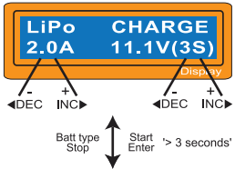

Figure 8.1: Display of Turnigy Charger

The left side of the first line shows the type of battery you select at the users setting. The value on the left side of second line sets a charge current and the value on the right side of second line sets the voltage of the battery pack. After setting the current and voltage, press Start/Enter key for more than 3 seconds to start the process. (Charge current: 0.1~5.0A, Voltage: 1~6 series) This shows the number of cells it has been set up and the processor detects.‘R:’ shows the number of cells found by the charger and ‘S：’ is the number of cells selected at the previous screen. If both numbers are identical, start charging by press Start/Enter button. If not, press Batt Type/Stop button to go back to previous screen. Then carefully check the number of cells of the battery pack to charge again. The screen shows the present situation during charge process. When a battery is charged completely, the charger will beep to announce that charging is completed but to stop charging, press “Batt. Type/Stop” key once. [19]

8.3 Game Setup

Before proceeding to setup the web application, it is important to verify that all the equipment in the preceding sections have been successfully setup and are in the operational state. The web application is the essential tool that drives the game experience with all the equipment in places. The game application can be launched from any computer or mobile device that is connected to the ground station network. For the purposes of keeping the system simplified, the Mission Planner machine will be used to launch the application.

To begin, launch the Google Chrome or Mozilla Firefox browser available on the machine and type in the IP address of the BeagleBone server into the address bar and hit enter. A welcome screen will appear with a “Get Started” button verifying that the web app has loaded the initial content. Click the “Get Started” button and wait for the configuration page to be displayed.

On the configuration page, select the appropriate settings to start a normal game between 2 players. These sample configuration settings are as follows:

* 2 Players
* Victory type: Fixed timer
* Normal difficulty
* Normal LED stance
* For each player, choose a player color

When the settings are configured press the “Start!” button to begin the match. The system will take about a minute to configure and quick test the devices before starting the game. A loading screen will appear while this occurs and will automatically display the scoreboard once the system has loaded. Section 8.4 of this manual describes the actual gameplay.

8.4 Playing Drone Hunt

Upon the completion of the game configuration and initial system check, the game should commence. A buzzer will go off and the web application will display a vibrant scoreboard equipped with a timer and each player’s current score. Mr. DJ will begin moving in a semi-autonomous fashion according to the given difficulty settings. At this point, the players will be free to use their assigned guns to try and fire at the targets for points.

When a player hits a target on Mr. DJ, the LEDs will flash in a sequence and color related to the player. Depending on the accuracy of the hit or the specific target, a player is awarded a certain score. The game will end after the time runs out at which point Mr. DJ will safely return to its home point. The player with the highest score wins. To replay the same game click “Replay” at the bottom of the victory screen or click “New Game” to reconfigure the game setup.

It is important to note that there are various configurations are available and that the sample configuration (as mentioned in 8.3) is not the only way to play. The various configuration settings available are as follows:

* Number of players
  + This is limited by the number of guns available at the time of gameplay
* Difficulty: Easy, Normal, Hard, Very Hard
  + With each increase in level of difficulty Mr. DJ will display a more aggressive and more random behavior.
* Game Type: Fixed Time Limit, First to X Points, Lives Mode
  + A fixed time limit allows players to collect score until the timer runs out and the victor is declared afterwards. This is the default mode.
  + First to X points allows players to compete to see who can reach a set score first and be declared the victor.
  + Lives mode will allow players to compete in a challenge to see who can hit the most targets without missing. Degrees of freedom and number of lives can be tweaked to allow a certain amount of accuracy to count as a hit.
* LED stance: Normal, Chaotic, Mellow
  + Normal is a baseline for LED color changes. This is the default setting.
  + Chaotic sets the LEDs to blink and change at an aggressive frequency flashing different patterns per minute
  + Mellow sets the LEDs to have a progressive change between colors.
* Player Color: Simple Palette or from RGB color picker

8.5 Troubleshooting

Within Drone Hunt, as a whole, there is many risk associated with projects similar to these. One may say is due to the level of complexity and also the chance of something goring wrong at a certain time. It is understandable that things can go wrong while unpacking and setting up the system for use. Refer to the various tables below to troubleshoot a specific component of the system.

**Mr. DJ (Quadcopter)**

|  |  |
| --- | --- |
| Problem | Solution |
| Mr. DJ’s motors will not run and/or unable to arm the ESC’s. | 1. Have you completed all of the steps mentioned in section 7.1.1? 2. Make sure you are in Acro, Stabilize or Simple mode. The motor will not arm in any other mode. 3. Make sure the APM is powered as mentioned in section 7.1.1. Ensure the PDB is wired correctly and the jumper JP1 is set according to your specific power configuration. 4. Make sure you’re arming correctly. Verify that the yellow LED is solid after IMU calibration (flashing for 5 seconds). 5. Make sure the Yaw and Throttle channels are not reversed. 6. Make sure the transmitter is set to Mode 2. 7. Try plugging the USB cable first to boot the board. Then plug in the LiPo via XJ60 connectors. 8. Verify trim settings are centered. 9. Recalibrate the APM flight controller. |
| Mr. DJ’s flight controller keeps locking up. | 1. Cause is most likely a corrupted dataflash or “calibration loop”. Re-download the ArduCopter firmware and recalibrate. |
| Mr. DJ tilts/flips over or “toilet bowls” when I take off. | 1. Make sure the APM flight controller is facing forward in the correct direction during calibration. 2. Make sure the quadcopter firmware is setup correctly for the correct model (X or + configuration). 3. Run the “Motors” command in the CLI setup to verify that each motor is oriented correctly. Refer to section 7.1.1 for proper propeller rotation. 4. Inspect the signal cables on the PDB and verify that the cables are connected correctly. 5. Inspect the propellers and check to make sure that the propellers cannot rotate on their motor shafts as if they weren’t fully tightened. 6. Go through the entire calibration process including the GPS/Compass calibration. 7. Make sure ESC’s are calibrated and rotating at the same time. Verify this by arming the motors and lightly pulling the throttle to 5%. 8. Verify all of the radio knobs are setup correctly. Pitch, Roll. Throttle and Yaw should all be at 0 or near zero. Move each knob to verify in the Radio Test screen. 9. Check all of the sensors in the Mission Planner to make sure all of the hardware are working correctly. |
| Mr. DJ’s motors spin but the quadcopter does not take off. | 1. Verify that the correct parameter file is loaded. In this case, just reload the new parameter firmware file. 2. Verify that the propellers are setup correctly matching the diagram shown in section 7.1 for propeller orientation. |
| Mr. DJ skyrockets into the air and can’t be brought down unless the throttle is cut to 0%. | 1. Add extra weight to the frame to bring the hover throttle closer to mid stick. 2. Reduce the THR_MIN parameter to the lowest value that will keep all of the motors spinning reliably. 3. Set the pitch/roll gains at the lowest position during the first flight and slowly increase the percentage value until you notice stability increasing. |
| RC Transmitter setup isn’t reading the RC channels correctly and/or hangs. | 1. Run through the recalibration process once again as mentioned in section 7.1.1. 2. Make sure the transmitter getting power and is paired with the receiver. Verify this by looking at the green LED and making sure it is solid. 3. If the PDB and APM were assembled manually, double check the main contact soldering points. |
| Mr. DJ moves in a direction even though the sticks are centered. | 1. Verify all 4 trims are centered. 2. Verify that the RC channel 1 and channel 2 trim parameters are equal to the PWM values displayed in Mission Planner. 3. Make sure that the center of gravity of the quadcopter is in the dead center. 4. Execute the level command on a flat surface. 5. Recalibrate using the Auto-trim feature. This is further explained in section 7.1.1. |
| Mr. DJ always yaws to the right or left upon takeoff. | 1. Check the airframe for a bent or tilted motor. 2. Verify that the weight is fully centered as close as possible to the center of the APM board. 3. Redo the ESC calibration 4. Verify that the propellers are properly configured according to proper rotation. |
| Mr. DJ is unable to obtain a GPS lock. | 1. GPS lock usually only works outside. You will most likely not obtain a GPS lock indoors as the interference from household devices will prevent this from happening. 2. The GPS/Compass module may be defective. Try performing the recalibration, if this fails, your module is defected. |

**Ground Control Station**

|  |  |  |
| --- | --- | --- |
| Problem | Description | Solution |
| Dead switches | If a switch is pressed and nothing happens | 1. Check that all power and ground wires are properly connected. 2. Check that all switches are correctly soldered. |
| PC not power up | Once the power switch is pressed for the PC motherboard to turn on , it does not power up | 1. Make sure all the wires and hard drives and properly connected. 2. Check that the processor is connected. |
| Charger does not charge the batteries | Once a battery is connected, the battery charger does not charge | 1. Check that the power wires are properly connected to the charger itself. 2. Check that the wires are properly connected to the battery that is meant to be charged. |
| Screen powers on but does not show anything | There might be a problem in displaying the data from the PC | 1. Check that the VGA cable is properly connected. 2. Check that the RAM is properly seated. |
| Mr. DJ does not connect with the Mission Planner over USB. | When this occurs no data will be sent via telemetry. | 1. Reinstall the USB 2.0 drivers for the ground control station. 2. Verify that the proper baud rate is set during connection (115200). 3. Check the Windows Device Manager and inspect the used COM port. Make sure this is the same port selected in Mission Planner. 4. Verify that the USB cable is properly connected to the ground control stations USB port. |
| Mr. DJ does not connect with Mission Planner over 3DR telemetry radios. | As stated above, without this successful connection, no data will be sent via telemetry | 1. Make sure that the USB cable coming from the APM is not connected at the same time as the 3DR radios. 2. Verify that the proper baud rate is set during connection (57600). |

**Laser Guns**

|  |  |  |
| --- | --- | --- |
| Problem | Description | Solution |
| My gun doesn't appear to be emitting a laser or responding. | The microcontroller may not be powered on or hasn't properly established communication with the router. | Check to see that the battery is fully charged and properly connected to the microcontroller on the gun. |
| My gun is not shooting in the relative direction I'm pointing it in | The laser emitter may not be properly aligned. | Use a screwdriver to open the gun’s laser compartment and reposition the laser emitter and manually realign until the results are acceptable |

**Web Application**

|  |  |  |
| --- | --- | --- |
| Problem | Description | Solution |
| Web application does not load when address is entered into the web browser | Beaglebone Black is not on or the web server service is not running. | Run a quick "ping" test from any machine to verify connectivity. If no response, check all the wires to see if they are connected properly. If ping was successful, check the httpd (web service) on the BeagleBone to see if it is running. To do this type in "sudo systemctl status httpd" in a terminal window that is connected to the server whether it be through an ssh session or locally on the BeagleBone Black server. The service can be restarted using "sudo systemctl restart httpd" |
| The Web Application layout looks very odd and/or buttons don't respond | The browser used to access the server may not compatible or up to date. | Ensure that the machine running the web application has a web browser that is up to date and is compatible with modern standards that use AJAX and JavaScript. |

9.0 Administrative Content

This next and final section of this senior design paper discusses all the ingredients that were taken into account so that this group could easily keep in track and organized to a final senior design paper. This group arranged a very organized schedule of each month and what section should be worked on. As well as all the extra curriculum activities that were beneficial to this group.

9.1 Milestones Discussion

Milestones are important to project planning as it provides a pace for the team to work at to ensure that certain deadlines are met. Below is a tentative schedule that has been decided on starting from August 17th all through the first phase of the project. Each section has a designated color and is shown in the calendar below it. This phase includes research and design as well as any supplemental documents that can be designed at this point in time.

Outlook as of August 17th, 2014

Phase 1: Research and Design (Senior Design I)

|  |  |  |  |  |
| --- | --- | --- | --- | --- |
|  | Section | Task | Page per person | Due Date |
|  |  | **Research & Planning** |  | **Sept. 11th** |
|  | **1.0** | **Executive Summary** | **1/2** | **Sept. 19th** |
|  | **2.0** | **Project Description** | **2** | **Sept. 26th** |
|  | **3.0** | **Research Related to Project Definition** | **4** | **Oct. 3rd** |
|  | **4.0** | **Project Hardware And Software Design Details** | **10** | **Oct. 17th** |
|  | **5.0** | **Design Summary of Hardware and Software** | **3** | **Oct. 26th** |
|  | **6.0** | **Project Prototype Construction and Coding** | **3** | **Nov. 5th** |
|  | **7.0** | **Project Prototype Testing** | **5** | **Nov. 9th** |
|  | **8.0** | **Product Instructions** | **3** | **Nov. 13th** |
|  | **9.0** | **Administrative Content** | **2** | **Nov. 18th** |
|  | **Wrap-Up** | **Finalize Paper (binding & last minute editing)** |  | **Nov. 25th** |

**August**

For the month of August, the main objective was to get this senior design group in progress to a successful experience. The first month of this semester was mainly getting the members, attending lectures, and brainstorming. The first month was all about coming up with ideas of a good senior design project. Therefore, this group decided to formally initiate the schedule by declaring that the last month of August will be dedicated on concentrating on Researching and Planning. Below is a Calendar view of August.

|  |  |  |  |  |  |  |
| --- | --- | --- | --- | --- | --- | --- |
|  |  |  |  |  | **1** | **2** |
| **3** | **4** | **5** | **6** | **7** | **8** | **9** |
| **10** | **11** | **12** | **13** | **14** | **15** | **16** |
| **17** | **18** | **19** | **20** | **21** | **22** | **23** |
| **24** | **25** | **26** | **27** | **28** | **29** | **30** |
| **31** |  |  |  |  |  |  |

**September**

For the month of September, it was scheduled that the first two weeks was dedicated for the Research and Panning portion of the project. The next eight days (from the 12th-19th) was dedicated to concentrate in the Executive Summary portion of the paper. The next section was to be worked on from the 20th to the 26th and that section was called Project Description. And finally, to end the month of September, the last four days of this month was dedicated on the Research Related to Project. Below is a Calendar view of September.

|  |  |  |  |  |  |  |
| --- | --- | --- | --- | --- | --- | --- |
|  | **1** | **2** | **3** | **4** | **5** | **6** |
| **7** | **8** | **9** | **10** | **11** | **12** | **13** |
| **14** | **15** | **16** | **17** | **18** | **19** | **20** |
| **21** | **22** | **23** | **24** | **25** | **26** | **27** |
| **28** | **29** | **30** |  |  |  |  |

**October**

For the month of October, the first three days of this month corresponded for the Research Related to Project from the previous month. The next fourteen days (from the 4th-17th) was dedicated to concentrate in the Project Hardware and Software Design Details of the paper. The next section was to be worked on from the 18th to the 26th and that section was called Design Summary of Hardware and Software. And finally, to end the month of October; the week of Halloween, was dedicated on the Project Prototype of Hardware and Software. Below is a Calendar view of October.

|  |  |  |  |  |  |  |
| --- | --- | --- | --- | --- | --- | --- |
|  |  |  | **1** | **2** | **3** | **4** |
| **5** | **6** | **7** | **8** | **9** | **10** | **11** |
| **12** | **13** | **14** | **15** | **16** | **17** | **18** |
| **19** | **20** | **21** | **22** | **23** | **24** | **25** |
| **26** | **27** | **28** | **29** | **30** | **31** |  |

The month of October was by far the most difficult month for this team. It was difficult because this month many of the group's members had multiple midterms’ exams and some were hard to get in contact with. Also, the weekend of Halloween break was very difficult because no job on the paper was done for a total of eight days. This definitely put this group behind schedule tremendously. However, the group managed to get all those days back by working long nights to cash up.

**November**

For the month of November, the first five days of this month corresponded for the Project Prototype of Hardware and Software section of this senior design paper. The next four days was dedicated on the Project Prototype Testing. The next four days (from the 10th-13th) was dedicated to concentrate in the Project Instructions of the project as a whole. The next section was to be worked on from the 14th to the 18th and that section was called Administrative Content (in other words, the milestones, budget, and sponsors). And finally, to end the month of November as well as this senior design research paper, the next weeks was dedicated on the final touches and last editing this paper required until the night before the due day which is December fourth at 10AM. Below is a Calendar view of November.

|  |  |  |  |  |  |  |
| --- | --- | --- | --- | --- | --- | --- |
|  |  |  |  |  |  | **1** |
| **2** | **3** | **4** | **5** | **6** | **7** | **8** |
| **9** | **10** | **11** | **12** | **13** | **14** | **15** |
| **16** | **17** | **18** | **19** | **20** | **21** | **22** |
| **23** | **24** | **25** | **26** | **27** | **28** | **29** |
| **30** |  |  |  |  |  |  |

A quick milestone table has been determined for Phase 2 of the project. While the team is determined to have certain portions of the project done this table is highly likely to change due to the long amount of time in the future these goals are.

Outlook as of November 13th, 2014

Phase 2: Design, Implementation, and Construction (Senior Design II)

|  |  |
| --- | --- |
| Task Description | Expected Deadline |
| *Drone Base Construction* | December 21st, 2014 |
| *First Web Application Prototype (Raw)* | Mid January 2015 |
| *Second Web Application Prototype (Functionality)* | Mid February 2015 |
| *Gun and Laser Barebones Functionality* | Mid February 2015 |
| *LED Integration (onto Mr. DJ)* | Early March 2015 |
| *Final Web Application* | Mid March 2015 |
| *Laser Receiver Integration (onto Mr. DJ)* | Mid March 2015 |
| *Complete Mr. DJ assembly* | Late March 2015 |
| *Final System Integration and Testing* | Late March 2015 |
| *Supplemental Material for Design Paper* | Early April 2015 |

9.1 Budget and Finance Discussion

During the early stages of research and planning, the group decided to cover most of the costs using their own available funds. The reason for this choice was mainly due to the fact that if the group decided to use sponsor funds provided by Boeing or Duke Energy, the project would be kept by the school. The overall budget was originally set to $1,000 but due to incorrect calculations mid-way through research, the final budget ended up being a bit more costly ($1,500). The group's purchasing plan will put used parts in great condition at a higher priority over brand new parts to help keep budget costs lower over buying brand new parts.

There are several resources to find used and brand new parts for this project. The group plans to find all of its used parts on eBay, RCGroups.com, and DIYDrones.com forums. These community forums were established many years ago and provide a great resource for used parts in great condition with a platform that enables easy communication with buyers and sellers of the RC hobby community. For brand new parts, the group has decided to purchase the majority of components from AloftHobbies, and HobbyKing.com. This is mainly due to the giant selections, great prices, and fast shipping provided by these sellers.

9.2 Sponsoring Discussion

When determining what sponsoring this group was going to go after, a few opinions where considered. The team had a lot of questions when it came to who will be keeping the completed product if this project was being sponsored by a company. The reason why was because one group member was sure that once this project was completed and presented, he would want to keep this project. Therefore, sponsoring was out of the question because having a sponsor meant that some of the components purchased for this project will become property of UCF. This group member was willing to pay-out-of-pocket when it comes to building the drone itself. So, for this Drone Hunt project each member has agreed that they will be providing money for their appropriate section of the project.

However, even though this group did not pursue a company for sponsorship, the North America Innovation Challenge presented by Texas Instruments was considered. This group had the interest in participating in this challenge because it seems that it would not hurt since this group is already thinking about implementing certain TI components. In addition to that, if this group participates in this innovation challenge, a $200 dollars credit will be donated for the use on the TI store website; something that this group will take advantage of since a sponsor was not elected.

On the other hand, as previously stated, a Drone Hunt group member gathered a valuable contact information that was tremendously beneficial for this group at the robotics club at UCF. This group member asked the current Treasure of the club for any ideas on how to get a military case for a ground control station. This person reached for the contacts business cards and handed a business of a Directory of Sales at SKB Cases Ray Ellis; located in Orange, CA, USA. With this contact in hand, this group gathered and created a very professional project sponsoring proposal email asking for any type of help. As a result, he suggested the best type of cases for the purpose of this project's use and shipped that case at no cost. He was kind enough and sponsored this group with a case that cost around $200 dollars for free. At the end of the conversation he said "If there are any other cases you or any UCF guys need just let me know."

To conclude, this group is also seeking some type of outside sponsoring when it comes to gathering old laser guns at various laser tag locations here in Orlando. The closest one is Hard Knocks and this group plans on sending the professional proposal letter asking for some type of help when gathering two laser guns.

9.3 Group's Ethics

This section of this paper talks about how two members of this group attended the senior design boot camp that was offered this semester by all the engineering advisors and the Engineering Leadership & Innovation Institute(eli^2). This experience was very beneficial because from here, the two members that attended this workshop gathered much important information that helps on the senior design experience. The most beneficial idea that was inherited was the values activity. This group gathered at the beginning of this semester and went through everything that was learned from this senior design workshop.

This group did an activity that will be beneficial for rest of the semesters. This activity consisted of gathering each of the members' ten most important values, the ten not so important values, and to disregard the ten not important values from a list of plus 35 values words. These words consisted of family, communication, religion, teamwork, respect, etc. After everyone finished, it was demanded to also get rid of the ten not so important values since they were already considered not so important values. So now, each member had their top ten most important values as an individual. Each member had completely different top ten values. Then from there, it narrowed down to select only five top values as an individual. From here, it was time to come up with five team values. With this list of four people with five top five values, this group had to agree on deciding what five values will become the new team values that will become the groups ethics for the rest of the semesters. This group came up with five values which are: Respect, Competitiveness, Communication, Teamwork, & Trust. This group now knows that these are the five ethics values that will be the most important things to follow.

9.4 Distribution of Work

Shortly after the team was established, a meeting was dedicated to determining the strengths and weaknesses of each member. The team came up with a table of such strengths and weaknesses along with additional constraints and the assigned roles that each member would take on based on those qualities. This idea was gathered by attending at the very beneficial Senior Design Boot camp that two of the members attended at the beginning of the semester. Ideas like these where some of the things that was adopted and used in this senior design experience that helped to a successful senior design. This table is illustrated below.

|  |  |  |  |  |
| --- | --- | --- | --- | --- |
| *Names* | *Strength* | *Weakness* | *Constraints* | *Role* |
| *Manny* | Microcontrollers | Syntax | Self-Motivation | Flying Robot |
| Flight Controller |  |  | Brain of Drone |
| Robotics |  |  | Drone Automation |
| *Randy* | Server | Lack Originality | Work | Communication |
|  |  |  | Server |
|  |  |  | Web App |
| *Devesh* | Electrical | Coding | Work | Laser System |
|  | Syntax |  | LED System |
|  |  |  | Proximity System |
|  |  |  | PCB |
| *Juammy* | Hardware | Syntax |  | Ground Control Station |
| Robotics |  |  | Build/Control Drone |
| MultiSim |  |  |  |

Table 9-1: Team Skill Set, Strengths, and Weaknesses

After the distribution of roles, the team decided on a concrete number of pages or otherwise measurable amount of work to distribute evenly. Additional pages were added in the event that several pages are lost due to editing. Below is a quick list of assumptions.

Paper Layout workload:

* 35 pages per person by the end of the semester
* 3 pages per week

Division of design:

* Teams of 2
* Drone and Hardware
  + Flight & Autonomous behavior
  + Ground Control Station
  + Manny & Juammy
* Laser Tag and Servers
  + Lasers and game implementations
  + Communication
  + Devesh & Randy

Appendices

A. Copyright Citations

[1] Doug Cameron and Robert Wall (2014, September 18), *Boeing Faces A Future Without Fighter Jets*. 2014, September 25. http://online.wsj.com/articles/boeing-faces-a-future-without-fighter-jets-1411063893.

[2] Figure 3.1. *Phantom 2 Vision - Your Flying Camera*. October 21, 2014. http://www.dji.com/product/phantom-2-vision.

[3] Figure 3.3. Elad Orbach (2013, February 5), *my diy ground control station*. (2014, September 1), http://diydrones.com/forum/topics/my-diy-ground-control-station.

[4] Figure 3.4. 2012, June 6, *Connecting Everything for ArduCopter*. 2014, September 21. http://www.arducopter.co.uk/all-arducopter-guides/2connectingeverything-for-arducopter.

[5] Figure 3.5. *Overview - Paparazzi | UAV*. 2012, October 10. http://wiki.paparazziuav.org/wiki/Overview.

[6] Figure 3.6. Adafruit. *Overview Iris LED and Prop Guards*. 2014, October 3. https://learn.adafruit.com/iris-leds-prop-guards?view=all.

[7] Figure 3.7. *PING))) Ultrasonic Distance Sensor (#28015)*. Parallax Inc. 2014, October 3.

[8] Figure 3.8: 2013, October 23 “Metalskin” *Academia Stack Exchange*, 2014, October 29. http://academia.stackexchange.com/questions/13602/.

[9] Figure 3.9. (1999, May 5), *RAMA UAV control System* (2014, August 26), http://rtime.felk.cvut.cz/helicopter/_detail/control_system_block_diagram.jpg?id=control_system_architecture&cache=cache.

[10] Figure 4.1. *Z700V2 Quadcopter Frame*. 2014, October 15. http://www.hobbyking.com/hobbyking/store/__40638__Z700_V2_Quadcopter_Frame_White_Red_With_Crab_Landing_Gear_700mm_V2.html.

[11] Figure 4.9. *Main Heads-Up Display From Mission Planner Control Station*. 2014, October 22. http://planner.ardupilot.com/wiki/common-mission-planner-ground-control-station/.

[12] Figure 4.10. *XL-MaxSonar-EZ Series*. Maxbotix Inc. 2014, October 17.

[13] Figure 4.11. *XL-MaxSonar-EZ Series*. Maxbotix Inc. 2014, October 17.

[14] Figure 4.12. *XL-MaxSonar-EZ Series*. Maxbotix Inc. 2014, October 17.

[15] Figure 4.28. Łukasz Więcek (2011, Oct 12), *A lab bench PSU from an old ATX power supply* (2014, September 23). http://majsterkowo.pl/a-lab-bench-psu-from-an-old-atx-power-supply/.

[16] Figure 4.29. Łukasz Więcek (2011, Oct 12), *A lab bench PSU from an old ATX power supply* (2014, September 23). http://majsterkowo.pl/a-lab-bench-psu-from-an-old-atx-power-supply/.

[17] Figure 5.1. Value Hobby. *Quadcopter/Multi-Rotor Power Distribution Board*. 2014, September 21. http://www.valuehobby.com/esc-distribution-board.html.

[18] Figure 6.1. HobbyKing. *Power Distribution Board*. 2014, September 24. http://www.hobbyking.com/hobbyking/store/__23140__Hobby_King_Quadcopter_Power_Distribution_Board.html.

[19] *Turnigy Accucell-6 Balance Charger/Discharger for NICD/NIMH/LITHIUM/PB Batteries: Operating Manual* (2014, September 29), Page 10-11.

B. Permissions

1. *Battery Testing Diagrams and Charts*



1. *APM Arducopter component related images*



1. *Ground Control Station Pictures*



1. *Figure 5.2:Arduino Tagger* *License*

### Attribution Non-commercial Share Alike (by-nc-sa)

  

This license lets others remix, tweak, and build upon your work non-commercially, as long as they credit you and license their new creations under the identical terms. Others can download and redistribute your work just like the by-nc-nd license, but they can also translate, make remixes, and produce new stories based on your work. All new work based on yours will carry the same license, so any derivatives will also be non-commercial in nature.